Commonly Asked ELA Questions and Answers for Grades 6-8

Curriculum

- How many modules will we engage in next year?
We will engage in 4 modules in grades K-8, one module per quarter.
- What are the names of the modules?
The modules for grades 6-8 are listed below.
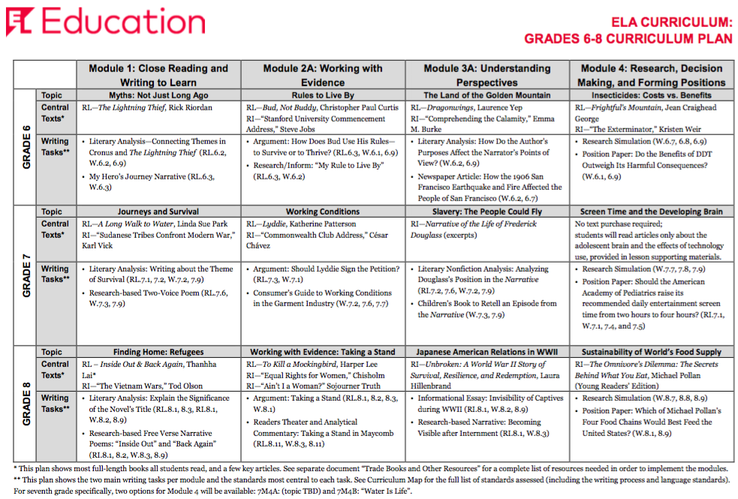
Materials
- What texts (trade books/novels) are used in these modules?

EL Curriculum for Middle School
2017-2018 / NEW for 2018-2019
  - Sixth Grade
Module | Book Title | Author | Qty | ISBN 13 | ISBN 10
1 | The Lightning Thief | Rick Riordan | One per student | 978-0786838653 | 0786838655
1 | D’Aulaires Book of Greek Myths | Ingri and Edgar Parin D’Aulaire | Teacher copy only | 978-0440406945 | 0440406943
2A | Bud, Not Buddy | Christopher Paul Curtis | One per student | 978-0440413288 | 043940200X
3A | Dragonwings | Laurence Yep | One per student | 978-0064400855 | 0064400859
4 | Frightful's Mountain | Jean Craighead George | One per student | 978-0141312354 | 0141312351

  - Seventh Grade
Module | Book Title | Author | Qty | ISBN 13 | ISBN 10
1 | A Long Walk to Water | Linda Sue Park | One per student | 978-0547577319 | 0547577311
2A | Lyddie | Katherine Patterson | One per student | 978-0140373899 | 0140373896
3 | Narrative of the Life of Frederick Douglass | Frederick Douglass | All excerpts that students read are provided in the lessons themselves.
3 | The People Could Fly: The Picture Book | Virginia Hamilton | Teacher copy only | 978-0375824050 | 0375824057
3 | Frederick Douglass: The Last Day of Slavery | William Miller | Teacher copy only | 978-1880000427 | 1880000423
4A | No text required for purchase |  | All excerpts that students read are provided in the lessons themselves.

  - Eighth Grade
Module | Book Title | Author | Qty | ISBN 13 | ISBN 10
1 | Inside Out & Back Again | Thanhha Lai | One per student | 978-0061962790 | 0061962791
2A | To Kill a Mockingbird (50th Anniversary Edition) | Harper Lee | One per student | 978-0446310789 | 0446310786
2A | To Kill a Mockingbird(film) | Directed by Robert Mulligan (1962) | One per teacher  To be ordered by C&I in August and delivered to schools
3A* | Unbroken: A World War II Story of Survival, Resilience and Redemption | Laura Hillenbrand | One per student | 978-0812974492 | 812974492
4 | The Omnivore’s Dilemma: The Secrets Behind What You Eat, Young Readers Edition | Michael Pollan | One per student | 978-1101993835 | 1101993839
*Module 3A is replacing the current Module 3B in grade 8.
- When will we receive the materials?
Materials for new modules, coded above in yellow, will arrive from the SCS Warehouse over the 2018 summer months. Textbook coordinators should follow regular textbook procedures when receiving the new materials.

- Will ESL and SPED teachers receive EL materials?
6-8
ESL and SPED teachers will receive all teachers’ manuals for each module for each grade level that they teach.

Close Out
- What is the message regarding close out (collection of materials/accountability)?
6-8

Materials used with EL curriculum implementation during the 2017-18 school year, coded above in white, should be collected, inventoried, and stored over the summer months in preparation for the next school year.

- What is consumable?
The only materials that are consumable are the student workbooks. All teacher manuals and trade books are non-consumable and should be collected and inventoried.

Professional Development
- What Professional Development and supports will teachers receive?
Please refer to the SCS Professional Development Summer Catalog or PLZ to find EL specific learning opportunities.
Link: https://vlp.scsk12.org/docs/summerpd/ProfessionalDevelopment.pdf
Teachers should take their Module 1 Teacher’s Guide and Supporting Materials manuals home with them for summer planning and PD.

