Book Club
September 28, 2018 Discussion begins at 5:45 PM sharp
Kol Emet Library Free and open to everyone!
RSVP: kimballa@verizon.net

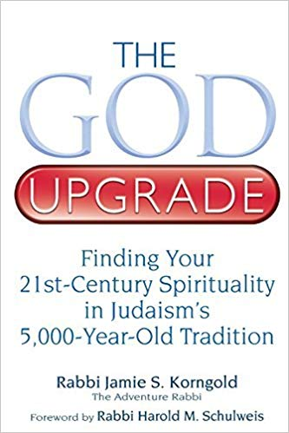

The God Upgrade: Finding Your 21st –Century Spirituality in Judaism’s 5,000 year Old Tradition
by Rabbi Jamie Korngold 2011 176 pages

For some people, the biggest stumbling block in religion is God—even for an ordained rabbi who admits her rational mind “can’t buy into a God in the sky who writes down our deeds and rewards and punishes us accordingly.” But not being sold on an intervening God shouldn’t bar you from living a vibrant and fulfilling Jewish life. The God concept has seen many upgrades over the centuries and it is these reinterpretations that have kept Judaism relevant.
In this provocative look at the ways in which God concepts have evolved and been upgraded through the centuries, Adventure Rabbi Jamie Korngold examines how our changing ideas of God have shaped every aspect of Judaism. With enthusiasm and humor, she shows that by aligning our understanding of God with modern sensibilities, Judaism can be made more meaningful, accessible and fully compatible with twenty-first-century life.

