September 2016
Dear Business Owner,
In order to support small business in our community, MP Gord Johns is initiating a series of “Business Walks” on the mornings of October 11-14, 2016 in the Courtenay-Alberni riding during Small Business Week:
Tuesday, Oct. 11 – Tofino and Ucluelet
Wednesday, Oct. 12 – Parksville and Qualicum Beach
Thursday, Oct. 13 – Courtenay
Friday, Oct. 14 – Port Alberni

What are Business Walks?
The Business Walk involves a partnership between MP Gord Johns, the local Chamber of Commerce and business owners. The program is designed specifically to establish a connection between the business community and their Member of Parliament, as well as to identify issues as a means of helping businesses remain strong and vibrant in our communities.
How does the Business Walk work?
A team of three volunteer “walkers” will come to your business to ask a few basic questions about doing business in your local area. The questions are meant to keep the visit very conversational to identify successes and obstacles that the local business community faces to help businesses remain in the community and grow. The visit is meant to be short in order to minimize the valuable time we take of business owners and/or managers.
How do I volunteer as a walker?
If you are interested in volunteering with the Business Walk event as a walker please contact your local Chamber of Commerce. You will meet for a short orientation at 9:30 AM on the day of your community’s Business Walk and MP Gord Johns will explain how the event will proceed. Volunteers will then break into groups of three and take to the streets surveying local businesses about their obstacles and successes based on a questionnaire we will provide.
How does my business participate?
On the morning of the event in your community, Business Walk teams will visit local businesses from about 10:00 AM – 11:30 AM. Each team will be comprised of three people, and made up of municipal councilors, Chamber volunteers and other small business owners, as well as MP Gord Johns.
Unfortunately, it won’t be possible for our Business Walk teams to visit each and every one of the local active businesses. Therefore, we have targeted key areas and key sectors as defined by the Chambers of Commerce. Simply plan to be at your place of business that morning at the aforementioned time.
If your business is not visited, please accept our apologies in advance and understand that we ran out of time!
If you are unable to participate in the Business Walk event, you are more than welcome to join the lunch roundtable discussion held immediately after the walk is finished. The lunch, on Gord Johns MP, is from 12:00 PM – 1:30 PM. Please RSVP if you would like to attend the lunch by Oct. 3.
With your participation, the Business Walks program offers an excellent opportunity for us to engage with you and to increase your knowledge of business support service providers available both locally and federally. We hope you will be able to participate!
For more information or to RSVP please contact:
Candace Wu, Assistant to MP Gord Johns
Office: 250-947-2140
Mobile: 250-240-0487
Gord.Johns.c1a@parl.gc.ca

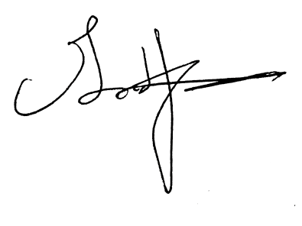
Sincerely,

Gord Johns, MP

