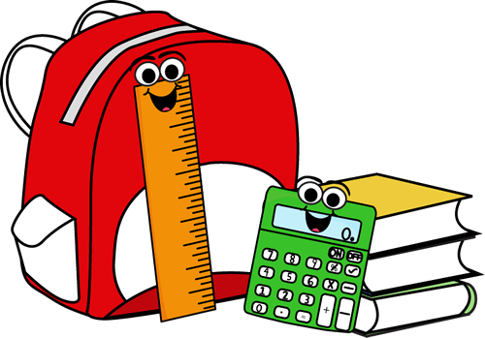
LEBANON LUTHERAN SCHOOL
2017-2018 School Supply List

Kindergarten

- 2 boxes-24 count Crayola crayons
- 1 plastic pencil box
- 1 yellow highlighter
- 1 hinged soap container (to hold crayons)
- 1 bag-type pencil case (for markers)
- 1 spiral notebook-wide ruled
- 1 heavy duty folders for daily use
- Plastic pencil box
- 1 pkg. 8 Crayola wide markers-classic colors
(not washable)
- 1 pkg. 10 Crayola fine markers (not washable)
- 1 pkg. index cards
- Scissors-round tip
- Gym shoes (left at school)
- 1 ½” binder with clear front pocket Spanish

1st & 2nd Grade

- Plastic pencil box (approx. 8” x 5”)
- 4 colored folders with two pockets inside (red, blue, green, orange)
- 1 heavy duty for home folder
- 1 wide-line spiral bound notebooks-No college ruled
- 2 large pink erasers
- 1 scissors
- 1 box Crayola crayons (24 count only)
- 1 box Crayola wide markers (classic colors)
- 1 pkg. dry erase markers (pkg. of 2)
- 8 glue sticks
- 12” ruler with inches & centimeters
- Gym shoes (left at school)
- 1 ½” binder (any color) clear pocket on front for Spanish (use/keep last year’s)
- 2 red pencils (can use colored pencils)
Available at – Office Max
- 2 pkg. blank 3 x 5 index cards
- 1 Earbuds
- 1 large book cover

3rd & 4th Grade

- 1 ear buds
- 1 pkg. #2 pencils (24)
- 1 pkg. dry erase markers (4)
- 1 box Crayola crayons (24)
- 1 box Crayola colored pencils (12)
- 1 box Crayola classic thin markers (8)
- 1 box Crayola wide markers (8)
- 2 highlighters (any color)
- 1 scissors – large/pointed
- 2 large pink erasers
- 1 12” ruler (cm and inches)
- 8 glue sticks
- 1 bottle Elmer’s glue
- 1 small plastic soap container
- 2 SMALL pencil storage boxes
- 3 JUMBO book covers
- 4 two pocket folders (red, yellow, green, blue)
- 3 heavy duty folders
- 4 spiral wide ruled notebooks (red, yellow, blue, green)
- 2 spiral wide ruled notebooks (any color/style)
- 2” binder (Spanish) NO BIGGER
- 2 packs of wide ruled loose leaf
- 2 Baroque fingering recorders (1 home-1 school)
- NIV Bible
- Gym shoes
- Art shirt to keep in locker

5th & 6th Grade

- 8 folders
- 9 spiral notebooks-70 sheets, wide ruled
- 2 graph paper spiral notebooks for math
- 4 large book covers
- Bible
- 24 pencils (will need more throughout the year)
- 1 box eraser caps
- Post-it notes
- 1 large glue stick
- 1 bottle tacky glue
- Scissors
- Highlighters (2 yellow, 1 pink, 1 green)
- 2 red pens
- 1 black sharpie
- Crayola markers-1 box thin, 1 box regular
- Colored pencils-24 box
- 1 ruler w/metric-wooden or sturdy plastic, not flexible
- Ear buds w/case
- Expo dry erase markers-4 pack
- Art shirt to be kept at school in the locker
- 2” binder for Spanish

7th & 8th Grade

- Bible & Luther’s Small Catechism
- Calculator (Texas Instruments Tl-30X II2 line)
- Ear buds & container to keep them in
- 6 pack expo dry erase markers (any colors)
- Scissors
- 5 2-pocket folders
- 1 box of colored pencils
- 1 box of markers
- 2 pkgs.( mechanical or wood) pencils
- 4 highlighters (green, yellow, pink, blue)
- 2 red pens
- 1 ruler – wooden or sturdy plastic
- 1 pkg. of pens (blue or black)
- Post-it notes
- 2 pkg. College lined paper
- 2 graph paper spiral notebooks for math
- 5 spiral notebooks (College lined)
- 2-2” binders (one for ELA & one for math)
- 2 pkgs. Binder tabs/dividers
- Tacky glue
- Gym shoes
- Spanish binder from last year (need dividers and tabs for binder)
- 3 pkgs. 3 x 5 note cards
- 1 dry erase eraser

Money earned through Box Tops will purchase Clorox wipes, reams of paper, paper towels & Kleenex for each classroom. Keep collecting those so we can continue this practice.

