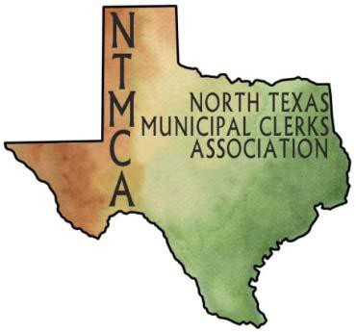
2018
Municipal Clerk of the Year
Nomination Form

PLEASE CHECK WHICH ORGANIZATION YOUR NOMINEE IS FOR:
If you would like to have your nominee considered for both organizations, please mark both slots

NTMCA
TMCA

Nominee Name: Municipality Address + Zip Code: Business Phone: Email: Tenure as City Secretary/Muni Clerk:
Has your nominee served on the Board of Officers for NTMCA? If so, list dates or titles:

Has your nominee served on NTMCA and/or TMCA committees? If so, list dates or titles:

In a couple of sentences, please state why you feel this person should be considered for this award.

Please list the professional accomplishments and additional comments regarding your nominee and feel free to elaborate on a separate page.
2018 Municipal Clerk of the Year Nomination Form Page 2

THE NOMINEE MUST MEET THE FOLLOWING REQUIREMENTS:

ELIGIBILITY REQUIREMENTS: NTMCA

1. A City Secretary who has been an active member of the NTMCA for at least three years;
2. Must have provided service to other Municipal Clerks on a local level where the opportunity exists;
3. Must have exhibited leadership abilities;
4. Must be a Texas Registered Municipal Clerk; and
5. Must currently be a City Secretary.

ELIGIBILITY REQUIREMENTS: TMCA

1. Must currently hold a municipal clerk position;
2. Must currently be an active member of the Texas Municipal Clerks Association, Inc., and must have been an active member for at least five years;
3. Must have provided service to other Municipal Clerks on a local level where the opportunity exists, or on a state level;
4. Must have exhibited leadership abilities;
5. Must be a Texas Registered Municipal Clerk; and
6. Must not be a prior recipient of the Municipal Clerk of the Year award.

APPLICATION MUST BE RECEIVED BY MAY 11, 2018
Finalist will be recognized at the June 21, 2018 Award Luncheon
North Richland Hills - TBD

FORWARD NOMINATION FORMS TO:
Aimee Nemer, City Secretary
City of Richardson
P.O. Box 830309
Richardson, TX 75083
aimee.nemer@cor.gov
Phone: 972-744-4290

Submitter’s Signature Date

Submitter’s Name, Title, and City

