Lamplighters
Invite you to join us for a
FREE CONCERT
Great family entertainment. Treat your family to the experience of LIVE music

Burbank Community Band
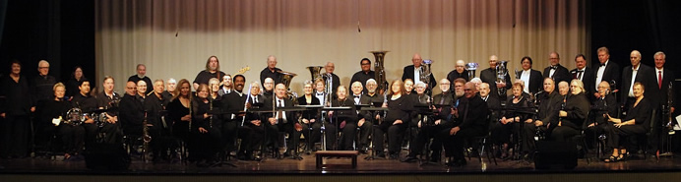

Saturday, February 25, 2017
Liberty Hall, Forest Lawn-Hollywood Hills, 6300 Forest Lawn Drive, Los Angeles, CA 90068

New choir member Paulette Westphal will be directing the Burbank Community Band in a performance Saturday, February 25th at 7 p.m. Featuring our soloist Eugene Carbajal, you will hear music from South Pacific, Victory at Sea, Pirates of the Caribbean, Shenandoah, the Blue Danube Waltz, and Handel’s “Water Music.”

For more information, contact Regina Meyers at 626.576.2718 or
Barbara Klein at 323.255.2410
(Possible dinner to be announced)

