Brought to you BY  WRITER’S BLOCK  Bookstore  Tuesday, Aug. 22  at Park Maitland School  Books will be signed and given to students on Aug. 22  PRE – ORDER the bOOK  VANISHED! Book 2  By James Ponti  BOOK 2 RELEASES on AUGUST 22!  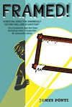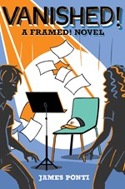  Book 1 Book 2  FRAMED! Selected for BOTH 3-5th and 6-8th  SUNSHINE STATE YOUNG READERS AWARD!  Student Name___________________________  Homeroom Teacher_______________________  Parent__________________________________  Check_____ Cash______ CC_____  Credit Card #_____________________________  Exp. Date___________ CCV# _________  Please make check payable to Writer’s Block Bookstore |  |  | Join us FROM 5:00 -7:00pM  8/22  BOOK  RELEASE  PARTY  Games & Prizes!  Mr. Ponti will be signing his books!  COME CELEBRATE WITH OUR AWARD WINNING LOCAL AUTHOR!  SPECIAL ONE DAY SCHOOL & EVENT  PRICING  Book 1 FRAMED!  $6.00 paperback  Book 2 VANISHED!  $14.00  Hardback only  QTY  Book 1 __________  Book 2___________  Total $___________

