House Leadership
Speaker
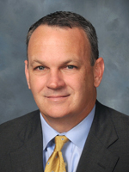 | Richard Corcoran
Location: | 420 The Capitol
Street Address: | 402 South Monroe Street  Tallahassee, FL
Phone: | (850) 717-5000
Fax:
Staff: | Chief of Staff: Mat Bahl  Special Assistant to the Chief of Staff : Lynn Imhof  Deputy Chief of Staff, Policy: Carol Gormley  Deputy Chief of Staff, Process: Tony Cortese  Deputy Chief of Staff, Administration: Celeste Lewis  Communications Director: Fred Piccolo  Special Assistant for Administration & Process: Jeff Takacs  Special Assistant for External Affairs & Policy: Jared Ochs  Scheduler & Logistics Coordinator: Porsche Knight  Administrative Lead: Eddie Westcott

Speaker Pro Tempore
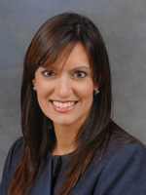 | Jeanette M. Nunez
Location: | 418 The Capitol
Street Address: | 402 South Monroe Street  Tallahassee, FL 32399-1300
Phone: | (850) 717-5119
Fax:
Staff:

Majority Leader
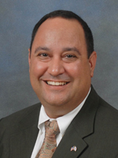 | Ray Wesley Rodrigues (R)
Location: | 322 The Capitol
Street Address: | 402 South Monroe Street  Tallahassee, FL 32399
Phone: | (850) 488-1993
Fax:
Staff: | Staff Director: Jason Rojas  Deputy Staff Director: Adrian Lukis  Communications Specialist: Kyle Wilson  Communications Specialist/Graphic Designer/Artist: Jayce Hill  Communications Assistant: Emily Bland  Program Analyst: Amelia Angleton  Program Analyst: Jeff Ivey  Program Specialist: Joseph Rhodes  Program Support: Ethan Perry  Program Support: Cameron Pennant  Administrative Lead: Margarita Mejia  Intern: Justin Tamayo

Majority Whip & Floor Leader
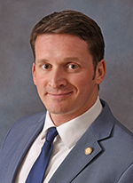 | Dane Eagle
Location: | 322 The Capitol
Street Address: | 402 South Monroe Street  Tallahassee, FL 32399-1300
Phone: | (850) 488-1993
Fax:
Staff: | Staff shared with Office of Majority Leader.

Minority Leader
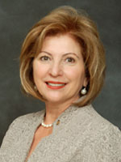 | Janet Cruz
Location: | 316 The Capitol
Street Address: | 402 South Monroe Street  Tallahassee, FL 32399-1300
Phone: | (850) 488-9622
Fax:
Staff: | Minority Floor Leader: Rep. David Richardson  Staff Director: Alexa Chappell  Communications Director: Anders Croy  Communications Specialist: Max Flugrath  Attorney: David Grimes  Legislative Analyst: David Spore  Program Analyst: Samuel Gilot  Program Analyst: Milan Thompson  Senior Administrative Assistant: Judy Mount

Minority Leader Pro Tempore
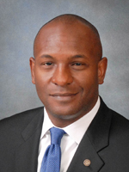 | Bobby DuBose
Location: | 316 The Capitol
Street Address: | 402 South Monroe Street  Tallahassee, FL 32399-1300
Phone: | (850) 488-9622
Fax:
Staff: | Staff shared with Office of Minority Leader.

Minority Whip
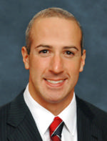 | Joseph Abruzzo
Location: | 316 The Capitol
Street Address: | 402 South Monroe Street  Tallahassee, FL 32399-1300
Phone: | (850) 488-9622
Fax:
Staff: | Staff shared with Office of Minority Leader.  Floor Leader: Representative Lori Berman  Deputy Whips: Representatives John Cortes, Katie Edwards, Shevrin Jones, and Richard Stark

Minority Policy Chair
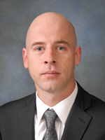 | Evan Jenne
Location: | 316 The Capitol
Street Address: | 402 South Monroe Street  Tallahassee, FL 32399-1300
Phone: | (850) 488-9622
Fax:
Staff: | Staff shared with Office of Minority Leader.

Minority Policy Chair
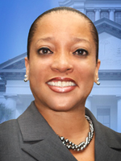 | Cynthia A. Stafford
Location: | 316 The Capitol
Street Address: | 402 South Monroe Street  Tallahassee, FL 32399-1300
Phone: | (850) 488-9622
Fax:
Staff: | Staff shared with Office of Minority Leader.

