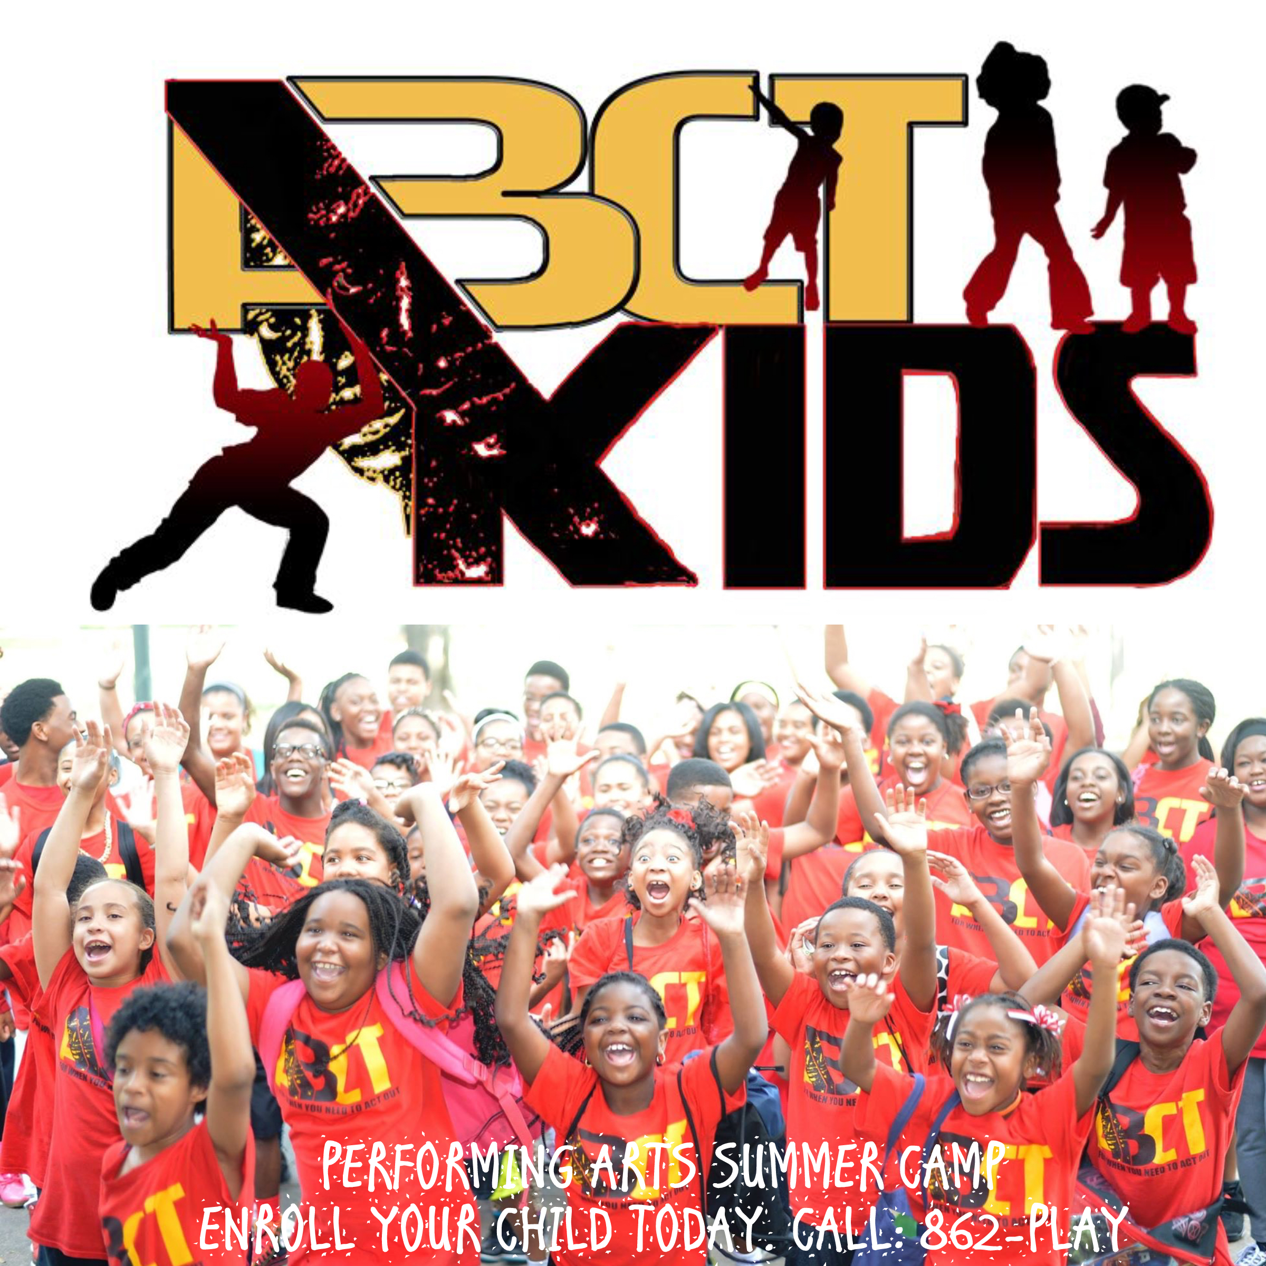
SPONSORSHIP
Commitment Form
Please send commitment form, payment, and
(email) logos to:
Anthony Bean
4527 Tchoupitoulas Street
New Orleans, LA. 70115
Telephone-(504) 862-7529
Email: abean@anthonybeantheater.com

I agree to sponsor a child to attend summer camp:
Date: _______________
Name / Organization: _______________________________________________
Address: Contact Name & Title: ___________________________________________
Email: _______________________________________________
Phone: ______________________
Sponsorship level: Please select an option below: (Full tuition for one camper is $460) ________
________Program Sponsor - $2,500
________ I would like to sponsor _____ camper(s) - Total Amount: $_________ (#)
_________Another amount - $ _______
* I would like to be included in social media and website shout outs! □ YES □ NO
Payment method: (Please submit form and payment by 06/04/2018) Check (Make checks payable to): Anthony Bean Community Theater or ABCT (Memo: Child Sponsorship-Summer Camp)
________Check
Copy and paste the link below into browser for PayPal Payment
https://www.paypal.com/cgi-bin/webscr?cmd=_s-xclick&hosted_button_id=YDNP3558JAKFL

Authorize signature_______________________________________________________________

