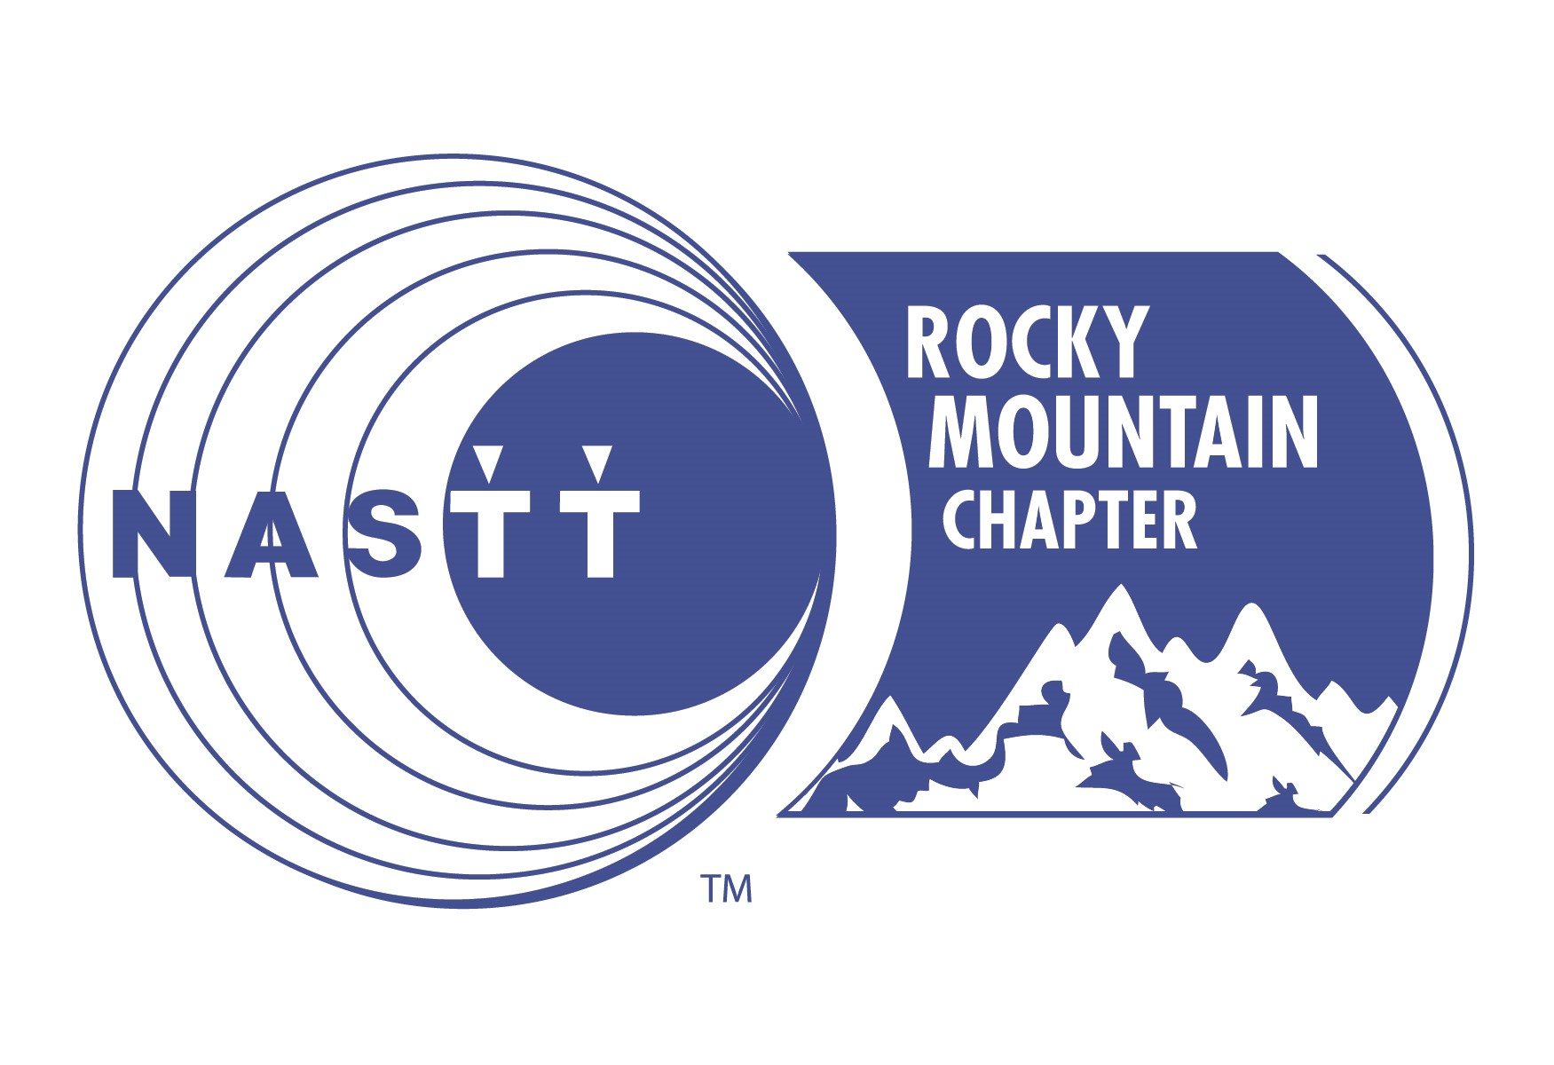
Trenchless Elevated - NASTT’s Rocky Mountain Chapter Event
November 1, 2018 PPA Event Center – 2105 Decatur Street, Denver, CO 80211
Sign up by September 21 to take advantage of the early bird discount, all company art work must be submitted to PTR by September 29th
*All sponsorships include the sponsor’s company name and logo prominently displayed on all conference marketing materials as well as on-site signage.

Platinum Sponsor
Sponsorship Investment: $1,500
Early bird price of $1,275, 15% savings!
Benefits:
- ¼ page Advertisement in NASTT Rocky Mountain Chapter magazine
- (2) full conference registrations
- Tabletop display for company literature distribution

Gold Sponsor
Sponsorship Investment: $1,000
Early bird price of $900, 10% savings!
Benefits:
- 1/6-page Advertisement in NASTT Rocky Mountain Chapter magazine
- Tabletop display for company literature distribution
- (2) full conference registrations

Silver Sponsor
Sponsorship Investment: $800
Early bird price of $720, 10% savings!
Benefits:
- 1/8 page Advertisement in NASTT Rocky Mountain Chapter magazine
- Tabletop display for company literature distribution
- (1) full conference registration

Bronze Sponsor
Sponsorship Investment: $500

Lanyard Sponsorship
Sponsorship Investment: $1,000
(Sponsor responsible for production and cost of lanyards)
Only (1) available
Benefits:
- Opportunity to provide lanyards for all conference attendees name badges

Networking Reception Sponsor
Sponsor Investment: $750
Only (2) available
Benefits:
- Five minute welcoming speech
- Opportunity to provide giveaways at the reception
- (1) full conference registration
- Signage as reception sponsor

Lunch Sponsor
Sponsorship Investment: $750
Only (2) available
Benefits:
- Five-minute welcoming speech
- Opportunity to provide giveaways on the luncheon tables
- (1) full conference registration
- Signage as the lunch sponsor

Breakfast Sponsor
Sponsorship Investment: $500
Only (2) available
Benefits:
- Opportunity to provide giveaways on the breakfast tables
- Signage as the breakfast sponsor

Coffee Break Sponsor
Sponsorship Investment: $250
Only (2) available
Benefits:
- Opportunity to provide giveaways
- Signage as the coffee sponsor

Become a 2018 Sponsor Today!
*Please check one or more of the following

Platinum Sponsor $1,500
Gold Sponsor $1,000
Silver Sponsor $800
Bronze Sponsor $500
Lanyard Sponsor $1,000
Reception Sponsor $750
Lunch Sponsor $750
Breakfast Sponsor $500
Coffee Sponsor $250
Company Information:
Company: _______________________________________________________________________
Contact: ___________________________________ Title: _______________________________
Address: ________________________________________________________________
City: _________________________ State/Province: _______________ Zip: ______________
Phone: __________________________________ Fax: ________________________________
E-mail: _______________________________________________________________________
Web site: _______________________________________________________________________

Payment Information:
Please charge my: □ Visa □ MasterCard □ AMEX □ Discover

Name on card: _______________________________________________________________________
Billing Address: _______________________________________________________________________
City: ____________________________ State: __________________ Zip: _______________
Card Number: _______________________________________________________________________
Exp. Date: _____________________ Auth. Code (last 3 digits on signature panel): _____________
E-mail (address where receipt should be sent):_________________________________________________

Please mail checks payable to:  Stephanie Nix- RMNASTT Treasurer  1893 E. Skyline Dr. Suite 203  South Ogden, Utah 84403  801-479-9000  stephienix@chnix.com | Send Company Artwork for Signage, etc. to:  Elaine Chouinard  PTR COMMUNICATIONS INC.  elaine.ptrcom@mts.net  204-255-6524

