APRIL

**7**

**MIDDLE SCHOOL SPRING FLING DANCE**

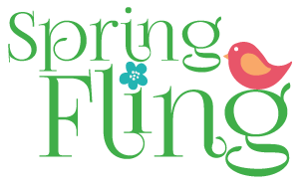

**5-8th graders**

Come join us on April 7, 2017 in the ECCA hawk room for the spring fling dance! There will be dancing, games, prizes, food, and lots of fun! Friends are welcome from other schools.

Admission: $5.00

+1 Friends: $5.00