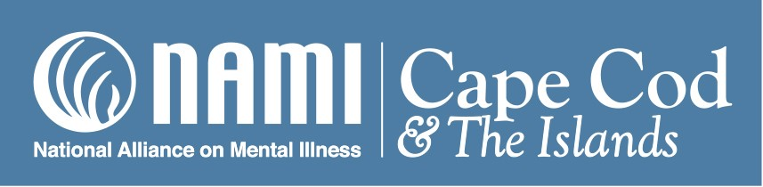

Executive Director’s 2016 Annual Report

2016 has been another year of growth and expansion for NAMI Cape Cod and the Islands. With the continuation of our branding and marketing efforts, we have seen a consistent increase in name recognition and demand for our services. We have attempted to respond to community needs as they have become evident with increased educational programming, on site support as well as telephone support, and a new advocacy initiative. Through the efforts of Arlene Hoxie, our office administrator, our list of contacts continues to grow and our monthly newsletter now has a circulation of around 1200. We are adding to and updating our website on a regular basis.

We have increased our F2F presentations and have conducted four 2017 winter classes, enabling around 60 people to experience the educational elements of the program and the shared experience of those with mentally ill loved ones. We recently trained 15 new F2F teachers including 4 bilingual teachers (Spanish) and now will be able to easily cover all of our geographic area with classes. We also have 2 trained Family Connection (Borderline Personality) teachers and will be able to offer that course on a regular basis. Kim Lemmon, our Outreach Coordinator, has facilitated these efforts which are dependent on volunteers.

Jud Phelps, our Director of Client Services, now visits the behavioral health inpatient facilities at Cape Cod Hospital as well as the DMH Pocasset facility on a regular basis making contact with family members who have loved ones in those facilities. Our relationship with these primary providers continues to grow enabling us to help families receive the services needed. A large part of our outreach has been to police departments and we have been instrumental in arranging meetings and connecting them to the hospital resources in an attempt to facilitate treatment instead of incarceration for those mentally ill people with whom the police need to interact.

Last Spring we were able to engage Mary Zdanowicz, Esq. as a consultant to help us with our advocacy efforts. Mary has a life time of experience advocating for the seriously mentally ill and their families at the national level as well as locally. Her wealth of knowledge on laws, legislation, and legal issues in the field of mental health and her willingness to share it has added a whole new dimension to the services which we are able to offer. Mary has also started an Advocacy Network of NAMI people to help determine and address the most important issues affecting us on the Cape.

During the course of the year, we began work on three important initiatives which are ongoing and will continue well into the future. During the summer and fall of 2916 we worked with the CCIT training team from Taunton to design our Cape specific CCIT (Community Crisis Intervention Team) training for Cape police departments. We received a $50,000 grant from the Weny Charitable Trust to present this program and the first 40 hour training was held at the end of January 2017 with 14 out of 15 Cape police departments in attendance. We will be holding the second training late this fall. We also held our second Think:Kids (Collaborative Problem Solving) introductory workshop at the Nauset High School in October and worked with the Barnstable school district to plan a required all school presentation in the fall of 2017. We recently received a three year $90,000 grant from The Peter & Elizabeth C. Tower Foundation for the purpose of initiating Think:Kids in the public schools throughout the Cape. We are continuing our collaboration with YMCA Cape Cod and the Diabetes Resource Center adding a mental health component for those who are suffering from a chronic illness. We collaborated with the YMCA on a $20,000 grant from the Community Benefits fund of Cape Cod Health Care to initiate this program. We also received a grant from the Nantucket Fund for work in the Nantucket school system. Arlene Hoxie, our office administrator, assists in the grant writing process.

The production of the “Primer,” (concept of Jud Phelps based on the questions from his work with our clients) a simple guide to mental health and services on the Cape and islands has been ongoing and a final editing and proofing will take place during the next month. We have received grants from Cape Cod Healthcare ($5,000), the Kelley-Bangs Foundation ($5,000), and the Cape Cod Five Foundation ($2500) for the production and printing of 2,000 copies to be distributed free to our clients and collaborating partners.

The Siobhan Leigh Kinlin Memorial Golf Tournament continues to grow and grossed close to $250,000 in 2016 with a net profit of about $213,000. We have the Kinlin family, friends, and business associates as well as a growing number of businesses and individuals to thank for this impressive growth. Another important and successful fundraising event, Dragonfly for NAMI CC&I on Nantucket, made its debut in September 2016. This event (cocktail party and silent auction), conceived and produced by Kate Kling, in memory of her sister who suffered from chronic depression and eventually committed suicide, grossed $60,000 and netted $40,000 which is being used to increase our services on Nantucket. Ruth Blount, a long time NAMI on Nantucket volunteer was hired as a very part time program coordinator on the island. Dragonfly will be an annual event and sponsorships are already coming in for 2017 event.

Our Board of Directors continues to be active giving direction and help as we move forward in our growth and development. 2017 BOD plans include continued strategic planning, sessions on non -profit governance, and the development of additional policies and procedures, including HR policies. The staff and I look forward to working together with this talented and supportive group as we continue to work for the people of the Cape, Nantucket and Vineyard communities.

Respectfully submitted,

Jacqueline D. Lane, Executive Director

NAMI Cape Cod and the Islands

.

