2017 ISM – New York’s Annual Conference
Speaker Bios

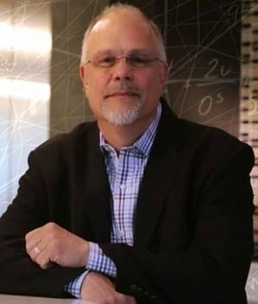 | GREG IAQUINTO  Leader in Global Supply & Risk Solutions,  Dun & Bradstreet  20 years in the enterprise software and content space working with customers and prospects in engineering, procurement and supply chain management organizations of several fortune 100 and 500 companies. Prior to Joining D&B, Greg was responsible for product strategy and strategic partner relationships for IBM covering the B2B, commerce and procurement portfolios. Greg joined IBM through the acquisition of Emptoris where he was VP of product strategy for the strategic supply management suite of products.  Prior to working at Emptoris, Greg has worked in the PLM arena as the Director of Product Management at PTC and Sr. Business Consultant at Agile software (now Oracle), i2 Technologies (now JDA) and Aspect Development. As a business consultant Greg was responsible for conducting strategic value assessments and providing best practice workshops that have helped many procurement and supply chain organizations across multiple verticals identify profit leakages, voids in their business processes and disconnects within their enterprises systems.
CHRIS BERGER
Global Head of Vendor Risk Management,
Bloomberg, LL.

Chris has over 25 years of Procurement experience as a change agent of business-wide procurement processes & delivering improved business benefits.

He’s had the privilege of working for companies such as AIG, A.T. Kearney, MetLife and CA Technologies. He’s performed Source to Pay transformations at Metlife as Head of Global Sourcing and CA Technologies where he was CPO.

Chris Joined Bloomberg as CPO in 2011 went on to successfully execute a Global Procurement Transformation.

In 2014 he was tasked to establish a Vendor Risk Management (VRM) program and has recently been appointed as Global Head of Vendor Risk Management at Bloomberg – responsible for managing and leading the development of an enterprise-wide risk management framework including; risk identification, policy and program requirements; governance and the technology to support the framework.

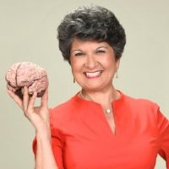 | KARLA ROBERTSON  Founder and CEO,  Shifting Gears Executive Coaching  Karla Robertson is Founder and CEO of Shifting Gears Executive Coaching & Keynote Speaking. For the past 18 years, Karla’s focus has been coaching executives (director to C-Level) and their teams to drive better results by becoming better thinkers and leaders. Karla’s professional credentials include being a Professional Certified Coach, a Master MTBI® Practitioner with Myers-Briggs® Type Indicator assessments, and holding her B.S. degree with dual majors in Psychology and Marketing. She is a member of the International Coach Federation and a past board member of the New Jersey Coaches Association. Her professional coaching work includes assignments with Wells Fargo Home Mortgage, CR BARD, L’Oréal and Navitus Health Solutions, Inc. and Willis Towers Watson to name a few.  Prior to launching her business in 1999, Karla had a highly successful sales career in mortgage banking and the pharmacy benefit management industries where she was the top producer for her company in both fields. Karla’s sales success stems from knowing how to connect with people and build successful relationships that endure through good times and challenging ones. She has particular expertise and success in developing the “trusted advisor” status with her clients and many executive across diverse industries seek her out to help them achieve their aspirations, make more powerful contributions to their organizations and build stronger teams and cultures.  Karla has received very high marks wherever she has spoken over the last 6 years from conferences to associations to offsite leadership and strategy retreats.

