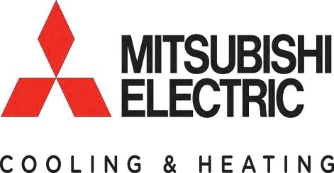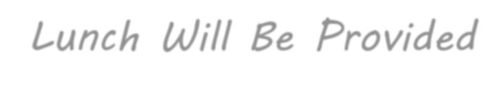M- and P- Series Application Training
February 21, 2018 8:00am – 5:00pm
Air Conditioning, Refrigeration & Pipefitting-Education Center
13201 NW 45 Avenue, Miami, FL 33054

Description:
This course will increase product knowledge of the M- and P-Series product lines and improve the participant’s
ability to select the most appropriate applications for these products. The course will also provide participants
with the tools to better service their customers

Intended audience:
This course is particularly useful to distributors, counter personnel, and contractors who are newly exposed to the
Mitsubishi Electric Cooling & Heating M- and P-Series product lines. It’s also useful for updating personnel that
have been familiar with the product in the past but need to learn about the current product (i.e. a refresher
course)

Prerequisites: None

Performance objectives:
Upon completion of this training course the participant will be able to:
• Convey the advantages of INVERTER-driven technology and the benefits of this technology to potential
customers
• Recognize the M- and P-Series product lines as a “first approach” rather than a “last resort”
when it comes to replacement of existing systems and/or new construction
• Suggest the best equipment for various applications such as single-zone versus multi-zone,
standard heat pumps versus Hyper-Heating, ducted indoor units versus wall-mount or other style
• Based on a specific application, identify the proper components and accessories to correctly
install a complete system
• Locate installation requirements such as maximum piping lengths, operating ranges, and power requirements
• Recommend controllers applicable for various M- and P-Series applications and describe the operating features
of these controllers
• Accurately explain the various functionality of our controllers, our equipment, and how they
work compared with traditional unitary products
• Identify the basic unit type, capacity, and operating voltage, as well as other general features,
based on Mitsubishi Electric model numbers

CEU: 0.8
Lunch Will Be Provided

To enroll in the seminar, click
HERE
This will bring you directly to the sign-in screen.

If you have any questions, please contact Mitsubishi Electric Training at training@hvac.mea.com or 678-730-1710

