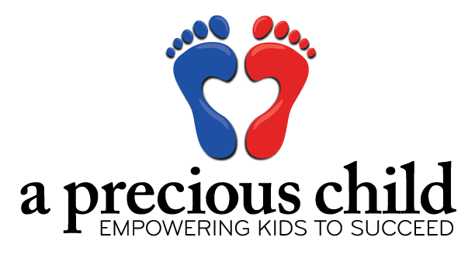

**Contact email**

**Your Company**

**CONTACT**

FOR IMMEDIATE RELEASE

**Date**

Insert your logo here, or use your own template. Sample verbiage follows for your ease!

**[Insert Your Name] Teams Up With Local Non-Profit to Collect [insert type of items you are collecting] for Disadvantaged Colorado Children**

**BROOMFIELD, CO** (date) — [Insert your name] has stepped up as a A Precious Child Drive Partner and is hosting a [items you’ll be collecting] collection drive now through [insert drive end date]. Individuals are encouraged to drop off [insert items you are collecting] at [insert location] to help support A Precious Child, a local non-profit that provides children in need with opportunities and resources to empower them to achieve their full potential.

Qualifying Colorado children are referred to A Precious Child by Agency Partners (such as: schools, health and human services, churches, hospitals, safe houses, fire and police departments) to receive clothes and other basic essentials to ease the financial burden and to help them thrive academically. Businesses and community groups host clothing and supply drives (diaper drives, sporting equipment drives, toy drives, etc.) on behalf of A Precious Child to help stock the racks of their Resource Center, where clients are able to “shop” for needed items at no cost. All items collected from [insert company’s name]’s [insert type of drive] will go directly to help children and families in need.

“Poverty is linked to a number of negative outcomes for children, including fewer years of schooling, working fewer hours and earning lower wages as adults. Since 2008, A Precious Child has provided clothing and essentials to more than 182,000 children,” said Carina Martin, CEO and Founder of A Precious Child. “This would not be possible without the support we receive from caring community members that volunteer their time and efforts to hold drives, collecting many of the essentials we are then able to distribute to those in need”.

For more information about A Precious Child visit APreciousChild.org. For more information about [Insert your company or organization name here] visit [Insert your email address here].

**Contact**

**Contact phones**



**Contact phones**

**Contact**

**About A Precious Child, Inc. -** A Precious Child is a 501(c)(3) nonprofit organization that provides children in need with opportunities and resources to empower them to achieve their full potential. A Precious Child provides impoverished Colorado children and families with basic essentials such as clothing, shoes, baby formula, diapers, coats, backpacks and school supplies, sports equipment, holiday gifts, and more. A Precious Child is now directing its efforts to five key focus areas, Essentials to Thrive, Equipped to Learn, Activities to Enrich, Gifts to Celebrate, and Advocacy to Outcome, all of which empower kids to succeed. A Precious Child serves eight counties surrounding the Denver Metro area, including: Arapahoe, Adams, Boulder, Broomfield, Denver, Douglas, Jefferson, and Weld Counties. For more information, call 303.466.4272, or visit [APreciousChild.org](http://www.APreciousChild.org).

[Insert your company’s boilerplate]

###

**Your Company**

**Contact email**

**January 30, 2017**

FOR IMMEDIATE RELEASE

**CONTACT**