Sample Social Media posts

In February we celebrate Black History Month. This year The Network would like to share a little bit about our logo inspired by the Philadelphia Pride Flag. We would also like to celebrate Trans Black Women who have and continue to change the world.

We invite you to share the included graphics and social media posts during February. Please share using #out4MentalHealth.

Facebook:

- Protective factors like supportive community decrease the risk of negative mental health impacts. This Black History Month let’s celebrate the amazing trans black women who have advocated and built resilient communities. #Out4MentalHealth

- Ever wonder why the #out4MentalHealth Team decided to include a brown and black stripe in our project logo? The origin of adding these stripes goes back to the 2017 Philadelphia Pride Flag, which added the stripes as an inclusionary way to highlight the contributions of LGBTQ people of color, and was a part of the launch of Philadelphia’s #MoreColorMorePride campaign. #Out4MentalHealth #BlackHealthIsLGBTQHealth

- Accurate and positive representations of our communities are crucial to our mental health and well-being. It’s why we supported the FAIR Education Act and it’s why we support Black History Month. You can use these tips from @GLAAD to highlight the contributions of Black LGBT people throughout the month of February. #Out4MentalHealth https://www.glaad.org/publications/blackhistorymonthkit

Twitter:

- #CelebrateBlackHistory by learning about trailblazing Black Transgender women, who are creating a safer and healthier tomorrow for our communities #Out4MentalHealth #BlackHistoryMonth
- Have you seen our #Out4MentalHealth logo? We included the black and brown stripes as an homage to Philadelphia Pride Flag, which added the stripes in 2017 as an inclusionary way to highlight the contributions of LGBTQ people of color #MoreColorMorePride #BlackHistoryMonth

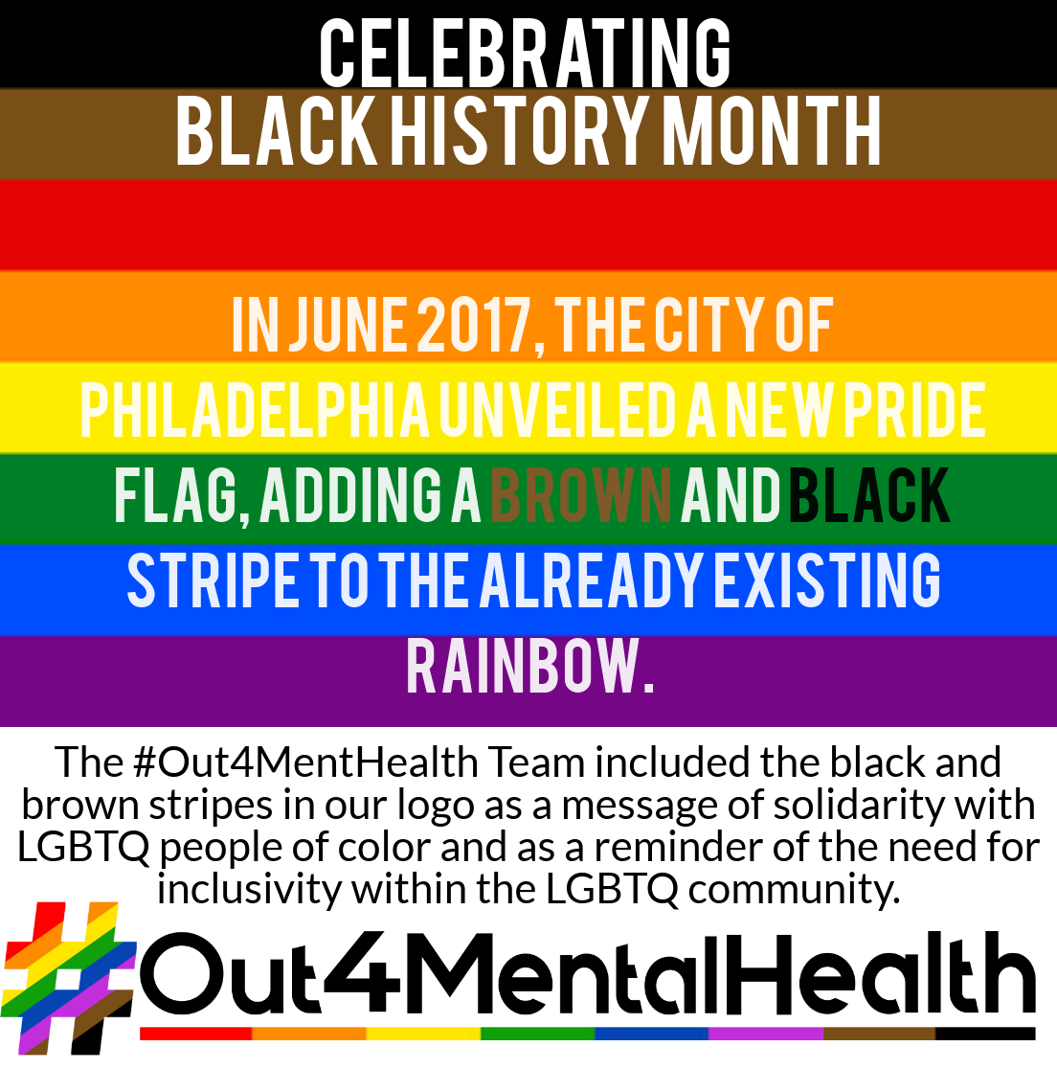
Images

