Temple Shalom
Congregational Hanukkah Dinner
Friday, December 15
6:00 pm Wine and Cheese Reception
6:30 pm Shabbat Service
8:00 pm Hanukkah Dinner, Radnitz Social Hall
Saturday, December 16 Young Families: food and crafts following services
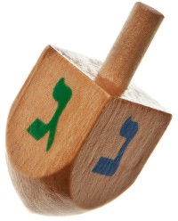
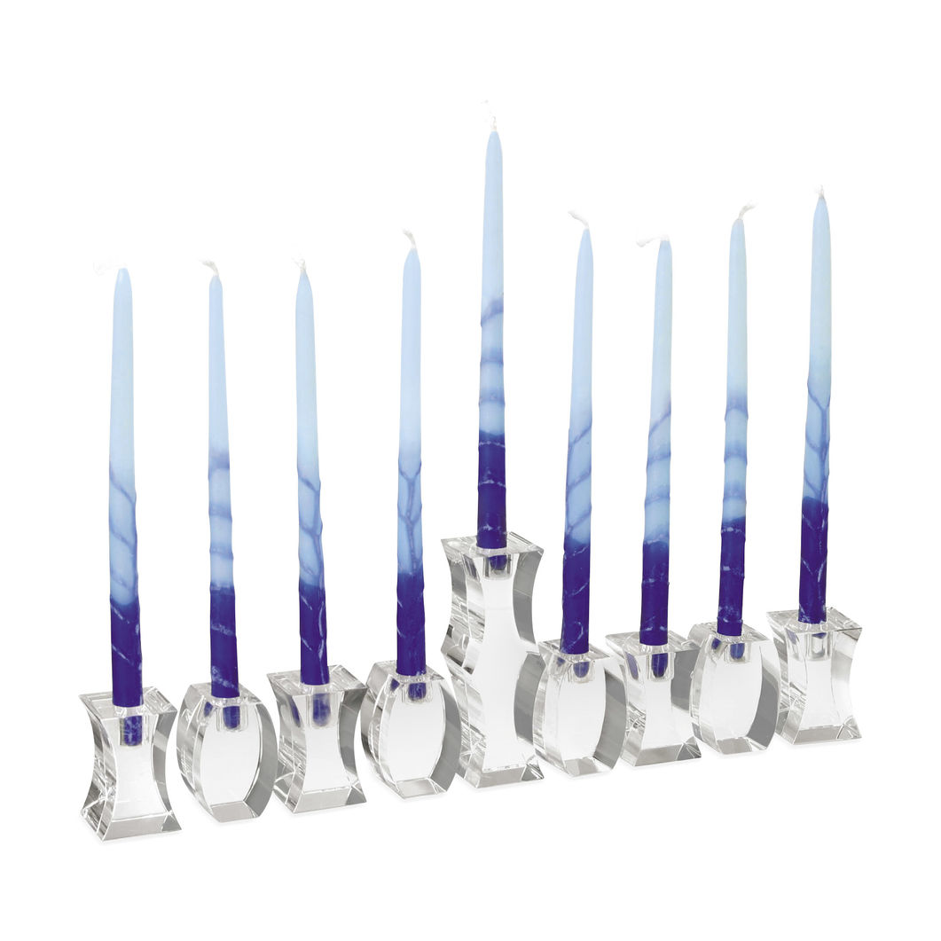
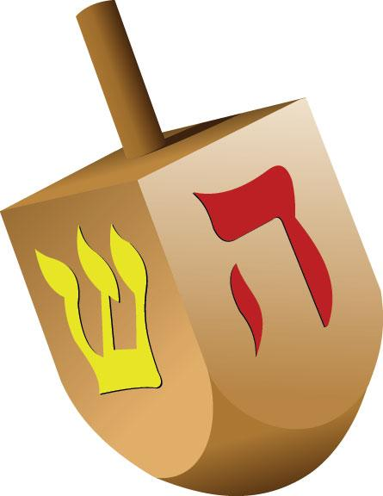

Bring your family’s Menorah to light!

Menu: BBQ Brisket, BBQ Chicken, Latkes, Vegetables, Salad, Dessert
Name that tune contest following dinner!
Donut decorating station and crafts for the kids!
Create an edible Menorah for display – be creative!
Questions? Contact Lonna Rae Silverman at lrsilvermtx@gmail.com
---------------------------------------------------------------------------------------------------------------------------------------
Congregational Hanukkah Dinner

Register and pay online: https://tinyurl.com/hannukahdinner

OR, complete and return this form with payment to the temple office:
Temple Shalom Hanukkah Dinner, 6930 Alpha Road, Dallas, TX 75240

Names of those attending:
Adults _____________________________________________________________
Children/Ages _____________________________________________________________
Phone Number or email ___________________________________________________

# Adults @ $12 ______ # Children (5-12 years) @ $8 ______ #Children 4 and under – FREE ______

Please indicate method of payment: _______Check (payable to Temple Shalom) ________ Credit Card
MasterCard or Visa # ____________________________________________ Expiration Date ____________
Name as it appears on your card: ________________________________________________

Total Enclosed $________________

Reservation deadline is Friday, December 8th

