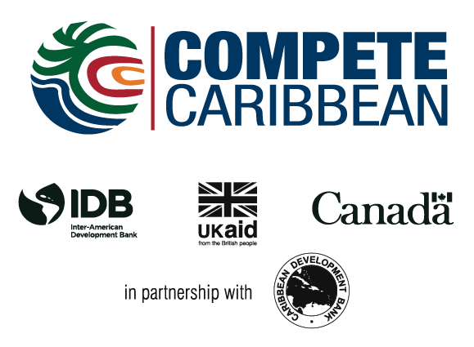

$20M Funding Support for Tourism in Treasure Beach, Jamaica

Treasure Beach, Jamaica, August 28, 2016 – The Ministry of Tourism has established a $20 million loan facility for the operators of small resorts and attractions in Treasure Beach, St. Elizabeth.

Beneficiaries can access up to $2 million each under the scheme, which is being financed by the Tourism Enhancement Fund (TEF) and administered by Jamaica National Small Business Loans Limited.

This provision is part of the Ministry’s National Community Tourism Policy and Strategy. It aims to diversify Jamaica’s resort product offerings by facilitating tourism developments at the community level.

The Community Tourism Loan Facility will complement funding support which has also been provided for resort developments in Treasure Beach under the $5 billion (US$40 million) Compete Caribbean Programme.

Nearly $80 million (US$627,000) has, to date, been allocated to community stakeholders under the private sector development initiative that provides technical assistance grants and investment funding for projects in 15 Caribbean countries.

Compete Caribbean is jointly funded by the Inter-American Development Bank (IDB), United Kingdom Department for International Development (DFID) and the Government of Canada.

The Community Tourism Loan Facility, which is initially being implemented as a pilot, was launched recently by Portfolio Minister, Hon. Edmund Bartlett, at BREDS Treasure Beach Sports Park in St. Elizabeth.

Mr. Bartlett said the provision will enable the beneficiaries to carry out upgrading consistent with industry standards, and which would appeal to discerning clients.

He contends that this is vital in positioning Treasure Beach as a unique destination offering a “rustic experience where the link with nature is never broken, but the quality is still at the highest level.”

This, the Minister added, would cater to persons seeking alternatives to the formal luxurious settings characterising the more established resorts and attractions.

In noting that the south coast is “a treasure to be honed and established as a global brand”, Mr. Bartlett said the stakeholders were being offered the opportunity to “respond to the demand for destination assurance that the industry requires of you.”

This, he pointed out, includes licensing and compliance, “so that when we sell destination Treasure Beach, we are not second-guessing the quality of the experience or the integrity of the product.”

In anticipation of increased visitor arrivals in Treasure Beach, Mr. Bartlett announced that the TEF will fund road repairs in the community at a cost of $28 million.

Consideration will also be given to upgrading the Lionel Densham Aerodrome in St. Elizabeth to accommodate visitors desirous of travelling by air.

In encouraging the stakeholders to seize the available opportunities, Mr. Bartlett, who anticipates that the pilot will be successful, expressed the hope that “it will be replicated across the island.”

Mr. Bartlett also hailed the longstanding partnership forged between the Ministry and JN Small Business, which he said has facilitated the provision of over 240 loans totalling $556 million to fund developments at various other small tourism entities.

---END---

