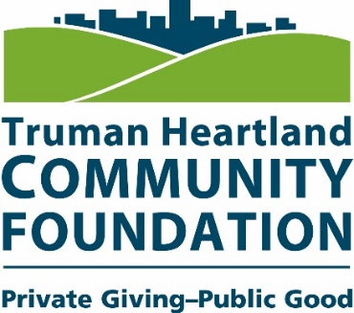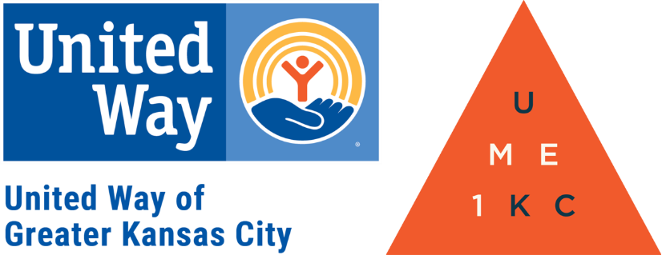
Boomers Get Connected FAQ

What is Boomers Get Connected?

Boomers Get Connected is an initiative started in partnership with Truman Heartland Community Foundation and United Way of Greater Kansas City to help Baby Boomers find the best volunteer opportunities for them to help the communities they love.

With the interactive Get Connected website, users can register for a free account and find hundreds of volunteer opportunities in partnership with numerous non-profits serving Eastern Jackson County.
What makes Get Connected different from other volunteer websites?

Get Connected is great resource for Baby Boomers coming into retirement who are still looking for ways to be involved! This is a local database, so your volunteer hours will be helping impact your immediate area and community.

Get Connected makes volunteering easier than ever. When you sign up with Get Connected, you’ll start receiving emails listing volunteer opportunities that fit your interests. Get Connected takes the work of searching, so you can spend more time making a positive impact and change.

Truman Heartland and United Way are working to make Get Connected the go-to volunteer database in the region. By joining us you're choosing to be a part of a greater purpose and touch the lives of people in your community and beyond.

How do non-profits list their needs?

Truman Heartland and United Way of Greater Kansas City have done all the work of reaching out to the leaders of local non-profits to encourage their participation with Get Connected. Each agency is responsible for posting its volunteer opportunities from their own Get Connected accounts.

Does having a Get Connected account cost any money?

No. Get Connected is a free service offered to you by United Way as a means to make volunteering easier. The goal is to connect people like you with volunteer opportunities that excite you, while helping to make your local community a better place.

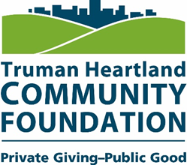

Signing Up with Get Connected

Get Connected Web Address: http://www.thcf.org/Boomers-Get-Connected

Step 1 – Create Your Account
Go to the Get Connected website listed above to begin by creating your account. Be sure to mark "Boomers Get Connected" when asked how you heard about the program.
Step 2 – Select Your Causes
Select the causes you want to be involved in for a more accurate volunteer opportunity list.
Step 3 – Select Your Interests
Select your skills and interests. Tell us how you would like to spend your time volunteering.
Step 4: - Select your non-profit agencies
Select the agencies that you’d like to get started volunteering with. Get Connected will create a list of non-profit partners and agencies that fit your interests.
Step 5 – Get Started
Verify your email address, and get started! You will be given a personalized Get Connected dashboard that allows you to track your upcoming events, see the dollar impact your volunteer work has made, track your volunteer hours, and access to countless volunteer opportunities near you.

If you have questions about Get Connected or would like someone from the Foundation to come to your organization to talk more about the initiative, please contact Rachael Watkins at watkins@thcf.org or by phone at 816-912-4185

