FCSI THE AMERICAS’ INNOVATION SHOWCASE

As part of the 2018 FCSI The Americas Conference in Denver, CO USA, April 19-21, 2018, FCSI The Americas is pleased to continue our partnership with the FCSI Educational Foundation in welcoming entries for the Innovation Showcase. The Innovation Showcase is designed to recognize manufacturers whose commitment to research and development has resulted in a truly innovative product that is a clear leap forward for the foodservice industry.

All FCSI The Americas Corporate member companies are eligible for participation. Products submitted for consideration will be reviewed by a panel of FCSI’s emerging consultants, as well as FCSI TA Board of Trustee members, along with distinguished FCSI Fellows. Judging will result in the selection of 10 products for inclusion in the Showcase. Consultant members will have the opportunity to examine the entries and obtain detailed information about them from corporate member company representatives.
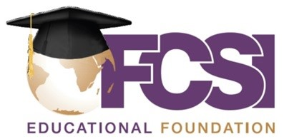
The Showcase will be located in the Denver Room 1-6 at the Hilton Denver City Center, and will be open Thursday and Friday, April 19-20. All consultant members will be asked to evaluate the entries on display and cast a ballot for the most innovative product. The product receiving the most votes will be recognized as the FCSI The Americas Product of the Year and be featured in a future issue of Foodservice Consultant magazine.

PARTICIPATION
The product must currently be on the market. Products that are still in the research and development phase are not eligible. The product must be approved by at least one of the following testing authorities: UL, ETL, NSF, CE, ULC, CSA.

Entry forms must be received at FCSI The Americas Headquarters by Monday, February 12, 2018. A panel of judges will be assembled which will include members of our Committee for Emerging Consultants Committee, as well as distinguished members of the FCSI Council of Fellows.

Products selected by the judging panel will be announced Monday, March 5, 2018. If selected, the fee for participation in the Innovation Showcase is a US$2,000 tax deductible donation to the FCSI Educational Foundation.

EXHIBIT SPACE
Each participating manufacturer will be assigned their own space at the Hilton Denver City Center. The space will include signage identifying the product and manufacturer, a 6’-8’ draped table, 110V electrical outlet and two chairs. Any additional display material must be provided by the manufacturer and must fit inside a space 4’ deep x 8’ wide x 8’ high.

Presentations and videos are welcomed and participants may choose to display the actual product and related brochures, but will be responsible for their own shipping, receiving, transfers and placement of the equipment. Arrangements for all audiovisual needs are the responsibility of the manufacturer. (Hotel A/V contact can be provided.) Powering up of the featured product will not be permitted in the exhibit area.

Please direct your questions to Kimberly Kissel, Director of Education ~ kimberly@fcsi.org ~ 309.808.2165
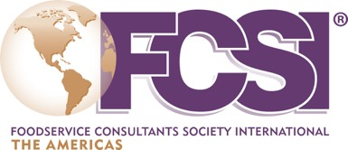

2018 Innovation Showcase Entry Form

Please complete the following application and submit it, along with any supporting material, to FCSI The Americas Headquarters by February 12, 2018. Electronic submission of all materials preferred.

Send this form to:
Kimberly Kissel, Director of Education, kimberly@fcsi.org

Product Name:
Company:
Address:
City: State/Province: Zip/Post Code:
Country:
Administrative Contact Person:
Phone:
E-mail:
Product Contact Person for more information on the product / your company (If different than above):
Phone:
E-mail:
Product Description:
Describe the product and why it is innovative. Attach additional information as deemed necessary.

