Support Material
Risk Assessment Plan for Mid Coast Careers Market 2018

This information is provided for the use of schools and teachers and may assist with the preparation of your risk assessment which covers the attendance of an individual or groups of students at MCCM 2018 on Tuesday 22 May 2018.

This document is only to be used to assist you in your Risk Assessment which will be needed to be completed by individual schools.

This event is available as a school excursion and should reflect the relevant school policies and procedures to ensure duty of care is maintained by the supervising teachers.

Venue
The MCCM 2018 is conducted at the Glasshouse Port Macquarie, located on Clarence St in the Port Macquarie town centre. Activities will occur within a confined identified area within the two levels of the Entertainment centre and the Hay St Forecourt area. The event is designed for students to enter via Clarence St from the bus stop and walk in a one way flow through the event.

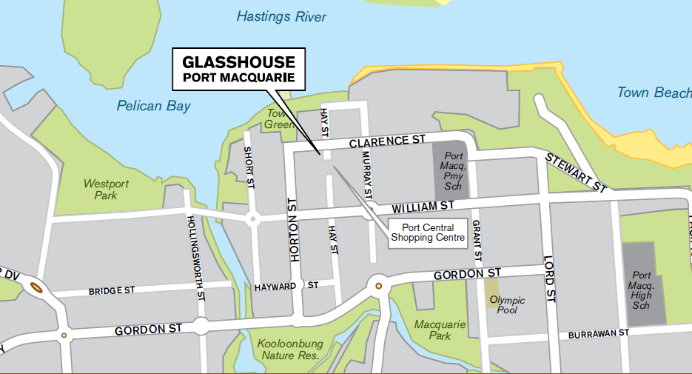

Ground floor of the Glasshouse

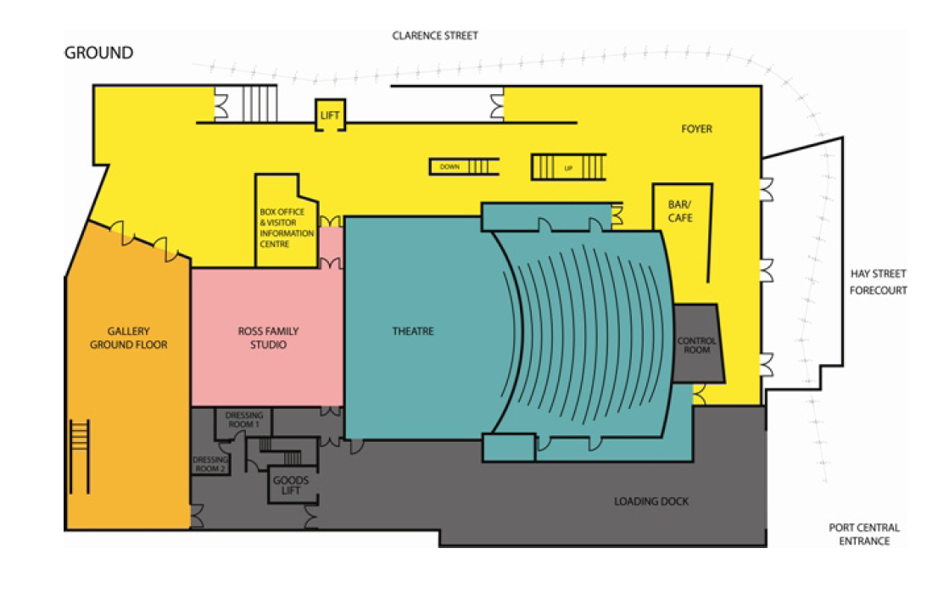

Level 2 of the Glasshouse
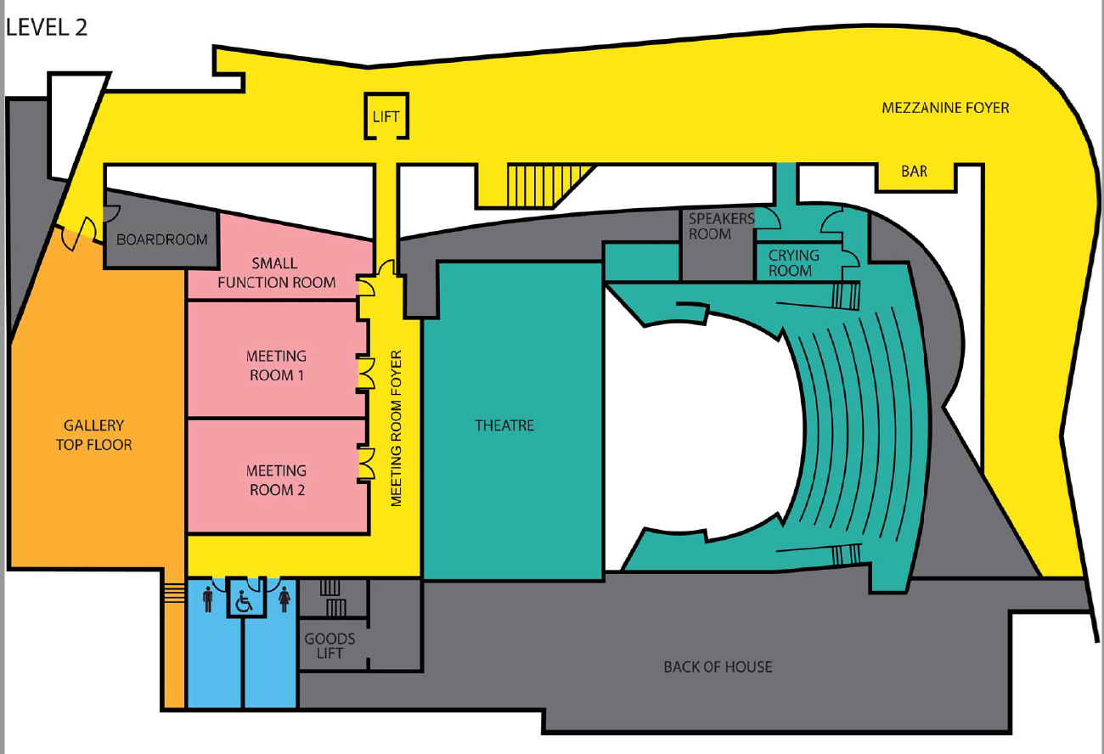

Suggested Student and General Identified Risks
RISK EVENT | POSSIBLE REASON | LIKLIHOOD | CONSEQUENCE | RISK LEVEL | RISK REDUCTION ACTION  (ELIMINATION OR CONTROL MEASURES) | CONTINGENCY PLAN  (JUST IN CASE IT HAPPENS) | WARNING SIGN
Travel to Mid Coast Careers Market  Students do not arrive at expected time | - Transport delays  - Traffic accident |  |  |  | THIS IS TO BE INCLUDED IN A RISK ASSESSMENT PREPARED BY INDIVIDUAL SCHOOLS
Student involved in traffic accident | - Struck by vehicle on road  - Involved in vehicular accident | Maj  Maj | U  U | Med  Med | - Brief participants on rules & behaviour  - Remain on pedestrian pathways & use pedestrian crossings at all times  - Wherever possible ensure bus parks where students do not have to cross roads | - Depending on the extent of the injury or accident;  - treat the injury using a First Aid kit. There is also a First Aid kit available at the Glasshouse  - transport to medical practitioner if necessary  - contact 000 if needed  - contact emergency number for student & inform parents / guardian | - Unruly behaviour  - Pushing  - Crowding  - Running from the bus  - Erratic and unsafe driving
Unacceptable behaviour | - Student engages in:  Abuse of illegal or illicit substance (drug / alcohol)  Violent and aggressive or inappropriate behaviour | Mod | P | Med | - Expected behaviour, rules and regulations outlined in written notes for parents and students  - On arrival induction / information briefing session reinforces expected behaviour | - School policies and procedures followed  - Emergency procedures followed  - Student dismissed from activity | - Absenteeism  - Unexplained sleepiness or hyperactivity  - Argumentative behaviour
Student is injured during activity | - In the course of carrying out activity students is injured | Min | U | Low | - Brief induction given at start of each activity  - Utilise activities which are tried and tested for risk minimisation  - Assess and evaluate all stages of activities in terms of potential risk and risk reduction.  - Make modifications as appropriate  - Employ trained staff | - Treat injury using First Aid Kit  - A First Aid Kit is also available at the Glasshouse for use by your nominated First Aid Officer for your excursion.  - Mobile phones as identified by your school  - Medical personnel advised  - Emergency procedures followed | - Student unrest and unruly behaviour

RISK EVENT | POSSIBLE REASON | LIKLIHOOD | CONSEQUENCE | RISK LEVEL | RISK REDUCTION ACTION  (ELIMINATION OR CONTROL MEASURES) | CONTINGENCY PLAN  (JUST IN CASE IT HAPPENS) | WARNING SIGN
Missing student | Abducted  Absconds  Lost | U  U  P | Maj  Min  Min | Med  Low  Low | - Explain rules, regulations and responsibilities regarding staying within designated areas.  - Roll call when boarding bus to depart | - Follow schools own policy and procedures | - Student misbehaving, not interested in activities, withdrawn  - Unknown person (people) in area

Risk Assessment Matrix

Consequence | Likelihood
 | Unlikely | Possible | Likely | Almost Certain
Catastrophic  Eg. Kill or Permanently maim | MEDIUM | HIGH | EXTREME | EXTREME
Major  Eg. Long term Injury or Illness | MEDIUM | MEDIUM | HIGH | EXTREME
Moderate  Eg. Medical attention with several days off work | LOW | MEDIUM | MEDIUM | HIGH
Minor  Eg. First Aid needed | LOW | LOW | MEDIUM | MEDIUM

