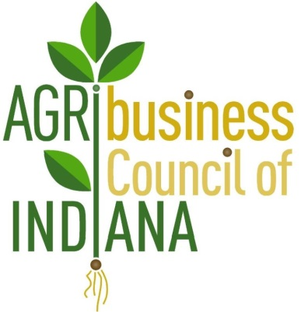
AGRIBUSINESS COUNCIL OF INDIANA NEWSLETTER
Promoting Agribusiness Policy in Indiana
January 19, 2018

Indiana General Assembly Week 3
The third week of the General Assembly is at an end, with less than 8 weeks to go in this short session. The list of all filed bills is available here. Bills that ACI is closely monitoring this year, the ACI Bill Track, can be found here.
Bills to Review
The ACI Government Affairs Team will be monitoring session for bills impacting ACI members including items related to food safety regulations, certification programs, transportation and environmental issues, rulemaking from the seed board and more. Frequent updates will be sent to members along with action alerts as needed. There are several bills of interest:
- SB 330: Seed Commissioner Rulemaking. This bill provides that the state seed commissioner may not adopt rules banning all varieties of Amaranthus. ACI supports this bill.

- SB 331: Implementation of Federal Food Safety Regulations. ACI is watching this legislation closely; we believe there is an amendment being prepared that will limit the scope of the bill so it is applied consistently and with the least regulatory burden.

- SB 384: Liens for Agricultural Supply Dealers. This bill establishes conditions concerning the creation of, priority of and enforcement of this new lien.

- HB 1012: Neonicotinoid Pesticides. Requires the pesticide review board to adopt rules prohibiting the use of neonicotinoids, which are certain insecticides having a chemical structure similar to the chemical structure of nicotine. It is unlikely this bill will be heard.

- HB 1098: Seed Commissioner and State Chemist. This bill provides that the state seed commissioner or state chemist may adopt emergency rules for a purpose for which the seed commissioner or state chemist is currently authorized to adopt rules under certain horticulture product and control laws.

Mark Shublak, lobbyist for ACI, testified in support in committee on the bill last Thursday; Mark said that emergency concerns must be balanced against regulatory burdens, and advocated for more consultation. HB 1098 was called on Second Reading yesterday and passed with an amendment that specifies that any excess funds accumulated from the fees collected under certain pesticide laws must be paid to the treasurer of Purdue University and administered by the board of trustees of Purdue University.

- HB1227: Noxious Weeds. Specifies that waterhemp, marestail, Palmer amaranth, and poison hemlock are noxious weeds for purposes of the weed control board law, which requires the weed control board to take all necessary and proper steps to control noxious weeds affecting agricultural production in Indiana.

On Thursday, the House amended the bill to include “poison hemlock” on the list of noxious weeds. (ACI lobbyist Mark Shublak testified in favor of this bill in front of the House Agriculture and Rural Development Committee last week.)

Representative Friend and Others Announce Retirements
Representative Bill Friend (R-Macy), Speaker Pro Tempore and a friend to Indiana agriculture, has announced he will not be seeking re-election in 2018. Rep. Friend is a long-time member of the Indiana General Assembly, representing the 23rd district since 1992. He is the owner and operator of Friend Farms and president of Green Acres Ham LLC in Miami County.
Several legislators have announced they won't seek reelection in 2018 including: Representatives Scott Pelath, Linda Lawson, Kathy Kreag Richardson, Greg Beumer, Charlie Brown, Clyde Kersey, Wes Culver, Steve Stemler, and Thomas Washburne. Retiring Senators include Doug Eckerty and Jim Smith.

RSVP Today: ACI Legislative Reception – This Week!
As many of you know, it is imperative to engage with elected officials on issues affecting your business. The ACI Policy Committee strives to engage with state legislators and decision makers during the Indiana General Assembly and throughout the year. ACI will be hosting its first Legislative Reception before the Annual Conference to introduce our members to state policymakers and the government affairs process. Please mark your calendars for Thursday, January 25 from 8:00-10:30 a.m. at the Indiana Statehouse, 3rd Floor North Atrium. RSVP to Katie Glick at Katie.Glick@icemiller.com if you plan to attend.
Click here for the Full House Session Calendar.
Click here for the Full Senate Session Calendar.
Please contact Mark Shublak at mark.shublak@icemiller.com or Lesa Dietrick at lesa.dietrick@icemiller.com if you have any questions.

