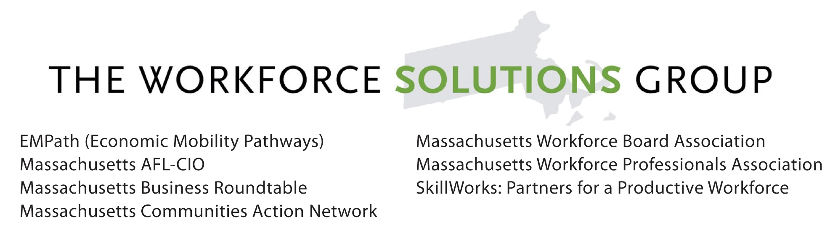

SB 674 - An Act Relative to Ensuring Quality Education and Training Programs

Lead sponsor: Senator Kenneth J. Donnelly

Co-sponsors: Senators DiDomenico, Eldridge, Lesser, Lewis, Lovely, McGee

Representatives Crighton, Decker, Gordon, Malia, Provost, Schmid, Vega

Referred to the Joint Committee on Higher Education

The purpose of this bill is to help close Massachusetts’ skills gap by providing workforce and education data more effectively to students, educators, employers, program managers, and policymakers to help inform decisions on program development, resource allocation, career pathways, and recruiting and hiring skilled talent.
What the bill does:
- Codifies the existing practice of public higher education institutions to annually submit student level information to the Department of Higher Education;
- Requires the Department of Revenue and the Division of Unemployment Assistance to share wage information with the Department of Higher Education to determine whether graduates are finding employment and how much they are earning;
- Requires the Department of Higher Education to create a website offering students a place to find information on their education and training options based on graduation rates, job placement rates, wage information and loan debt, as well as information about occupations and programs;
- Creates a task force that will focus on improving and coordinating the state’s data infrastructure across and between workforce, education and social service agencies and ensuring more effective use of data.

Who This Bill Benefits
- Students and Parents - This bill will provide prospective students and their families with the information they need to make decisions about their postsecondary options – before they invest time and money.
- Policymakers - This bill will provide policymakers with information about institutions and programs, which they can use to improve education, workforce, and economic development policy in the state.
- Employers – This bill will help ensure that employers can access information about which programs and institutions are giving students the skills they need to be successful in the workforce.
- Educators and Program Managers – This bill will give educators and programs the information they need to improve the quality of their program offerings and to tailor programs for struggling demographics.

How does this bill help Massachusetts?
- Positions Massachusetts more competitively by creating an efficient means to analyze and critically use big data that will help close the skills gap.
- Supports state’s effort to showcase our greatest natural resource; our talent.
- Creates greater parity for Massachusetts with 23 other states that have already implemented a workforce and education scorecard, and 18 states that have a mechanism to provide program level data to improve program and institutional offerings. for example:
  - Washington state uses wage records to evaluate the outcomes of nearly 20 workforce development programs. When data showed strong employment and earnings outcomes for the state’s apprenticeship programs, the legislature enacted laws to increase the state’s number of apprentices.
  - Texas law requires the Texas Workforce Commission to maintain an automated workforce development evaluation system that has data on nine of the state’s workforce programs. The Texas legislature uses that information to make decisions about the state’s budget.
  - For example, instructors at California’s community college system evaluate and adjust their career and technical education (CTE) programs using an online tool called LaunchBoard, which shows information on student progress through CTE courses and into the labor market.

Sample dashboard from California: 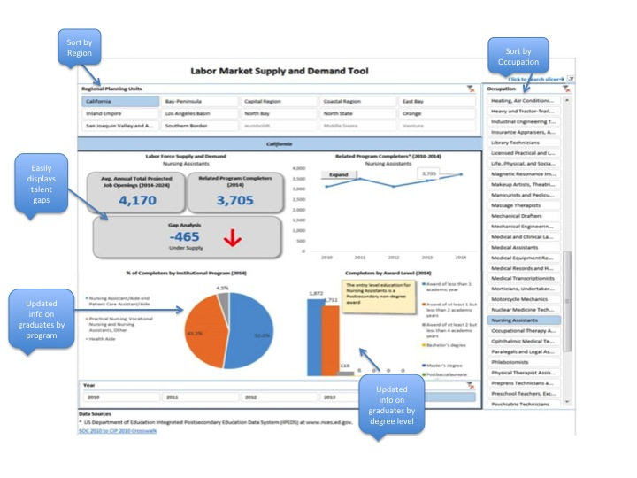

Prince, Health, et. al, Are People Getting Credentials That Lead to Jobs? (Washington, DC: National Skills Coalition, 2015), accessed March 3, http://www.nationalskillscoalition.org/resources/publications/file/SWEAP_Using_Dashboards_for_State_Workforce_Planning.pdf.

