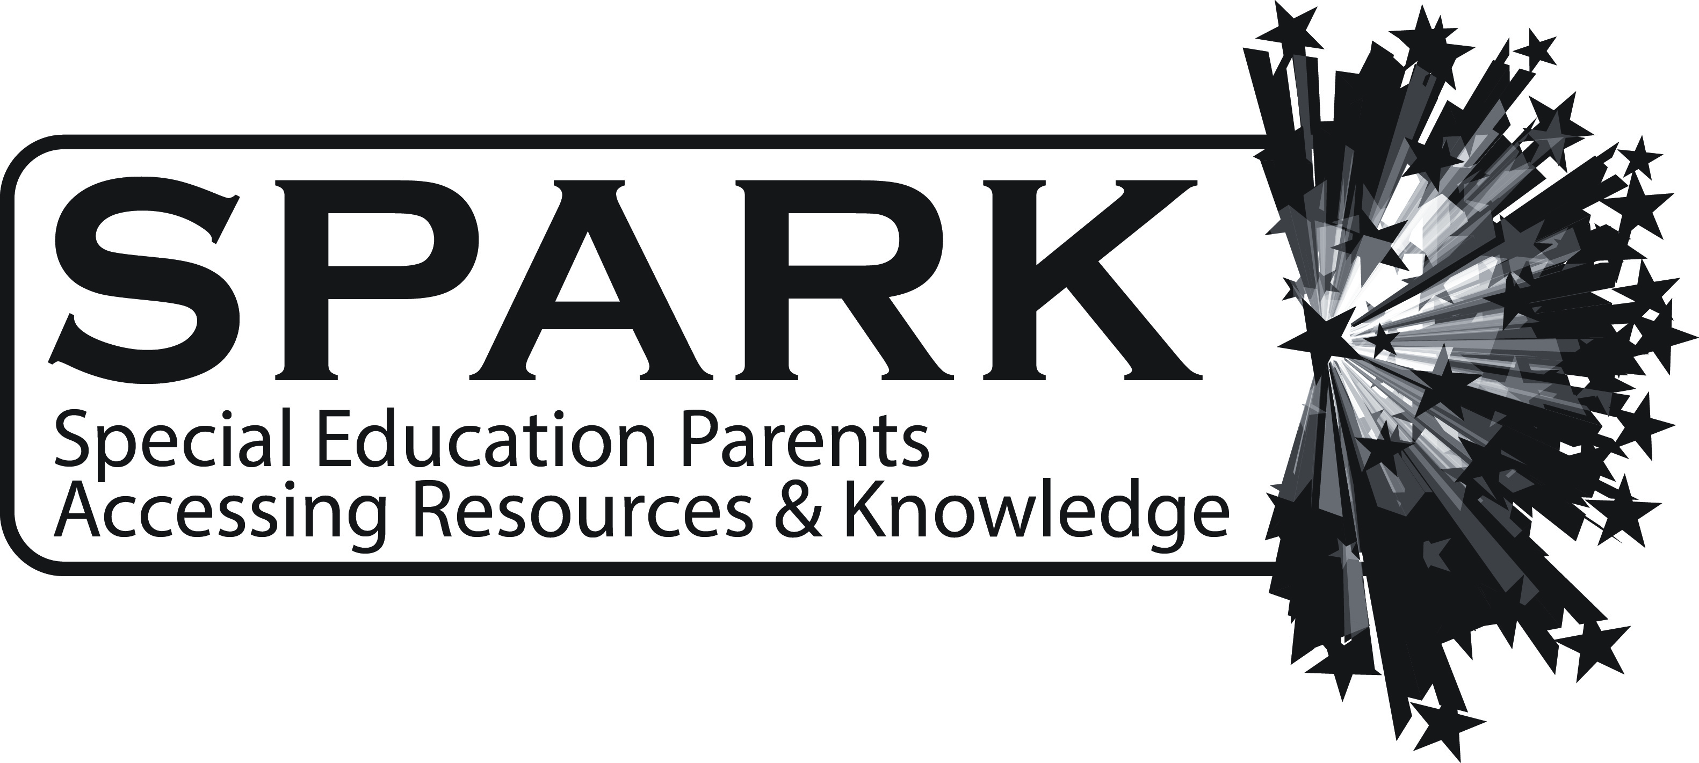
Empowering Bright, Struggling Learnings
to Thrive and Succeed

Monday, March 20, 2017
Walter R. Sundling Junior High School
1100 N. Smith Street, Palatine, IL 60067
7:00 – 8:30 pm

Come to this free workshop that is open to anyone in the local community. Would you like to teach your child to wake up each morning eager to learn, be focused and engaged in life and learning and experience healthy self-esteem? If you have a challenged learner who is struggling, frustrated, anxious exhausted and/or depressed by the learning process, it may not be that your learner is not recognizing and using their strengths. Plus, your child’s unique learning style may be different than the prevalent teaching style! Deb Singleton, Whole Learning Coach at Lotus Learning Power will be discussing ways to recognize each child’s learning strengths and learning style, and sharing strength-based strategies to maximize learning success and minimize stress and anxiety.
Deb Singleton has enjoyed coaching, advising and teaching young people in traditional and alternative learning settings for 35 years. She has deep knowledge and experience with innovative teaching strategies, giftedness, learning challenges, brain plasticity, psychology and traumatic brain injury. Deb believes that each of us is a treasure in this universe, a unique individual worthy of respect, compassion and faith.
* Spanish Translation will be available*
SPARK meetings are designed to give parents information to help them in their current and future steps of the journey of parenting children with unique needs. At SPARK we realize the importance of providing:
- Relevant programs and resources related to special education
- Opportunities to network, receive support and help
- Connections for parents with outside sources

The programs can also be found on the District 15 website: www.ccsd15.net.
If you would like to be contacted by or connected with SPARK, contact Sarah Winter (sarahwintertj@comcast.net)

SPARK is a Northwest Suburban Council of PTA committee serving families of children
with special needs in Community Consolidated School District 15 and beyond.
SPARK is proud to be in partnership with PTA!

