ALASKA WIND WORKING GROUP
WIND-DIESEL WORKSHOP
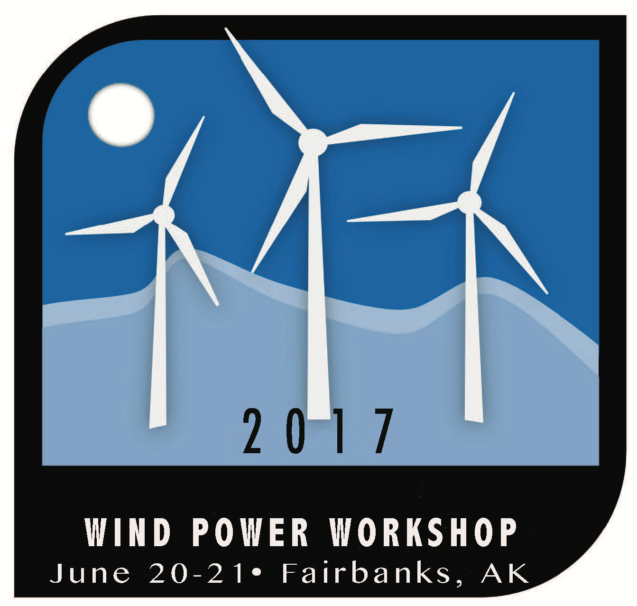
June 20-21, 2017
Fairbanks Pipeline Training Center
3600 Cartwright Court
Fairbanks, Alaska 99707

DRAFT AGENDA

TUESDAY, JUNE 20

1:00PM - 4:30PM HOMER Energy training (Univ. of Alaska)
*This optional training event is for conference participants already familiar with HOMER modeling program. Instructors from HOMER energy will be on hand to provide advanced training with the HOMER program using real life examples from Alaska. Participation is limited and on a first come, first serve basis.

3:30PM - 4:30PM WIND ENERGY 101 (Josh Craft, AK Energy Authority)

5:00PM - 6:15PM Opening Reception place (Cold Climate Housing Research Center)

WEDNESDAY, JUNE 21

7:00AM - 8:00AM REGISTRATION & HOSTED BREAKFAST

8:00AM - 8:30AM WELCOME & STATE OF THE MARKET
The technology market for islanded grids is rapidly growing, from applications on islands and in remote communities to microgrids in large urban areas. Learn about the state of the market, and ways to optimize existing wind-diesel systems in Alaska and elsewhere.

8:30AM - 10:00AM WIND-DIESEL INTEGRATION PART 1: Data and Controls
Good data, good planning, and good controls and energy storage all play a part in successful integration of renewable technologies in a hybrid diesel grid. This moderated panel will examine case studies and walk through the steps to successful integration of wind and other renewables.

10:00AM - 10:30AM NETWORKING BREAK

10:30AM – 12:00PM WIND-DIESEL INTEGRATION PART 2: ENERGY STORAGE
Cost effective, reliable energy storage is critical to achieve high contributions of renewable energy in hybrid systems. This moderated panel will look at optimizing existing systems as well as highlight challenges and best practices for using storage to increase the utilization of renewable energy and better balance system frequency and loads.

12:00PM - 1:00PM HOSTED LUNCH
1:00PM - 2:30PM PROJECT SUPPORT: FINANCING, TRAINING & POLICY
This moderated panel will explore one possible option for financing small wind projects and discuss training and policies to encourage and support communities seeking sustainable energy solutions

2:30PM – 3:00PM NETWORKING BREAK

3:00PM - 4:30PM SOLVE IT!
This moderated session will highlight how various communities have resolved common and maybe not so common issues facing hybrid systems on islanded grids from financing and training to O & M problems.

4:30PM - 5:30PM THROUGH THE LOOKING GLASS: A PEEK AT THE FUTURE
This end-of-the-day moderated discussion will look at what’s next in the remote and islanded grid market in the various areas of finance, policy, technological innovation, and capacity building.

