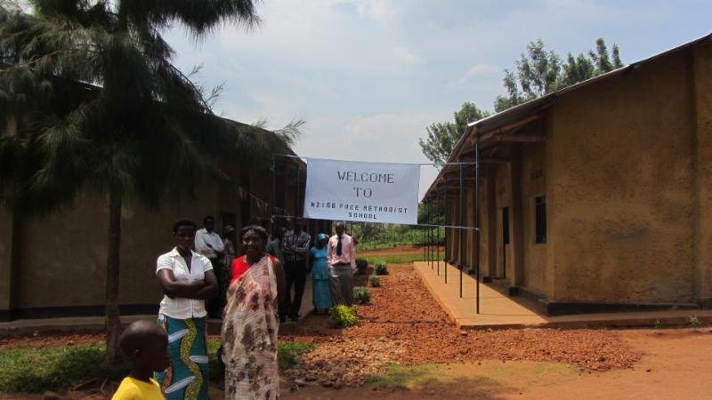

Written April 2015:
Over the first week of January. 2015 I (Lydia) had the opportunity to travel to Rwanda, Africa with Pastor Wally and two women who are part of the Pearce mission leadership
team. The purpose of the trip was to investigate with the leadership of the Rwandan and African International Child Care Ministries how the Pearce family might partner with the a new preschool school in a small village in Rwanda.

International Child Care Ministries (ICCM) is a child sponsorship initiative serving 20,000 children in over 30 countries. They work with Free Methodist Churches for high levels of care and accountability. Through education, meals, clothing and basic medical care, children in need have an opportunity for a better life. Rwanda is just one of the countries where ICCM is making an impact on the lives of children and their families. As a partner with the school, we will not be seeking to tell the school how to operate or take over in any way. We will only be partnering with them as a support to what they are already doing and their dreams for the future of their school. Actually, we all have much to learn from each other!

As the Pearce 4 Kids Director, I was asked to go along on the trip and dream about how P4K might, with the larger church, partner with the school in the years to come and connect the children at P4K with the children at the children in Rwanda. What an exciting thought...that we could connect children on opposite sides of the world! I asked my Nursery School, Pre-Kindergarten, 4 year old day care and school age teachers if they would have their children draw some pictures that I could take with me to Rwanda and give to the children. The picture below shows some of the children who attend the school with some of the pictures that our P4K children sent with me. Already, we have made a small connection between P4K and Rwanda!
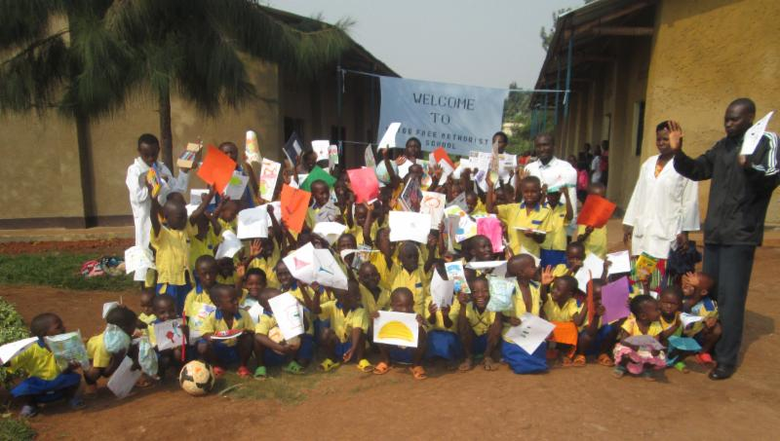
Below is some of the information about the preschool:
- The preschool is a Free Methodist International Child Care Ministry school called the Nzige (pronounced Inzeegay) School. Nzige is in a region outside of Kigali, the capital of Rwanda. We traveled some very interesting roads to get to this school!!
- Statistics are showing in Rwanda, just as they do in the US, that children who attend preschool are much more likely to succeed in primary school and the resulting retention rate through secondary school is much higher. The government there is very supportive of private schools developing and succeeding and works in cooperation with private agencies.
- It is a newly developed school under ICCM so none of the children are sponsored yet therefore no funds are flowing into the school.(Update 11/2015: with the current Pearce sponsorships, the school now has some incoming funds and have been able to build new desks, purchase some chickens so that the children have eggs to eat and they have installed a large water tank to catch rainwater.) In the coming months the plan is to enroll the children in ICCM sponsorship and get a minimum of 75 of them sponsored by Pearce Church (currently almost 100 children are sponsored through Pearce Church) in 2015, adding more sponsorships in future years with the goal to have 100% sponsorship through Pearce Church in the future. ICCM sponsorship funds go to the school, not just one child, but when someone sponsors a child they will get regular updates on and letters from that child as well as have the opportunity to send letters to the child to encourage them in their education.
- Currently it is just preschool - their long range hope is to add a grade level each year until it becomes a full preschool, primary and secondary school.
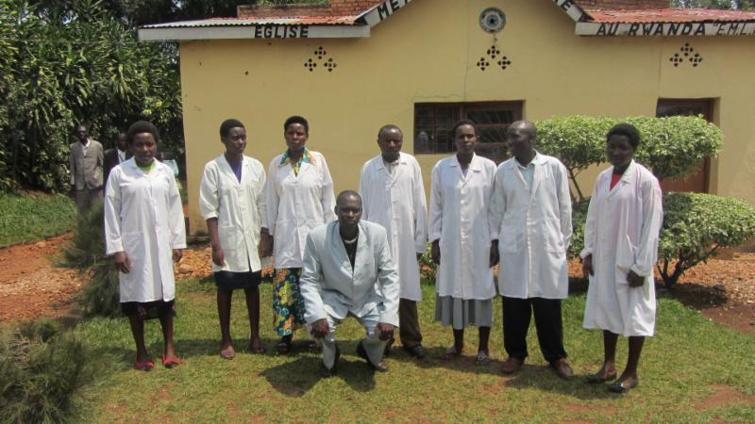
- There are over 300 children who currently attend this half day preschool.
- There are 7, yes SEVEN, teachers!!!! (very different than our required staff/child ratios!) Since there are no funds being funneled into the school, the teachers are currently not paid. (In the months since our sponsorships began, the teachers are now being paid a small salary.) They are all Christians who give of their time and talents to serve the children and families in the community. They are pictured on the right with the pastor of the church. Along with a salary and school supplies, there is a need for ongoing teacher training for these folks. (Plans are underway for this to take place in 2016.)
- The children may walk many miles to get to school. EVERYONE walks everywhere in Rwanda. It is called the "land of 1000 hills" and that's an understatement. You are either going up or down everywhere you go so walking distances is time consuming and requires a lot of energy!
- There is no food program and no running water. The first priority of our sponsorship with ICCM and the Nzige School is to help provide a food program so that the children have something to eat and drink when they arrive and before being sent home for the afternoon. (Chickens have been purchased for eggs and recently a water tank was installed to catch rainwater. Two dreams that the pastor has are 1)to purchase land and grow banana trees so that the children can learn how to take care of the plants, etc. and also have fresh fruit to eat while at school and 2) purchase a cow that will produce milk for the children to drink.) The school has very limited supplies/resources that child sponsorship will help provide.
- The 1994 genocide in Rwanda has had a major impact on the culture which is still very obvious today. We frequently heard the phrases "before the genocide" or "after the genocide". Life seems to be categorized either before or after. The entire country, which is roughly the size of Maryland, was impacted by that event which, in the matter of 100 days, annihilated upwards to one million people and left the country in ruin. It's a sad and tragic history but there has been healing, forgiveness and restoration of the people and the land over the past 20 years. If you are interested in reading more about that part of Rwanda's history and understanding how they have journeyed to forgiveness and healing, see the "Quick Links" above for a list of books that were recommended for our team to read prior to our trip.

Even with a limited number of teachers, supplies, food and water the Nzige school is a joyous and energetic place. The children love music and dancing, and even pulled us into their dances a time or two! They were overjoyed to have visitors come see them and swarmed us to get "high fives" or see their own beautiful faces in our cameras. It will be exciting to dream with the P4K teachers in the coming months about ways we can incorporate a partnership with the Nzige School into the P4K program. Watch for more news about this partnership in the future! For more information about ICCM, see the link in the "Quick Links" above.

