MassHealth
All-Provider Bulletin 272
November 2017
Commonwealth of Massachusetts
Executive Office of Health and Human Services
Office of Medicaid
www.mass.gov/masshealth

TO: All Providers Participating in MassHealth
FROM: Daniel Tsai, Assistant Secretary for MassHealth
RE: Overview of 2018 New Health Plan Options

MassHealth Payment and Care Delivery Innovations (PCDI)
Effective March 1, 2018, MassHealth will begin offering an expanded selection of health plan options to managed care eligible members. These new options are Accountable Care Organizations (ACOs), and a key part of MassHealth PCDI. MassHealth will also continue to offer Managed Care Organizations (MCOs) and the Primary Care Clinician (PCC) Plan as managed care options.

What’s New
- MassHealth is introducing three ACO models: (1.) Accountable Care Partnership Plans; (2.) Primary Care ACOs; and (3.) MCO-Administered ACOs.
- Accountable Care Partnership Plans and Primary Care ACOs will be available as enrollment options to managed care members. MCO-Administered ACOs are part of the MCO delivery system and will not be presented as an enrollment option because members will be attributed through their MCO.
- Most MassHealth managed care members will be assigned to a health plan so that they can continue to receive care from their primary care provider (PCP). All members will have the opportunity to choose a different health plan.
- The Eligibility Verification System (EVS) on the Provider Online Service Center (POSC) will be updated with messages that indicate which type of health plan a member is enrolled in and whom to contact for billing information.
- MassHealth will require ACOs to enhance primary care efforts and will provide additional supports to facilitate those changes.
- Primary care practices will be exclusive to their ACO—they will only be able to see managed care eligible members who are affiliated with their ACO.

What’s Staying the Same
- MassHealth will seek to keep members with their PCPs throughout enrollment changes.
- MassHealth will continue to offer the PCC Plan and MCOs as health plan options.
- Members will have Plan Selection and Fixed Enrollment periods.
- These changes do not apply to non-managed care eligible members.

Affected Members  MassHealth managed care eligible members are:  - Younger than age 65, without any third-party insurance coverage (including Medicare)  - Living in the community (not living permanently in a nursing facility)  - Covered by MassHealth: Standard, CommonHealth, CarePlus, or Family Assistance | PCDI does not affect members who receive MassHealth coverage through:  - Fee-for-service (including those over age 65 or with third-party coverage)  - One Care plans  - Senior Care Options (SCO) plans  - Program of All-inclusive Care for the Elderly (PACE) Organizations

Overview of ACO Models
ACOs are provider-led organizations that coordinate care, have an enhanced role for primary care, and are accountable for the quality and total cost of care.

Reimbursement arrangements with ACOs will provide incentives to improve care coordination and achieve performance standards across multiple measures of quality, including prevention and wellness, chronic disease management, and member experience. This program requires that participating providers engage with their ACOs and take appropriate ownership of meeting the ACO’s goals (cost, quality, and member experience performance).

We have contracted with 17 ACOs across the three models described below, and will allow new provider organizations to contract with our existing ACOs in later years of the program, subject to MassHealth review. Providers who are not already affiliated with an ACO but are interested in learning more should contact ACOs in their area to understand available options.

- Accountable Care Partnership Plans
An Accountable Care Partnership Plan is a network of PCPs who have exclusively partnered with an MCO to use their provider network to provide integrated and coordinated care for members. Accountable Care Partnership Plans are paid a prospective capitation rate for all attributed members. Accountable Care Plan Partnerships are responsible for all contractually covered services and take on full insurance risk. The plan is accountable for providing high-value, cross-continuum care across a range of measures. Accountable Care Partnership Plans pay provider claims for all plan-covered services. Accountable Care Partnership Plans may earn savings if they meet certain quality thresholds.

- Primary Care ACOs
A Primary Care ACO is a network of PCPs who contract directly with MassHealth, using MassHealth’s provider network, including the Massachusetts Behavioral Health Partnership (MBHP), to provide integrated and coordinated care for members. A Primary Care ACO does not receive capitation payments for attributed members. MassHealth pays providers on a fee for service basis directly. Behavioral Health providers must enroll with MBHP and are paid in accordance with their MBHP provider agreements. The ACO is accountable for providing high-value, cross-continuum care across a range of measures. The ACO may earn savings if it meets certain quality thresholds.

Primary Care ACOs will use the MassHealth network for specialty services and have the option of defining a Referral Circle. If a member’s specialist is part of the Referral Circle identified by the member’s Primary Care ACO, the member will not need a referral to receive services from that specialist.

- MCO-Administered ACOs
An MCO-Administered ACO is a network of PCPs who may contract with one or multiple MCOs and use the MCO provider networks to provide integrated and coordinated care for members. MCO-Administered ACOs are not presented as an enrollment option because members will be enrolled with the MCO and attributed to the contracted ACO through the MCO they are enrolled with. MCOs pay claims to providers in their networks. The ACO is accountable for providing high-value, cross-continuum care across a range of measures. The ACO may earn savings if it meets certain quality thresholds.

Continuity of Care Requirements
MassHealth, ACOs, and MCOs have procedures to minimize disruptions to provider relationships and authorized services. Members should contact the plan directly for any questions or concerns related to existing provider relationships, scheduled appointments, and/or authorized services. MassHealth will work closely with plans to share information and facilitate transitions for particularly vulnerable members, including sharing and honoring prior authorizations.

Members are encouraged to work with their healthcare providers to obtain authorizations for healthcare services they are currently receiving at the time of transition into a new Plan. PCPs and their care team are responsible for working with the member as well as the plan’s network of providers to support coordination and continuity of care.

Primary Care Participation and Exclusivity
- ACO-participating primary care practices are set for the first year of the ACO program (March 2018 – December 2018).
- ACO-participating PCPs cannot participate as primary care providers in MCOs or the PCC Plan or any other ACO.
- ACO-participating PCPs exclusively provide primary care to MassHealth managed care members enrolled in their ACO.
- This exclusivity is enforced at the practice or entity level rather than at the individual doctor level.

This fall, MassHealth will “special assign” to each ACO the members who have primary care assignments to that ACO’s PCPs effective March 1, 2018. Members may choose to change plans following special assignment.

Exclusivity does not apply to other programs, such as Senior Care Options (SCO), One Care, the Program of All-inclusive Care for the Elderly (PACE) or MassHealth fee-for-service. PCPs can continue to provide services to members in the above-mentioned plans and fee-for-service members regardless of their contracts with ACOs.

PCPs who are also specialists can continue to provide specialty services across managed care plans.

Specialist, Hospital, and Other Provider Participation
Specialists, hospitals, and other providers may contract with multiple health plans at the same time and can provide services to members in any of the health plans with whom they are contracted. The managed care assignment of the member to an MCO, ACO, or PCC Plan is crucial for specialists to understand. This will ensure that specialists provide services to members of plans that they are contracted with.

A specialist may see MassHealth members enrolled with the PCC Plan or a Primary Care ACO if the specialist is a MassHealth participating provider. For members enrolled in an Accountable Care Partnership Plan or MCO, specialists will need to contract with each of these health plans to provide services to members enrolled in these plans.

Long-term services and supports (LTSS) that are currently paid for by MassHealth on a fee-for-service basis, and are not covered by MCOs will continue to be paid by MassHealth. This includes Personal Care Attendant, Adult Foster Care, Group Adult Foster Care, Adult Day Health, Day Habilitation, Continuous Skilled Nursing, and long-term (over 100 days) Nursing Facility, Chronic Disease, and Rehabilitation Hospital services. Providers do not need to contract with the new health plans for these services.

The contracting and payment process for dental services and non-emergency medical transportation services is also not changing as part of PCDI.

Member Assignment and Noticing
Effective March 1, 2018, current managed care members will be assigned to an ACO, MCO, or the PCC Plan based on each member’s PCP relationship in mid-October 2017. This process, known as special assignment, is designed to keep members with their PCP whenever possible. If a member prefers to maintain relationships with providers other than their PCP, the member should contact those providers to find out which plans those providers are contracted with, and then contact MassHealth for assistance enrolling in a plan that is available in their service area and has their preferred providers.
- If a member’s PCP is moving to a new health plan, the member will be special assigned to that health plan to prioritize and maintain their current PCP relationship.
- If a member is enrolled in an MCO that will not be available after March 1, 2018, and their PCP is not joining an ACO, the member will need to select a new health plan before March 1, 2018. If the member does not select a new plan, MassHealth will assign a new plan.
- If a member’s PCP is not changing health plans, the member can stay enrolled in their current health plan, or explore new health plan options during their Plan Selection Period.

Through November and December 2017, managed care eligible members will receive a notice and Enrollment Guide from MassHealth explaining their health plan enrollment options effective March 1, 2018. These notices will be unique to each member, and will explain that they’ll have the option of selecting a new PCP and/or health plan, and what will happen if they decline to make a choice.
Important Member-Choice Dates
The member assignment and noticing dates below are for managed care members with enrollments effective March 1, 2018.
- Member Noticing Begins: November 13, 2017
- Member Enrollments Effective: March 1, 2018
- Plan Selection Period: March 1, 2018–May 31, 2018
- Fixed Enrollment Period: June 1, 2018–February 28, 2019

For new members, after March 1, 2018, the Plan Selection Period is the first 90 days after enrollment in an ACO/MCO, and the Fixed Enrollment Period is the remaining 275 days of the year. All members have a new plan selection period every year.

Compare Online
A new online tool is be available at www.MassHealthChoices.com that allows managed care eligible members to search a complete list of plan options and PCPs, and use the Learn, Compare, and Enroll tabs to
- Learn about important MassHealth information
- Compare health plan options available in their service area and PCPs that participate in their available health plan options; and
- Enroll in the plan of their choice that best meets their needs.

MassHealth will also offer members Enrollment Events for in-person one-on-one assistance with plan enrollment. Events and additional information can be found at www.MassHealthChoices.com

Member Options and Changes
Managed care members will have Plan Selection and Fixed Enrollment periods. Members enrolled in an MCO or ACO health plan will have a 90-day Plan Selection Period every year, based on initial enrollment date. MassHealth will notify members annually about their Plan Selection Period. During that period, members can change health plans for any reason.

Members who are in an ACO or MCO when their Plan Selection Period has ended will be in their Fixed Enrollment Period. During their Fixed Enrollment Period, they will not be able to change their health plan until the next annual Plan Selection Period, with limited exceptions.

Members who are enrolled in an ACO or an MCO effective March 1, 2018 will be in their Plan Selection Period until May 31, 2018. These members will be in their Fixed Enrollment Period from June 1, 2018 – February 28, 2019.

Members enrolled in the PCC Plan can change to an ACO or an MCO at any time.

Members can switch plans by:
- Enrolling online at www.MassHealthChoices.com
- Contacting the MassHealth Customer Service Center at 1-800-841-2900 (TTY: 1-800-497-4648)
- Completing and mailing the enrollment form

Referrals
Referrals for certain services are required for the PCC Plan and Primary Care ACOs. The requirements for referrals for all other plans are subject to the requirements of the health plan in which the member is enrolled.

Referral Circles
Primary Care ACOs will use the MassHealth network for specialty services and have the option of defining a Referral Circle. If a member’s hospital or specialist is part of the Referral Circle of the member’s Primary Care ACO, the member will not need a referral to receive services from that hospital or specialist. To participate in a referral circle for a Primary Care ACO, the provider must be enrolled as a MassHealth billing provider and identified to MassHealth by the Primary Care ACO.

Accountable Care Partnership Plans and MCOs may have preferred networks within their overall networks that have modified authorization requirements. For more information on these potential arrangements, talk to the health plans you have contracted with.

Community Partners (CPs)
Effective June 1, 2018, Community Partners will work collaboratively with ACOs and MCOs to provide care coordination to certain members identified by ACOs, MCOs or MassHealth. Behavioral Health Community Partners will provide care management and care coordination to members with significant behavioral health needs. LTSS Community Partners will provide LTSS care coordination and navigation to members with complex LTSS needs. Providers will receive communication from their plans and MassHealth about the Community Partners program as the program launch date approaches.

MassHealth Eligibility Verification System (EVS) Enhancements
Providers can continue to check member enrollment and eligibility using the Eligibility Verification System (EVS) on the Provider Online Service Center (POSC). As PCDI is implemented, MassHealth will enhance the EVS Restrictive Messages so providers know which type of health plan, including ACOs, a member is enrolled in, and who to contact for help with inquiries regarding billing and service authorization for medical and behavioral health claims, including contact information for BH contractors.

There are two types of Restrictive Messages that will appear on EVS: Eligibility Restrictive Messages, and Managed Care Data Restrictive Messages. The Managed Care Restrictive Messages are currently being enhanced for members who will be enrolled in an ACO plan effective March 1, 2018.

Screenshot Examples of New EVS Restrictive Messaging Effective March 1, 2018

Example 1. Accountable Care Partnership Plan
Plan Name: Tufts Health Together with BIDCO
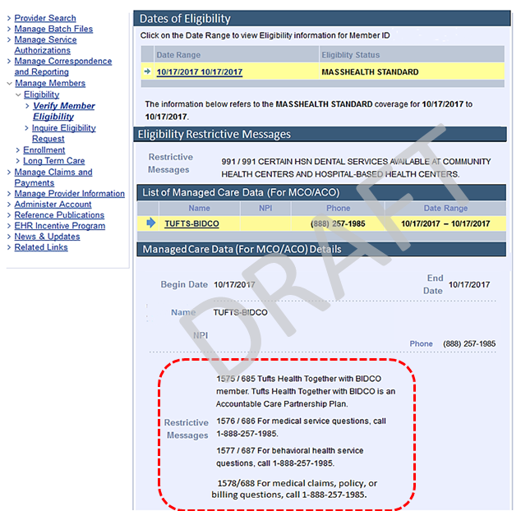

Screenshot Examples of New EVS Restrictive Messaging – Effective March 1, 2018

Example 2. Primary Care ACO Plan
Plan Name: Community Care Cooperative (C3)
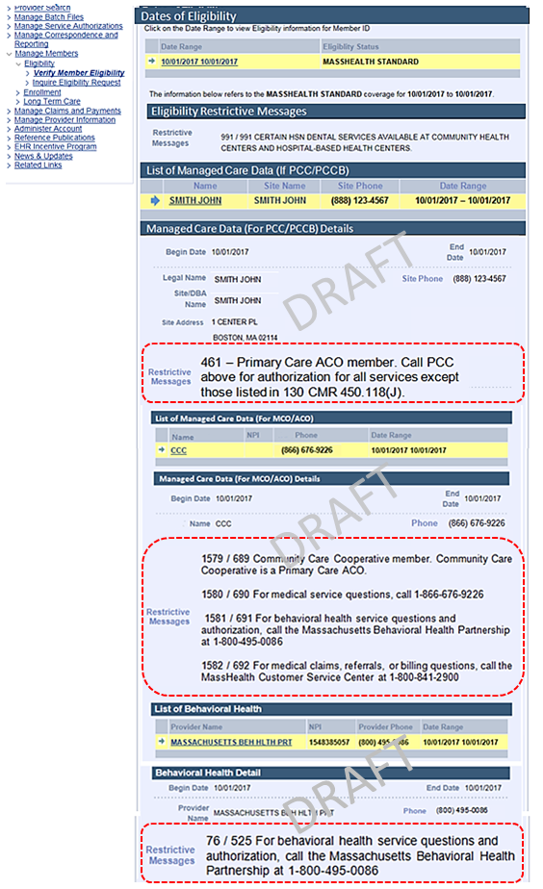
Screenshot Examples of New EVS Restrictive Messaging – Effective March 1, 2018

Example 3. MCO Plan
Plan Name: Boston Medical Center Health Plan - MassHealth Standard

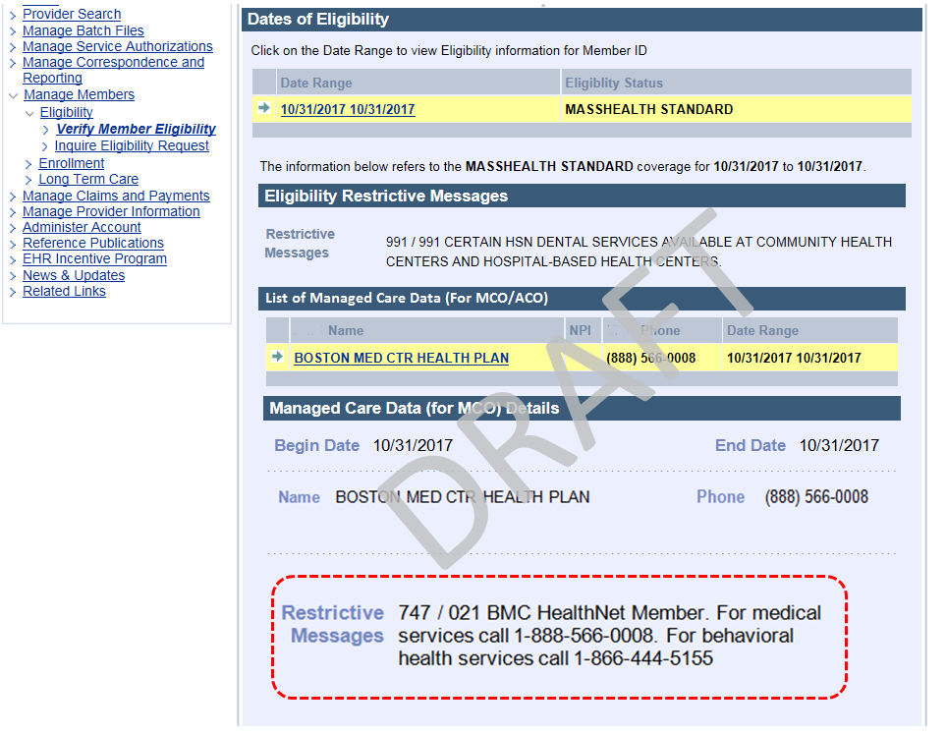

Screenshot Examples of New EVS Restrictive Messaging – Effective March 1, 2018

Example 4. Primary Care Clinician (PCC) Plan and Behavioral Health
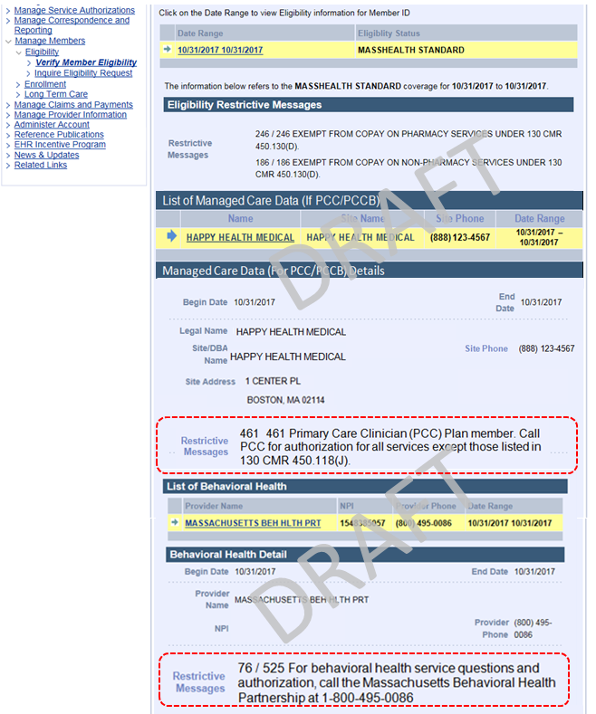
PCDI Provider Education and Communication
MassHealth will conduct three phases of education, training, and communication for the provider community throughout PCDI implementation. Tailored content will be offered to align with each phase.
- Phase 1: Awareness (October 31 – December 21, 2017)
- Phase 2: Operations (January 4 – March 30, 2018)
- Phase 3: Community Partners (April 1 – May 31, 2018)

PCDI Phase I: Awareness – 2017 Webinar Series
This is the first in a series of webinars related to PCDI. The objectives of Phase 1 webinar sessions are to provide all attendees with an understanding of the MassHealth PCDI initiative and its impact on providers and members.
Topics |  | Description
Overview of MassHealth PCDI |  | Overview of the MassHealth PCDI delivery system and new payment models
Key Terms and Concepts |  | Review glossary of PCDI key terms, acronyms, and concepts
Member Assignment and Noticing |  | Inform providers of special assignment and auto-assignment member noticing
MassHealth Choice Tool |  | Inform providers of the new online MassHealth Choices tool to search for providers and compare plans
Eligibility and Claim Submission |  | New enhancements made to the Eligibility Verification System (EVS) to assist providers with inquiries regarding eligibility, billing and service authorization for medical and behavioral health claims
Provider Resources |  | Notify providers of available resources such as the Fact Sheets for PCPs, specialists, hospitals, and Behavioral Health providers, web took kits, and FAQs
PCDI Phase I: Awareness – 2017 Webinar Schedule
November 2017 |  |  | December 2017
Date | Time |  | Date | Time
November 28,2017 | 1:00 p.m. |  | December 5, 2017 | 1:00 p.m.
 |  |  | December 7, 2017 | 10:00 a.m.
 |  |  | December 12, 2017 | 1:00 p.m.
 |  |  | December 14, 2017 | 10:00 a.m.
 |  |  | December 19, 2017 | 1:00 p.m.
 |  |  | December 21, 2017 | 10:00 a.m.

To attend a webinar session, please visit the MassHealth Learning Management System (LMS) at www.masshealthtraining.com and create a profile. Once you are registered, select the preferred course date and time available.

PCDI Provider Education and Communication (cont.)
Schedule of Upcoming PCDI Provider Events
January 2018
Location | Date | Time | Maximum Occupancy
Bristol Community College  777 Elsbree Street  Fall River, MA 02720 | January 10, 2018 | 10:00 a.m. 7:00 p.m. | 150
Holiday Inn  30 Washington Street  Somerville, MA 02143 | January 19, 2018 | 10:00 a.m. 7:00 p.m. | 70
Lawrence Public Library  51 Lawrence Street  Lawrence, MA 01841 | January 25, 2018 | 10:00 a.m.- 7:00 p.m. | 200
UMass Medical School  Amphitheater  333 South Street  Shrewsbury, MA 01545 | January 31, 2018 | 10:00 a.m. –7:00 p.m. | 100
March 2018
Location | Date | Time | Maximum Occupancy
Holiday Inn  30 Washington Street  Somerville, MA 02143 | March 5, 2018 | 10:00 a.m. 7:00 p.m. | 70
Castle of Knights  1599 Memorial Drive Chicopee, MA 01020 | March 21, 2018 | 10:00 a.m.- 7:00 p.m. | 300
Berkshire Crowne Plaza  1 West Street  Pittsfield, MA 01201 | March 28, 2018 | 10:00 a.m. –7:00 p.m. | 100

To attend one of our events, please visit the MassHealth Learning Management System (LMS) at www.masshealthtraining.com and create a profile. Once you are registered, select the preferred event date and time available under the Community Based Training Events tab.

Additional Resources for Providers
For more information about these changes, please visit
- www.mass.gov/masshealth-for-providers
- www.masshealthtraining.com

MassHealth Customer Service Center
If you have any questions about the information in this bulletin, please email your inquiry to providersupport@mahealth.net or call 1-800-841-2900 (TTY: 1-800-497-4648).

Accountable Care Partnership Plans | Customer Service | Behavioral Health Services | Member Card Image
BMC HealthNet Plan Community Alliance  Boston Accountable Care Organization  in partnership with BMC HealthNet Plan  www.bmchp.org/community | 1-888-566-0010 | Beacon Health Strategies  1-888-217-3501 | 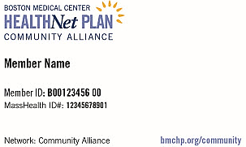
BMC HealthNet Plan Mercy Alliance  Mercy Medical Center  in partnership with BMC HealthNet Plan  www.bmchp.org/mercy | 1-888-566-0010 | Beacon Health Strategies  1-888-217-3501 | 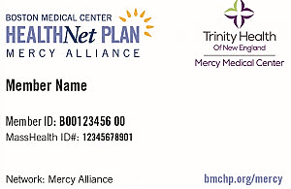
BMC HealthNet Plan Signature Alliance  Signature Healthcare  in partnership with BMC HealthNet Plan  www.bmchp.org/signature | 1-888-566-0010 | Beacon Health Strategies  1-888-217-3501 | 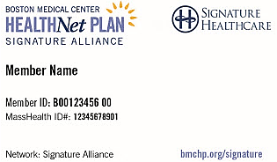
BMC HealthNet Plan Southcoast Alliance  Southcoast Health  in partnership with BMC HealthNet Plan  www.bmchp.org/southcoast | 1-888-566-0010 | Beacon Health Strategies  1-888-217-3501 | 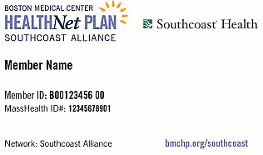
Berkshire Fallon Health Collaborative  Health Collaborative of the Berkshires  in partnership with Fallon Health  www.fallonhealth.org/Berkshires | 1-855-203-4660 | Beacon Health Strategies  1-888-877-7184 | 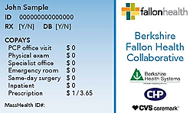
Fallon 365 Care  Reliant Medical Group  in partnership with Fallon Health  www.fallonhealth.org/365care | 1-855-508-3390 | Beacon Health Options  1-888-877-7182 | 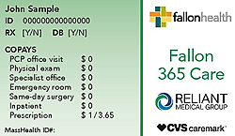
Wellforce Care Plan  Wellforce Care Plan  in partnership with Fallon Health  www.fallonhealth.org/wellforce | 1-855-508-4715 | Beacon Health Options  1-888-877-7183 | 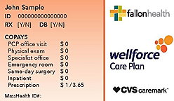
Be Healthy Partnership  Baystate Health Care Alliance  in partnership with Health New England  www.behealthypartnership.org | 1-800-786-9999 | Massachusetts Behavioral Health Partnership (MBHP)  www.masspartnership.com  1-800-495-0086 | 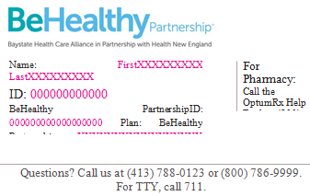
My Care Family  Merrimack Valley ACO  in partnership with Neighborhood Health Plan (NHP)  www.mycarefamily.org | 1-800-462-5449 | Beacon Health Options  1-800-414-2820 | 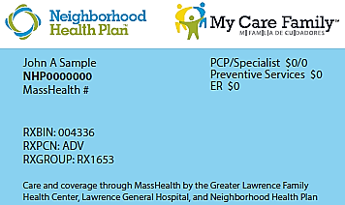
Tufts Health Together with Atrius Health  Atrius Health  in partnership with Tufts Health Plan (THP)  www.TuftsHealthTogether.com/atriushealth | 1-888-257-1985 | Tufts Health Together  with Atrius Health  1-888-257-1985 | 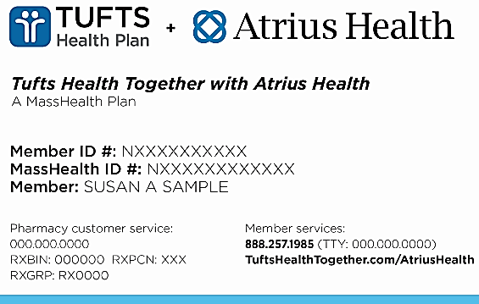
Tufts Health Together with BIDCO  Beth Israel Deaconess Care Organization (BIDCO)  in partnership with Tufts Health Plan (THP)  www.TuftsHealthTogether.com/BIDCO | 1-888-257-1985 | Tufts Health Together  with BIDCO  1-888-257-1985 | 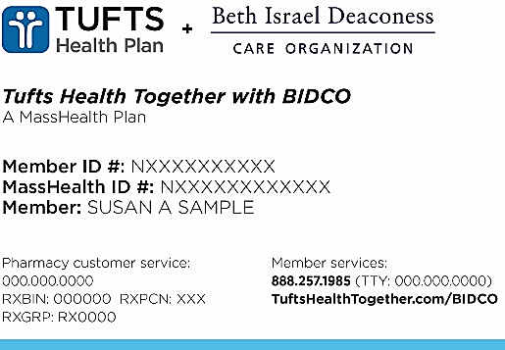
Tufts Health Together  with Boston Children’s ACO  Boston Children’s ACO  in partnership with Tufts Health Plan (THP)  www.TuftsHealthTogether.com/BCACO | 1-888-257-1985 | Tufts Health Together with Boston Children’s ACO  1-888-257-1985 | 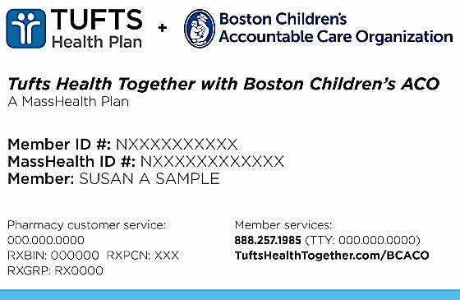
Tufts Health Together with CHA  Cambridge Health Alliance (CHA)  in partnership with Tufts Health Plan (THP)  www.TuftsHealthTogether.com/CHA | 1-888-257-1985 | Tufts Health Together  with CHA  1-888-257-1985 | 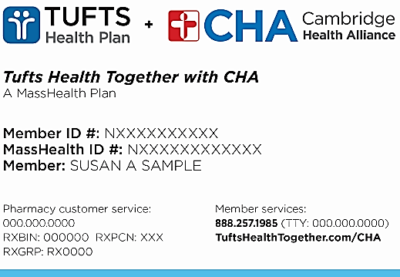

Primary Care ACO Plans* | Customer Service | Behavioral Health Services | Member Card Image
Community Care Cooperative (C3)*  C3 members get primary care at a community health center and have access to the most MassHealth specialists and hospitals.  www.c3aco.org | 1-866-676-9226 | Massachusetts Behavioral Health Partnership (MBHP)  www.masspartnership.com  1-800-495-0086 | 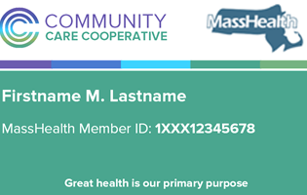
Partners HealthCare Choice*  http://www.partners.org/for-patients/ACO/Partners-HealthCare-Choice-Medicaid.aspx | 1-800-231-2722 | Massachusetts Behavioral Health Partnership (MBHP)  www.masspartnership.com  1-800-495-0086 | 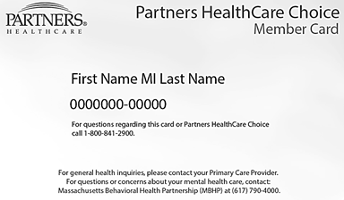
Steward Health Choice*  www.stewardhealthchoice.org | 1-855-860-4949 | Massachusetts Behavioral Health Partnership (MBHP)  www.masspartnership.com  1-800-495-0086 | 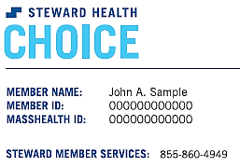
*Note: To enroll in a Primary Care ACO, members must also select a PCP in that ACO’s network. PCPs may not be available in all service areas.

MCO Plans | Customer Service | Behavioral Health Services | Member Card Image
BMC HealthNet Plan  www.bmchp.org | 1-888-566-0010 | Beacon Health Strategies  1-888-217-3501 | 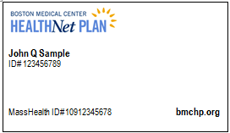
Tufts Health Together  http://www.tuftshealthtogether.com | 1-888-257-1985 | Tufts Health Together  1-888-257-1985 | 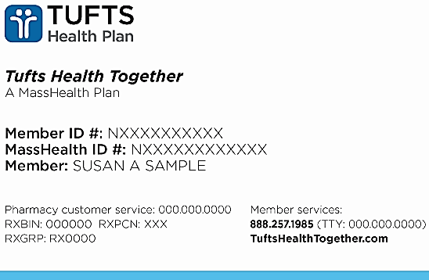

PCC Plan* | Customer Service | Behavioral Health Services | Member Card Image
Primary Care Clinician (PCC) Plan*  http://www.mass.gov/service-details/primary-care-clinician-pcc-plan-for-masshealth-members | 1-800-841-2900 | Massachusetts Behavioral Health Partnership (MBHP)  www.masspartnership.com  1-800-495-0086 | 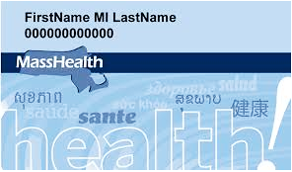
*Note:
- To enroll in the PCC Plan, members must also select a PCP in the MassHealth network. PCPs may not be available in all service areas.
- PCC Plan members can enroll in an ACO or MCO at any time.
- Community Partners, who provide long-term services and supports, are not available in the PCC Plan.
- Behavioral Health Community Partners are only available for PCC Plan members who also participate in Community Based Flexible Supports (CBFS), a Massachusetts Department of Mental Health program.

