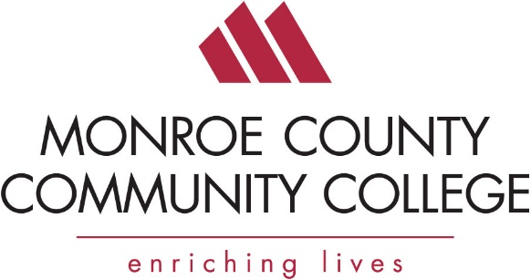

Safety Expo and MIOSHA Update

Event: Thursday, March 16, 9 am to 12 pm
Doors Open at 8:30 am
Monroe County Community College’s La-Z-Boy Center
*Registration Deadline March 3

Company Name: ___________________________________________
Attendees: 1.___________________________________________
2.___________________________________________
3.___________________________________________
4.___________________________________________

Address: _____________________________________________
City, State, Zip _____________________________________________
Telephone: _____________________________________________
Email: _____________________________________________

Please bill my credit card for ____ registrations at $5 each.

Print Credit Card Holder’s Name: ___________________________________________

Credit Card #___________________________________________ Exp. Date: ____________

VISA MC Discover Credit Card Zip Code:_________

Signature: ___________________________________________

Please invoice me

Date: March 16, 2017
Location: Questions: Barry Kinsey
Monroe County Community College (734) 384-4124
La-Z-Boy Center bkinsey@monroeccc.edu
1555 S. Raisinville Road
Monroe, MI 48161

