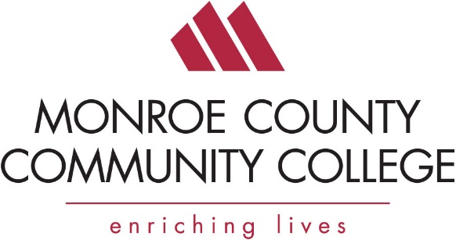

Safety Expo and MIOSHA Update
Thursday, March 16, 9:00 am to 12 pm
Monroe County Community College’s La-Z-Boy Center

Monroe County Community College will be hosting its 2017 Business & Industry Safety Expo on Thursday, March 16, 2017 from 9:00 am to 12 pm.

This event will include vendor booths showcasing the latest in industrial safety equipment and services and a light breakfast with Keynote speaker Nella Davis-Ray, Program Director, Consultation Education & Training Division, Michigan Occupational Safety & Health Administration (MIOSHA), providing an update on MIOSHA. The keynote begins at 9 am. Coffee and doughnuts at 8:30 am.

The cost is $5 per person. Registration is required
If you would like to attend please complete the attached registration and return it to me via email (bkinsey@monroeccc.edu) or fax (734-384-4190). You can pay with a credit card or pay at the door.

Please contact me with any questions that you might have.

Barry Kinsey
Director of Workforce Development
bkinsey@monoreccc.edu
(734) 384-4124

