*Support St. Joseph Parish & School through the following:*

**Kroger Community Rewards**

Register your Kroger Plus Card by going to [www.kroger.com/communityrewards](http://www.kroger.com/communityrewards) and link St. Joseph Church.

**St. Joseph Church ID: #80177**

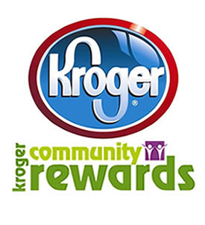

**Remke Markets: Caring Neighbors Program**

Register your Remke Rewards card at [www.remkes.com/my-account](http://www.remkes.com/my-account), find St. Joseph Church / School in Caring Neighbor section. The Parish receives up to 2% of total purchase.

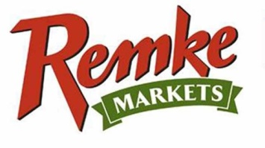

**Box Tops for Education**

Box Tops can be found on many items such as General Mills products, Lysol, Yoplait and Annie’s Organic foods. The amount ranges from $.10 - $6.00 per Box Top or Bonus slip.

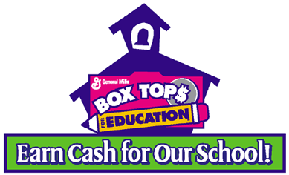

**Office Depot & Office Max**

Simply make a purchase of [qualifying school supplies](https://www.officedepot.com/fm/files/od/promo/2018/week_1/gtbs/0118_qualifyingproducts.pdf), provide the school ID at checkout and St. Joseph School will receive 5% back in credits for **FREE** supplies!

**St. Joseph School ID: 70039765**

