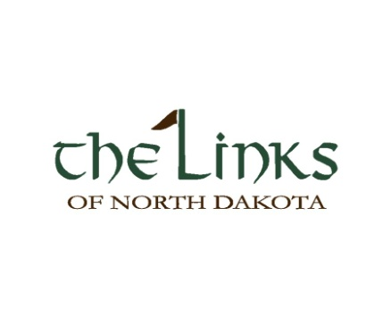
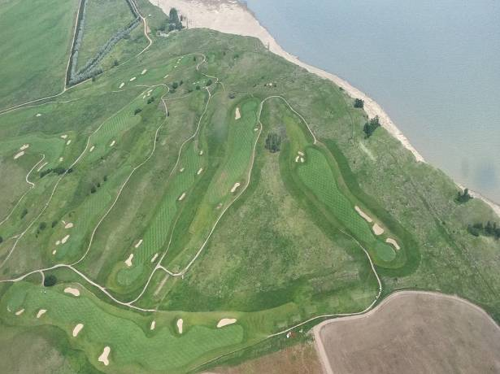

Kasmer & Aafedt Oil, Inc.
For more information contact: Sara Kasmer at 701-570-8148
Or text John Kasmer at 701-570-3636
John@kaoil.net

Registration Due: July 28th, 2018
Saturday,
August 4th,
2018
SPONSORSHIP &
VOLUNTEER OPPORTUNITIES
VOLUNTEER: IF YOU ARE INTERESTED IN VOLUNTEERING YOUR TIME PLEASE CONTACT US FOR MORE
INFORMATION.
SPONSORS: BEING A SPONSOR IS REWARDING AND A GREAT WAY FOR ADVERTISING! YOUR NAME OR BUSINESS NAME WILL BE PRINTED
ON A BANNER FOR RECOGNITION OF
YOUR GENEROSITY!
The Day of the Tournament:
Check-In………………………..……...8:30 am Shot Gun Start ……………….…...10:00 am Buffet Style Dinner ……………… 4:30 pm

INDIVIUALS AND 4-MAN
TEAMS WELCOME!

There will be food and drinks Carts throughout the course!!

AWARDS AND PRIZES
Awards and prizes will be presented at dinner.

Kasmer & Aafedt Oil, Inc.’s 5th Annual Golf Tournament proceeds will go to a Non-Profit of your choice including examples of St. Joseph school, Opportunity Foundation, Schools , Salvation Army, or any Church organization
Sports Clubs

SATURDAY AUGUST 4, 2018
REGISTRATION DUE: July, 28 2018

TOURNAMENT INFORMATION 4-MAN SCRAMBLE

PLACE
The Links of North Dakota
The Links is 28 miles East of Williston on Hwy 1804

The Links of North Dakota 5153 109th Avenue NW Ray, ND 58849
http://www.thelinksofnorthdakota.com

If you need assistance with directions feel free to contact us at 701-570-3636!

TIME

Saturday, August,2018 Check-In….8:30 am
Shot Gun Start………..10:00 am Buffet Style Dinner……..4:30 pm
REGISTRATION INFORMATION

______________________________
PLAYER 1

_____________________________________________
Company

_____________________________________________
Address

----------------------------------------------------------------------------
City/ State

----------------------------------------------------------------------------
Phone

----------------------------------------------------------------------------
Email

PLAYER 2:___________________________________

PLAYER 3:----------------------------------------------------------

PLAYER 4: --------------------------------------------------------

- $150 PER PLAYER/ $600 PER TEAM
- SINGLE $300
- DOUBLE $500
- TRIPLE $1000
- HOME RUN $2000
- GRAND SLAM $5000
- Player over 80 years old
TOTAL ENCLOSED: $
PLEASE PAY BY CASH OR CHECK PAYABLE TO : The Non-Profit of your choice

REMIT TO:KASMER & AAFEDT OIL, INC. C/O GOLF TOURNAMENT
PO BOX 1949
WILLISTON, ND 58801

