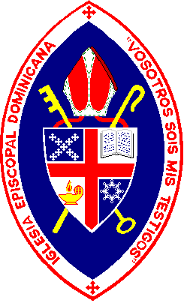

**2018 Tampa Deanery Dominican Mission**

**Diocese of Southwest Florida**

**Team 1 June 16-23**

**Team 2 June 23-June 30**

**Team 3 June 29-July 7**

**Iglesia y Albergue San Timoteo, Nizao**

**Colegio San Matías, Santana**

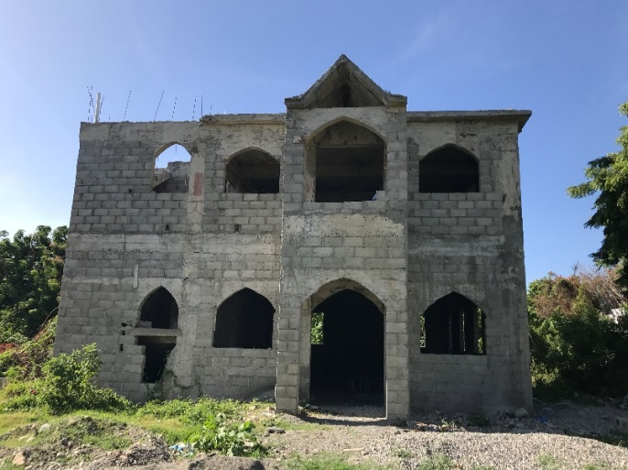

**The Tampa Deanery project for 2018** is the third and final year of our project to build the new San Timoteo Episcopal Church in the town of Nizao. Our teams will also work at the San Matías School in Santana, Bani where they will complete much needed repairs, including painting and carpentry.

**Nizao and Santana, Bani** are located on the Southern Coast of the Dominican Republic, about 30 miles west of Santo Domingo. The new building in Nizao will house the San Timoteo Church (first floor) and a children’s shelter (second floor); additionally the land in the rear of property will house an agricultural cooperative. There is a major need in the community for this facility and the programs it will bring.

**San Timoteo Church**, like many other congregations in the Dominican Republic started as a home-based Bible study, a mission congregation to the San Matías Church located in nearby Santana, Baní. The congregation grew until it could no longer fit into a parishioner’s home and began meeting outside. In 2012 the Dominican Episcopal Church was able to purchase a parcel of land, including a basic wood storage structure, with the hope of building a new church. The needs of this poor urban community were carefully assessed by Bishop Holguin who decided that the church facility should also house a children’s shelter or “Albergue” on the second level. The second floor will also be used for other educational programs including an adult literacy program and language and cultural programs in music and dance.

***The New Iglesia Episcopal San Timoteo***

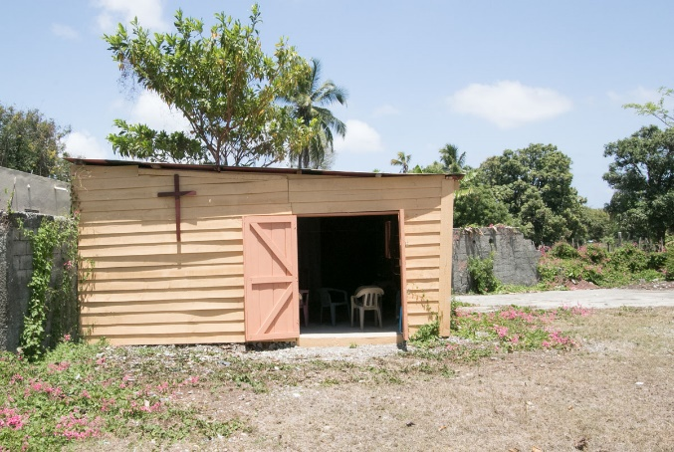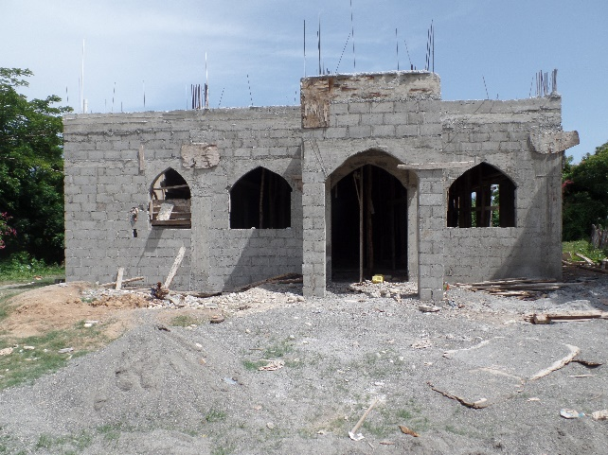

***The Progression of the San Timoteo Church***

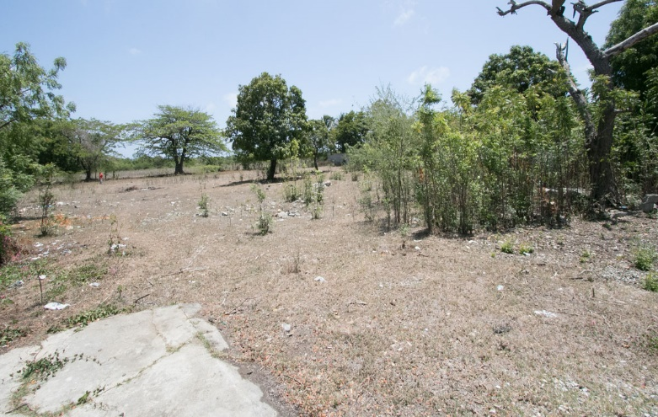

***The land to be used for an agricultural cooperative***

To best utilize the land the Bishop plans to begin an agricultural cooperative to work with families in the community to grow their own fruits and vegetables. The excess crops harvested can be sold to provide income to those families.

**San Matías Primary and Secondary School:**  The lower school was built as a Tampa Deanery Project in 2002-2003. In 2009, Tampa Deanery members returned to assist Grace Church, Charleston, SC, with work on the upper school. New playground equipment was assembled and installed in February 2017. Major repairs, painting, carpentry, sealing the concrete roofs and building a protection wall for the school were initiated in 2017.

.

**The goal for 2018** is to complete the new San Timoteo Episcopal Church to include plastering, painting, building church furniture and pews, and electrical installation. The team at San Matías will also continue much needed repairs, painting, and carpentry at San Matías School. The fundraising goal for 2018 is estimated at approximately $86,000 – a major commitment from the Tampa Deanery. The projected amount that each person is asked to raise, which will cover all expenses including materials, is $1900. Completing the new San Timoteo church building represents a significant challenge. Prior to our team arriving local workers and volunteers will continue to make progress, and our teams will work with these local workers and volunteers. The two-fold project will allow team members to work at either or both sites depending upon their physical skills

**Team Dates, Leaders, and tasks to be completed are as follows:**

**Team #1-** **June 16-23** (10-Participants)Electrical, plumbing, painting and plastering at San Timoteo Church.

Bill Kunkle/Dion Southard Repairs, painting and carpentry at San Matías School.

**Team #2 June 23-June 30**(25- Participants) Painting and building altar furniture and pews at San Timoteo Church

Bill Kunkle/Sally Thompson VBS Program, repairs, painting and carpentry at San Matías School.

**Team #3- June 29- July 7** (12- Participants) Complete sanding, staining, sealing and landscaping at San Timoteo Church

Mark Hunter/ Chuck Collins Repairs and painting at San Matías School and Morrow center.

**Three teams will stay** at the Paul & Luke Morrow Center in Santana, Baní (modeled after the Bishop Kellogg Center in San Pedro de Macorís). Breakfast and supper are served at the Morrow Center, and work day lunches are made locally and delivered to the mission sites. The Center is adjacent to the San Matías Primary and Secondary School.

For more information, contact: Bill Kunkle at 813-400-2722 or by e-mail at [bkunkle@dominicandevelopmentgroup.org](mailto:bkunkle@dominicandevelopmentgroup.org)