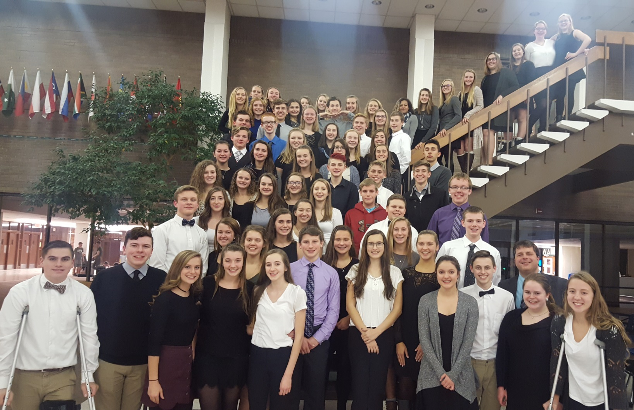

We The People
2016

The AP Government and Politics students competed in the We The People District Competition at Wauwatosa West on December 15th.
The top 6 HUHS teams qualified for the State Competition in Madison on January 21st.

The sophomore AP Government students really took on the challenge admirably, and they earned many complements from the attorneys, judges, civic leaders, and academicians who served as judges:

“Hartford just keeps on improving, and it is being noticed.”

“This is the first time I have ever made this point this to high school students - this is something I usually say to my college students…….”

“You guys are sophomores? Your poise and stylishness is off the charts.”

“Keep reading political theory - it warms my heart.”

“Sophomores? Wow! Compared to the other teams I am really impressed. You have a lot of the subtle nuances of older students”

“You have such thoughtfulness. I saw you guys thinking about the connections, and I really like that.”

“I’m impressed with you. You’re 10th graders. It takes a lot of moxie to talk with three adults about Constitutional law. I commend you tremendously. I encourage you to keep working hard as you move forward - you have a good foundation.”

“No one else clearly made the distinction between what they felt and what the court ruled….your group was the best we’ve seen all night at that.”

“I was really pleased in hearing the depth of your prepared statement and you did a nice job of focusing on big themes.”

“We were having conversations about the Constitution. I loved it.”

“It was fun listening to you and throwing things at you because I knew you were competent and capable to take it on. You have a great theory of ‘separation of powers.”

“Sophomores? I am very impressed by your preparation. I give you big kudos for taking this on.”

“Very specific and higher-level. You know more than 99% of adults.”

“You show that you believe in what you’re saying.”

“You’re increasingly in the mix of Wisconsin teams. I’m happy to see that. I just scored your team within 2 points of last year’s national team.”

“The best explanation of social contract theory we’ve heard tonight.”

“You were the best team at Constitutional reasoning. Other teams may have more detailed prepared statements, but they didn’t respond to the questions as well.”

“I’m surprised. Your group was so quick on your feet, yet you showed the depth that would indicate you really dove into your research.”

“I teach this to my Poli Sci students in college…..”

Several judges from HUHS volunteered their time. Here were some of their comments:

The groups that I saw were well prepared, confident and poised in their presentations. They were grappling with difficult political material and faced extremely challenging questions from the judges. I wish more people in our school knew and understood how well these students represented our school.

It was a privilege to watch our students as they represented not only HUHS, but our country as well; their knowledge of our Constitution and the democratic process was remarkable. -So much fun to see students committed to civic engagement.

I was very impressed by what I saw of our students. They were poised and prepared. They also were respectful of the judges' feedback and showed courage under the pressure of the judges' questions.

