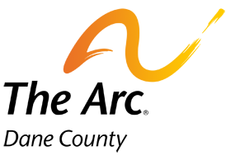

FC/IRIS Transition Learning Series: How do I choose?

An in-depth comparison of Family Care and IRIS
April 17, 2017 @ 4:00-6:00 pm OR 6:30-8:30pm
Alliant Energy Center: Mendota 7-8
1919 Alliant Energy Center Way
Madison WI 53713
RSVP: Marissa Hojnacke rsvp@lovdane.org

Speakers: Lynn Breedlove and Dennis Harkins, plus TWO family stories about using Family Care and IRIS

Session Description: Dennis Harkins and Lynn Breedlove will provide a more comprehensive comparison than has been offered at other LOV/Arc learning events. Two families will share their stories–the first uses Family Care and the second lives in a rural area and switched from Family Care to IRIS. Attendees should have attended an introduction session or watched the pre-session video at http://lovdane.org/projects/family-careiris-transition/

Registration: Please register by emailing rsvp@lovdane.org. Seating is limited in the room, so we are offering the session at two time slots (4-6pm and 6:30-8:30pm) on the same day. Let us know which one you would like to attend and how many people you are registering for.

Room Change: For those who have attended our previous events at Alliant Energy Center, we are located in a different room this time. We will be in Mendota 7 and 8. Please be aware, there is another event happening in the Exhibition Hall during this event, so please ensure ample time for parking. Parking is free, just indicate that you are there for the LOV-Dane Community Forum.

Interpretation services are available on request. We will do our best to accommodate requests made 10 days in advance of the event, but cannot guarantee availability of interpreters when requested after that date.

