INTERFAITH YOUTH INITIATIVE APPLICATION FORM

PLEASE SUBMIT APPLICATIONS WITH DEPOSIT.

Stephanie Sanger-Miller, IFYI Program Director
Cooperative Metropolitan Ministries
474 Centre Street, Newton, MA 02458
info@coopmet.org

I am applying for this IFYI track (please check one):
___ High School Track (For students entering 10th-12th grade, ages 14-17)
___ College Track (Incoming Freshman and Sophomores)

We are able to take students entering their freshman year of high school and junior/senior year of college on a case-by-case basis, based on enrollment numbers. Students in those age groups are still encouraged to apply!

Personal Information
Name (Last, first, M.I.)__________________________________________________________
Permanent Address____________________________________________________________
____________________________________________________________________________
Mailing Address (if different)_____________________________________________________
____________________________________________________________________________
Cell Phone__________________________ Home Phone ______________________________ Email_______________________________________________________________________
Date of Birth_________ Gender_______ Grade as of Fall 2017 _________________________
Dietary restrictions ____________________________________________________________
Health conditions (yes/no) explain __________­­­­­­­­­­­­­­­­­­­­­­­­­­­­­______________________________________
Name of parent/guardian 1______________________________________________________
Parent/guardian 1 phone and email _______________________________________________
Name of parent/guardian 2______________________________________________________
Parent/guardian 2 phone and email _______________________________________________

Religious Involvement
Religious affiliation (if any)______________________________________________________
Name of religious community, location (if applicable)_________________________________
Religious leader/educator and contact information___________________________________

How did you hear about IFYI? (Circle all that apply)
Religious Leader (Imam, Pastor, Rabbi, etc.) Religious Educator Youth Advisor
IFYI Participant/Alumni (Name)____________________ Other (Please specify)_____________

Reflections (Please write on a separate page)
1.What leadership, faith, or service activities have you been involved with in the past? (One paragraph)
2. Why do you want to attend the Interfaith Youth Initiative? What do you think might be challenging for you? What do you hope to learn or gain? (Two to three paragraphs).

Reference
Please provide one reference (a teacher, religious leader, coach, employer, youth advisor, or other non-family member).
Name _____________________________________________________________________
Position and Employer/Organization ____________________________________________
Address ___________________________________________________________________
Phone________________________ Email _______________________________________

Once accepted into IFYI, the IFYI program director will contact you/your parents to discuss the cost of the program. The subsidized cost of the program is $800 per participant. We never want finances to be a barrier to participation, so we accept tuition on a sliding scale. However, every participant is required to pay a $100 deposit to secure a space in the program. Please contact Stephanie Sanger-Miller at ifyi@coopmet.org with any questions.

IFYI Participant Agreement

All of the above information is true and complete to the best of my knowledge. If accepted to the Interfaith Youth Initiative, I agree to participate in the full program and to abide by the rules and regulations of IFYI. I understand that inappropriate behavior or failure to comply with these rules may result in my dismissal from IFYI and may prevent my participation in future IFYI programs.

Signature of Applicant ____________________________________________ Date___________

For participants under the age of 18: I give my permission for _____________________ to apply for and, if admitted, attend the Interfaith Youth Initiative, Summer 2017.

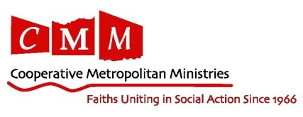
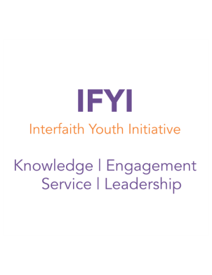
Signature of Parent or Guardian _____________________________________ Date___________

Dear Parents, Youth Educators, Clergy, and Students,

Hello IFYI friends and family! We have missed you since IFYI 2016, but we have been thinking about you and hard at work to prepare for IFYI 2017. Here are some of the new and innovative details of what we have in store for this year’s program:

● First and foremost, we are excited to announce the dates of IFYI 2017: Wednesday August 2nd - Friday, August 11th. (College participants will arrive on Wednesday, August 2nd and high school students will arrive on Friday, August 4th).

● For our college participants, we have continued in our redesign of the College Track to empower participants to lead as they learn. The College Track will include two days of exclusive learning with various local and national interfaith organizations. They will learn practical skills to take back to campus, and gain insight into interfaith leadership. When the high school participants arrive, the college participants (with help from their staff mentors) will be able to start putting those skills into action, reflect, and keep learning.

● IFYI 2017 will continue to work on developing our core values of knowledge, engagement, leadership and service, but this year we will focus on what it means to put interfaith work into action, or rather #interfaithing. Our goal is to help participants strengthen their practical skills as leaders within their communities, their sense of identity, and their ability to build relationships across religious and other boundaries. This year will focus on the opportunities for action that bring our communities together by celebrating our diversity and bettering our communities by knowing more about one another.

IFYI is an opportunity for young people to learn about their own religions and the religions of others, not by sitting in a classroom or reading a textbook, but by building relationships and through hands on experience. It is also an opportunity to come together around service projects and leadership training that start at IFYI, but continue grow well beyond our time together. Plus, it’s not just about the programs, and the learning, it’s about the people, and the IFYI participants are the best! Ready to join in the fun? Please check out our website, and fill out an application and contact us by email at info@coopmet.org with any questions, and we will see you in the summer!

All my best,

Stephanie Sanger-Miller
Cooperative Metropolitan Ministries

