Small Business Person of the Year
2017 Nomination Information

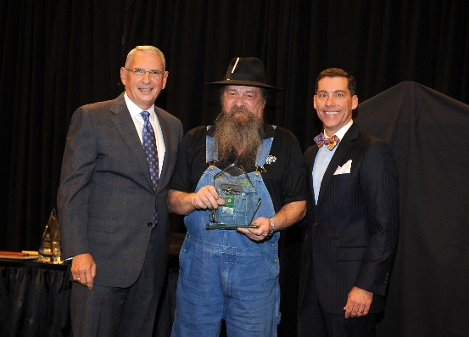
Do you know a small business person who should be recognized for outstanding service?
Nominate them for the
2017 Small Business
Person of the Year Award!

The winner will be announced at the
Chamber’s Banquet in October.
Mr. Raymond Butler, Master Distiller
Dalton Distillery, LLC
2016 Winner

Awards will be based on the following criteria:

- Must be a member of the Greater Dalton Chamber
- Associated with a for-profit company that employs 50 or fewer full-time employees
- Any individual who owns and operates or who bears principal responsibility for operating a small business

- Growth in number of employees
- Increase in sales and/or unit volume
- Current and past financial performance
- Innovativeness of product or service offered
- Must be involved in the development and growth of our community
- Nominees not receiving the award are eligible for re-nomination next year

Judging:
Judging will be conducted on a confidential basis by the Small Business Awards Committee made up of Chamber and Economic Development Professionals from across the state of Georgia.
Business Activity:
In order for the Awards Committee to gain a better understanding of your nominee, please fill out the nomination information and business activity form on Page 2. Please send your responses as a separate document.
Please submit Nominations no later than 5:00 p.m.
Monday, August 28, 2017
Return to Ali Harp
harp@daltonchamber.org | fax: 706-226-8739 Attn: Ali Harp
** Nominations received after 5PM will not be accepted.

Small Business Person of the Year

2017 Nomination Form
Nominee Name: _______________________________________________________________
Nominee Title: ________________________________________________________________
Business: _____________________________________________________________________
Address: _____________________________________________________________________
Phone: __________________________ Email: ___________________________________
Number of Employees: ____________ Years in Business: _________________________
Person making nomination: ____________________________________________________
Phone: __________________________ Email: ___________________________________

Business Activity: (Attach additional sheets as necessary)
- Please explain any ongoing growth and/or success within the nominees business over recent years. Examples may include, but are not limited to an increase in employees, expansions to your business, new inventory or processes, etc.

- Has the nominee been involved in recent community events or activities? If so, please provide brief details.

- What impact does the nominees business have on the economy of Greater Dalton?

- Has the nominee utilized a creative approach to management, or developed any new ideas within their business to maintain/increase their successes?

- Please list any involvement with the Greater Dalton Chamber of Commerce.

- What else should we know about the nominee and their business that would assist in the selection of the next Small Business Person of the Year award recipient?
Please submit Nominations no later than 5:00 p.m. on Monday, August 28, 2017. Nominations received after 5PM will not be accepted.
Return to Ali Harp - Email: harp@daltonchamber.org | Fax: 706-226-8739 Attn: Ali Harp Mail: 100 South Hamilton Street Dalton, GA 30720 Attn: Ali Harp

