AB School Store Order Form
SHOW YOUR SCHOOL SPIRIT!!
NAME:___________________________________________ | PHONE NUMBER:______________________________
E-MAIL:__________________________________________
KINDLY RETURN COMPLETED FORM TO SCHOOL STORE or e-mail ABSchoolStore@abschools.org
ORDERS MUST BE SUBMITTED BY 3PM THURSDAY, DECEMBER 7, 2017 IN ORDER TO BE RECEIVED BY DECEMBER 22ND
*Please Add $2.00 for 2XL
Adult Sizes: | Color  N = Navy  R = Royal  G = Gray | Unit Price | S | M | L | XL | 2XL* | Total Cost
Short Sleeved T-shirt |  | $15
Long Sleeved T-shirt |  | $18
Pull-over Hoodie Sweatshirt |  | $30
Crewneck Sweatshirt w/ “Colonials” |  | $25
Crewneck Sweatshirt w/”Acton-Boxborough” |  | $25
Full-Zip up Hoodie Sweatshirt (Embroidered with “AB”) |  | $40
Men’s Training Shirt – ¼ zip pullover (navy - only) | N | $30
Women’s Training Shirt – ¼ zip pullover (two-toned navy - only) | N | $30
AB Spirit Shirt (Royal – only) | R | $25
Sweatpants – “Acton-Boxborough” down left leg | N | $30
Sweatpants – “AB Colonials” on left hip | N | $30
Plaid Flannel Pants  “Acton-Boxborough” down left leg (navy or royal only) |  | $30
Plaid Flannel Pants “AB Colonials” on left hip (navy or royal only) |  | $30
Men’s Navy Fleece Vest | N | $30
Women’s Navy Fleece Vest | N | $30
Women’s Winter White Fleece Vest | WW | $30
Winter Hats  - Navy multi-colored Pom (NP)  - Royal multi-colored Pom (RP)  - Navy/Gold Beanie hat (NGB)  - Gray knit hat, lined (GK)  - Navy knit hat, lined (NK) |  | $15
Winter Scarfs  - Royal multi-stripe w/fringe (RF)  - Navy multi-stripe w/fringe (NF)  - Navy/Gold stripe – knit (NGSK) |  | $15
AB Blanket |  | $25
AB Umbrellas |  | $15
AB Drawstring Backpack |  | $7
AB School Store Gift Card (indicate $$ amount)
Flannel Pants  (Navy or Royal Plaid) | Sweatpants (navy only) | Men’s Training Shirt | Women’s Training Shirt
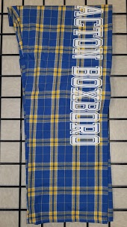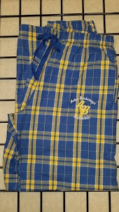 | 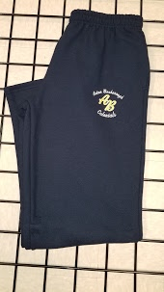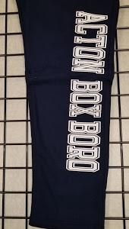 | 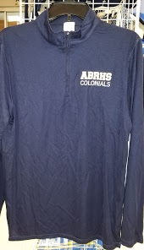 | 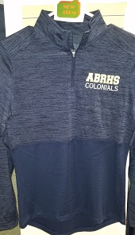
T-Shirts | AB Spirit Shirts | Flannel Vests
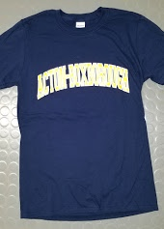 | 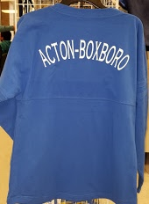 | 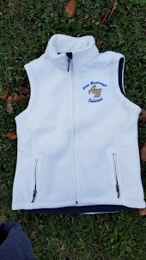 | 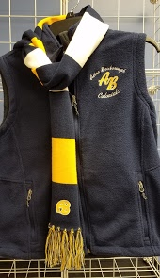
Sweatshirts
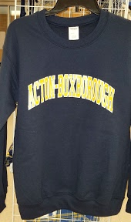 | 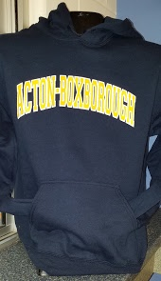 | 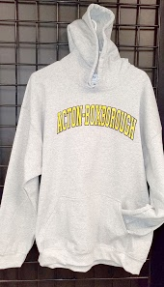 | 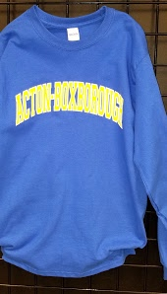
Winter Warmers
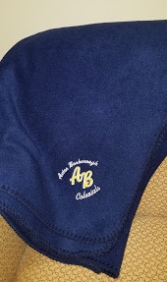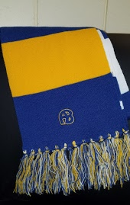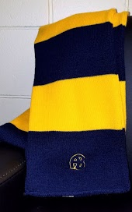
Not pictured are our Long-sleeved T-shirts – Umbrellas –Drawstring backpacks
Can’t decide – purchase an AB School Store Gift Card in the denomination of your choice!!

Visit our website: https://sites.google.com/abschools.org/school-store (Internet Explorer not supported)

