In the October 2012 General conference of the Church of Jesus Christ of Latter Day Saints, President Thomas S. Monson announced that the age for full-time missionary service in the church had been lowered to 18 for young men and 19 for young women.
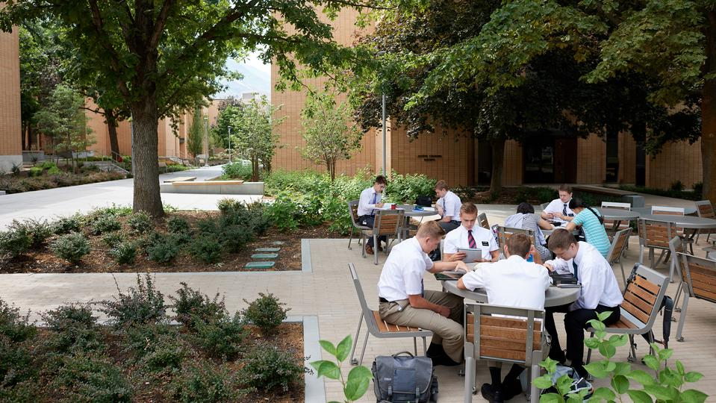
In order to accommodate the influx of new missionaries, plans were released to expand the MTC in Provo, Mexico, Ghana and the Philippines. The expansion project in Provo consisted of two new 6 story buildings that will serve primarily as classroom space, and will boost the capacity of the missionaries to 3,700 elders, sisters and senior missionaries at a time, which is an additional 25% increase in capacity of the original facility.
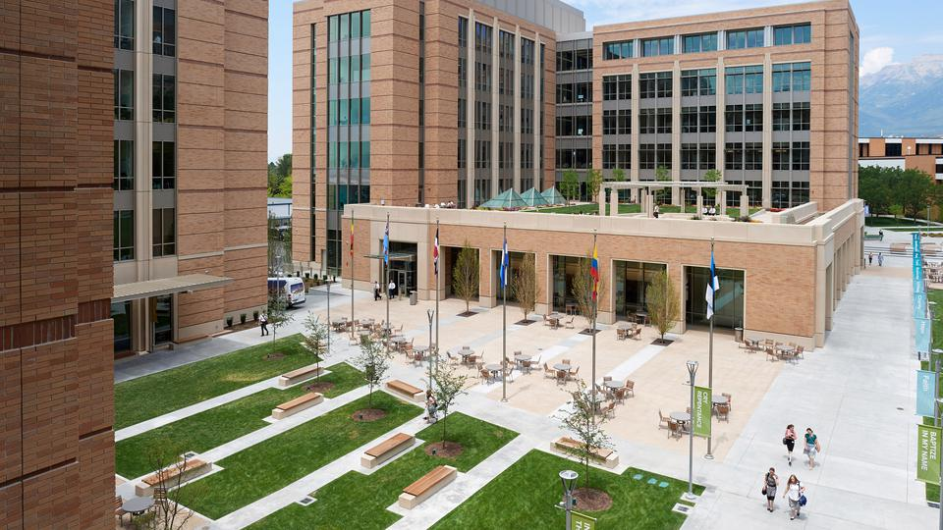

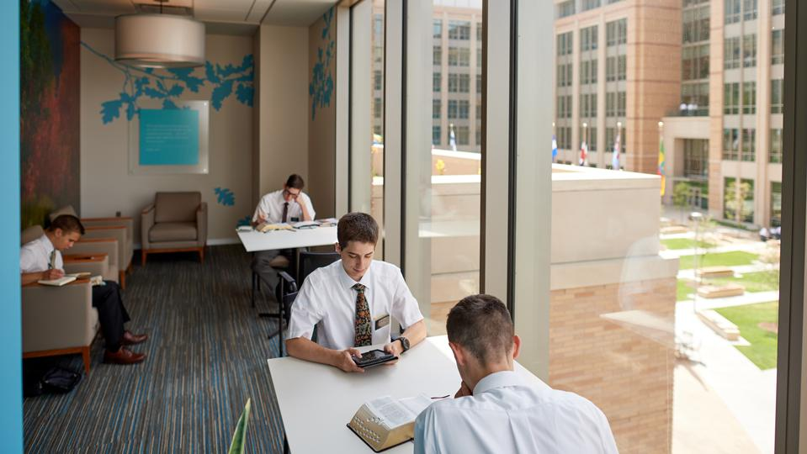
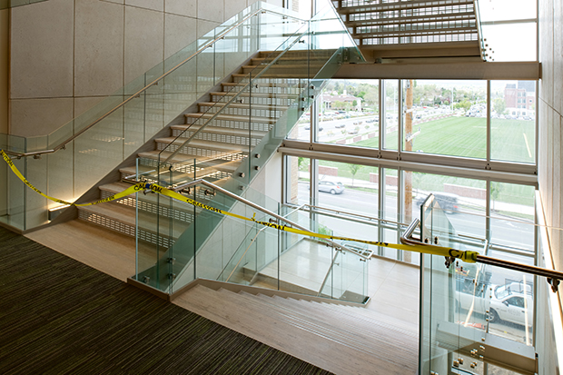
The two new pre-cast and masonry six-story buildings, along with the enhanced outdoor space and underground parking feature extensive glass exteriors to maximize use of natural light and create a sense of openness between the MTC and surrounding areas.

As the producer of the Glass Fiber Reinforced Concrete (GFRC) and Architectural Precast Concrete for this project, Unlimited Designs had the privilege of working with the Owners, ZGF Architects and FFKR Architects early in the design. Providing samples and connection methods along with budget numbers to be used in the creation of the Project. Working close with Okland Construction and the Design Team, products and colors were selected to be used and in what locations they would be used at.
The MTC Joint Venture construction team then came on board which was composed of Okland Construction, Jacobsen Construction and Layton Construction.
After bid day we were teamed up with Childs Masonry to do the installation of the products that Unlimited would be producing.
Unlimited produced the exterior precast base pieces throughout the project along with the GFRC columns and entryways that complemented the Masonry work done throughout the exterior of the project. Unlimited also created, with the direction of the Design team, the interior stairway panels that give a very high end elegant finish to those portions of the building. As the project progressed Unlimited Designs had the privilege to team up with IMS Masonry on the landscape precast, creating benches and accent elements that were used throughout the carefully planned landscape of the of the new complex.

The owner and Design team also approached Unlimited Designs directly to construct landscape rocks and trash cans that would be used to broadcast the cutting edge high speed Wi-Fi system. This is being used through the entire MTC complex. Collaboration with these teams was the key to a successful project that required a high level of quality and an accelerated schedule necessary to accommodate the influx of new missionaries. Much care and consideration was taken to bring these two new structures together in a way that complimented the design of the original facilities.
Unlimited Designs wants to thank all of our partners in their efforts of bringing this project to completion. We are excited to see the many awards it will be given in both Design and Craftsmanship in the months to come.

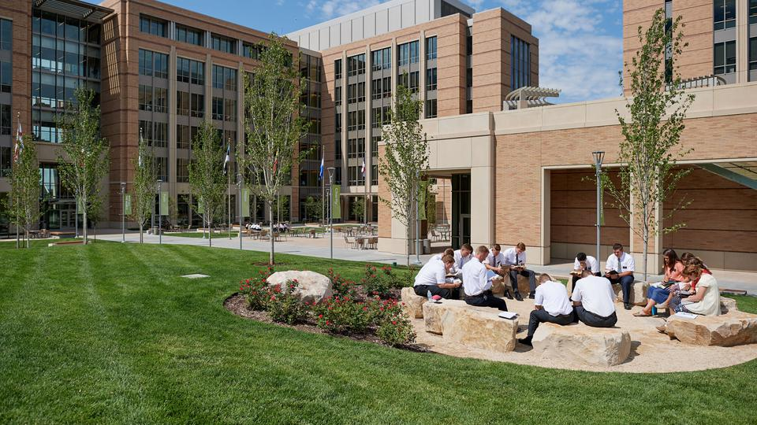

The Provo MTC will be hosting public open houses beginning
July 31, 2017 and running through Aug. 19, 2017.
The tours will operate six days a week, Monday through Saturday,
and be conducted largely by elders and sisters being trained at the center.
We hope you take the time to come by and see this amazing project first hand.

