Wednesday, March 7 @ 7:30 PM in the Lounge at Temple Sinai
“The Golem and the Jinni” by Helene Wecker
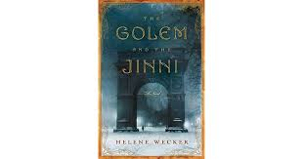
An Amazon Best Book of the Month, April 2013
Imaginative and meticulously researched, this enchanting debut novel from Helene Wecker is, in reality, an historical fiction. Set primarily in turn-of-the-century Manhattan, it deliberately details the immigrant experience--the wonders and hardships of being in a new country and the discoveries, triumphs, and failures that follow--while bringing the city itself to life with such passion that New York of yore seems like a magical land. Beyond reality, however, The Golem and the Jinni, as the title implies, is also a fantastic work of fantasy. The Golem is an insatiably curious clay "woman" that was created to seem human while serving only her husband; the Jinni is a magical "man" whose fascination with mortals has left him nearly stripped of his own nature and forced to live as one. These mythical characters from otherwise clashing cultures not only coexist, but come to rely upon one another in order to exist at all. In turn, their story finds us not only rooting for them to find peace and happiness, but gaining a better understanding of our own human nature in the process. --Robin A. Rothman
SAVE THE DATE! Our final meeting will be on Tuesday, May 8 at 7:30 PM.

