2017 Magnet  FEncing Camp  Epee Fencing Summer Camp will be held at Caddo Magnet High School. The camp will be four hours a day with high quality instruction that will culminate with a class tournament.  - No Experience or Equipment Required  - Dress: t-shirt, warm-up pants and tennis shoes.  - Dates: May 22-26, July 10-14  - Sessions: 8- noon or 1-5 (doors will open @ 7am)  - Students from all schools (grades 6-12) welcome  - Signup is exclusively on Signup Genius  - Class Fee: $100 (financial assistance available)  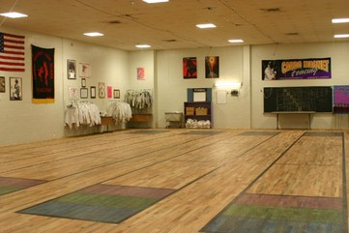 | EPEE FENCING SUMMER CAMP  ────  This is a rare opportunity for students grades 6 -12 to learn a unique lifetime fitness sport  ────  Small classes with maximum coaching interaction  ────  Week long instruction and personal coaching ────  Electric Fencing Tournament and medals by class completion  Caddo MAgnet Fencing Club  1601 Viking Drive  Shreveport, LA 71101  Jssullivan@caddoschools.org  TBA

