April 5, 2016

The Honorable Richard Blumenthal
United States Senate
706 Hart Senate Office Building
Washington, DC 20510

Dear Senator Blumenthal:

On behalf of the Elder Justice Coalition (EJC), a bipartisan 3000 member organization, I am writing to offer our endorsement of the “Elder Protection and Abuse Prevention Act.” Your leadership and unwavering commitment to ending elder abuse, neglect, and exploitation is extraordinary and we look forward to working with you to secure passage of this legislation during the 114th Congress.

This bill promotes concepts that the EJC has supported since its inception—to provide federal assistance to state Adult Protective Services programs, strengthen federal standards for abuse, improve the coordination of elder justice activities, and develop best screening practices. This bill also promotes states’ prevention of, assessment of, and response to elder abuse, including increased training for those who work with seniors.

The EJC would also like to recognize and acknowledge the history behind this bill, including its introduction in the previous two Congresses. We greatly appreciate your steadfast support of elder justice and your leadership in the fight against elder abuse and exploitation.

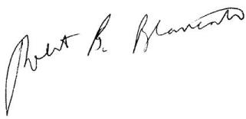
Sincerely,

Robert B. Blancato
National Coordinator

