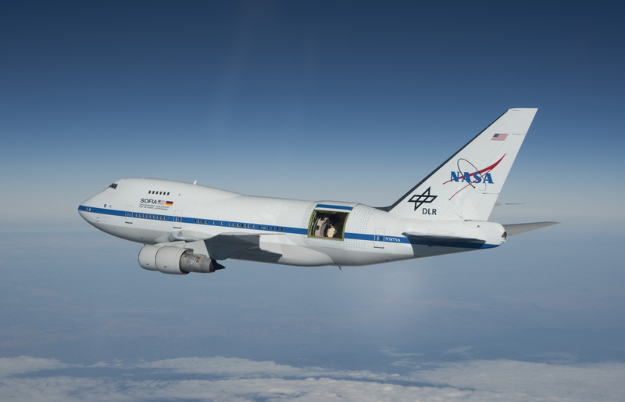
Airborne Astronomy
Ambassadors
The SETI Institute is seeking high school science teachers for participation in the NASA Science Mission Directorate Airborne Astronomy Ambassador (AAA) program providing content training, STEM immersion including a flight on the world’s largest flying observatory, and 3-dimensional lessons for the high school classroom
The Program:

NASA SMD Astronomy Airborne Ambassadors (AAAs)
The SETI Institute’s NASA Airborne Astronomy Ambassador Program will implement a new strategic approach to more effectively engage learners on NASA science education programs and activities.
The SETI Institute is responsible to NASA for conducting an education program that exploits the unique and inspirational attributes of the Stratospheric Observatory for Infrared Astronomy (SOFIA), improves science teaching, and impacts student standards-based classroom outcomes. The Institute will work in partnership with teachers, high schools, and school districts during the 2019 SOFIA research phase.

The extended experience for teachers includes a blended model of professional development: online training, an in-person workshop on 3-D curricular component, and an immersive flight week in California that includes an overnight flight aboard SOFIA.

Eligibility and Expectations:

Eligible teachers must:

- Be entering at least 3rd year of teaching
- Have at least one-year experience teaching high school level courses in a Physical Science, Earth/Space Science and/or Astronomy.
- Be teaching high school physics, astronomy, Earth Science, or integrated science in a district with an established AAA partnership (MOU) or willing to commit to a partnership.
- Have passion for bringing real world phenomena into the classroom.
- Complete short application online during application window (Applications for Cycle 6 open during late summer/fall 2018)
- Have eligibility vetted and approved for participation by sponsoring district and school. (post application)

Expected teacher participation/contributions/commitments:

- Successful completion of Professional Development in connection with AAA participation: blended model (8 in-person hours (workshop or intensive full-day), 2-hour or less per month average of tag-ups and/or webinars, and self-paced online training)
- Teacher Participants will travel to SOFIA’s base in Palmdale, Calif. for the flight week. Please note, this means leaving the classroom. During the week, the teachers will:
  - Fly on one or more overnight observing missions aboard SOFIA
  - Participate in pre- and post-flight trainings and meetings associated with the flight and the corresponding scientific research program.
- Implement a nominal 2-week SOFIA-based classroom curricular component (NGSS aligned; materials provided)
- Participate actively in the formative evaluation of the SMD AAA program.

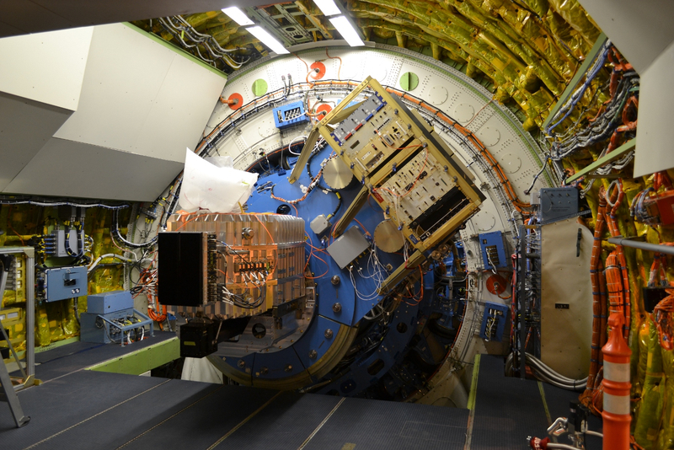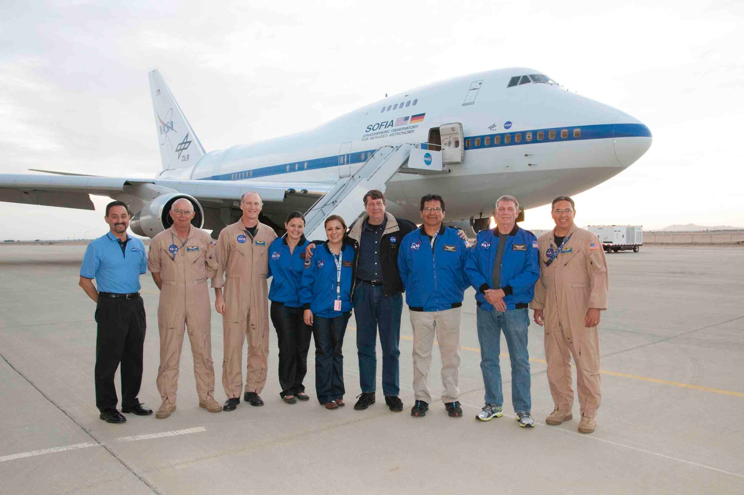

SOFIA AAA program commitment to educators & teacher benefits:

- Travel expenses, housing, and meals for required pre-flight meetings, flight, and required post-flight meetings costs paid by program.
- Flight facilitator/escort during flight week at NASA facility in Palmdale, CA.
- Flight week includes at least 1 overnight flight, NASA facility tours, and meetings with scientists & engineers
- Certifying letter with total professional development hours of AAA participation.
- Access to SOFIA Subject Matter Experts (scientists, engineers, and other professionals) for student questions, real world science guidance, and/or classroom presentations (virtual or in person).
- Materials and supplies needed to implement lessons will be delivered to the school site by the AAA program office.
- Optional induction to a national Public Engagement and Educator group for ongoing opportunities and educational support.

The Platform:
SOFIA (the Stratospheric Observatory for Infrared Astronomy)
SOFIA is the largest airborne observatory in the world, capable of making observations impossible for even the largest and highest ground-based telescopes. SOFIA is an extensively modified Boeing 747 carrying a 2.5 meter (100 inch) reflecting telescope. The plane includes a console dedicated for use by teachers in the program. SOFIA completed its Airborne Astronomy Ambassador program for educator professional development, providing PD and SOFIA flight experiences for over 105 U.S. Educators from 2011 through 2016. Evaluation confirmed the program’s impact both on the teacher participants and on their students and communities. The current phase of AAA partners with districts across the U.S.
For more information on NASA’s SOFIA Science and Operations:
- www.sofia.usra.edu (social media: @SOFIAtelescope)
For more information on the SETI Institute:
- www.seti.org (social media: @SETIInstitute)

Program information online:
https://www.seti.org/AAA

Apply online late summer/fall 2018

