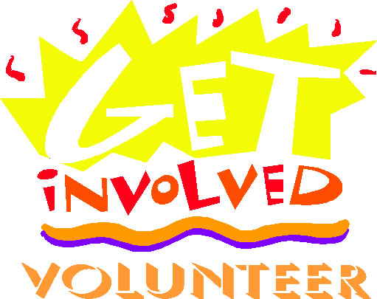
In celebration of the Feast of St. Timothy, the STS National Jr. Honor Society is challenging our fellow students to find a way to offer service to their family and neighbors. Our NJHS has come up with a list of 36 ideas, (these are only suggestions, you are only limited by your imagination!) Thirty-six ideas in honor of 36 years of STS!
- Make a card and send to your grandparents.
- Collect food in your neighborhood and donate to St. Vincent DePaul Food Pantry or another food pantry.
- Read a book to a younger sibling.
- Empty the dishwasher.
- Make muffins and deliver to your neighbors with a note. (Add a tea bag for good measure).
- Drop off some flowers to an elderly neighbor.
- Make a card for someone living in a nursing home (bring your card to the school front office).
- Make a card of encouragement for someone in prison (bring to the school front office).
- Play a game with younger siblings. (Joyfully)
- Help make a meal for someone who just had a baby or is recovering from surgery.
- Pick up trash in your neighborhood or around the STS grounds.
- Write a letter of appreciations to one of your teachers.
- Play your instrument or sing for someone (a neighbor, in a nursing home, or for your family).
- Write a letter to a favorite aunt or uncle.
- Make breakfast for your family.
- Make coffee for people who need it in the morning.
- Do a chore you don’t like without being asked.
- Say a prayer for someone.
- Help someone with their homework.
- Take out the trash.
- Help a teacher in the classroom.
- Visit a friend who is recovering from surgery.
- Help out at an animal shelter.
- Be a mother’s helper for a neighbor or friend without pay.
- Set the table.
- Make valentines for senior citizens.
- Donate kids craft kits or supplies to a local children’s hospital.
- Organize a board game night at your local nursing home.
- Have a garage sale for your favorite cause.
- Bring gently used board games or books to a homeless shelter.
- Write a letter to your elected official about a cause you believe in.
- Volunteer to read to nursing home patients.
- Donate stuffed animals to a firehouse or police station to give to children in emergencies.
- Go to Special Olympics event and cheer on the participants.
- Send a care package to deployed troops, veterans, or wounded soldiers.
- Stuff warm socks or gloves with snacks & toiletries and deliver to a homeless shelter

How did it feel? We want you to take a picture of what you did, and send it with a brief description to kschmank@sainttimothyschool.org.
Together we can help make a difference in the world around us.

