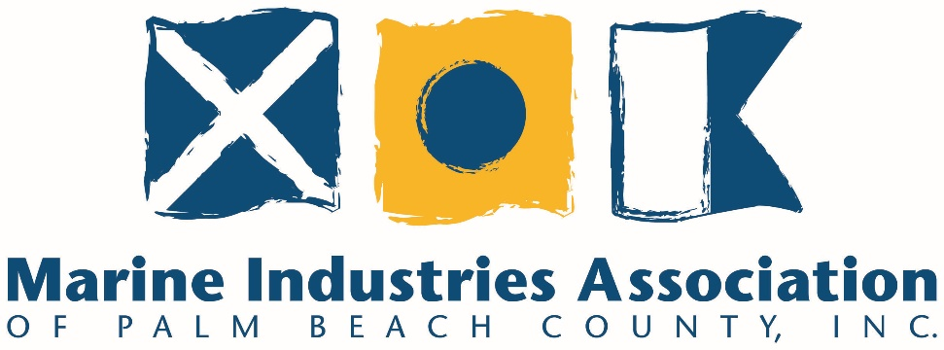

Annual Membership Awards

The MIAPBC will be recognizing members with 10, 20, and 30 years of membership.
MIAPBC will also award a Member of the Year.

MIAPBC MEMBER OF THE YEAR
Awarded to an association member who has been dedicated to the perpetuation of the highest
ideals, trust, and professionalism for the industry. If the award is given posthumously, the
recipient must have been a member prior to his or her demise.
JUDGING
The nominees will be reviewed and voted on by the MIAPBC Membership Committee.
CALL FOR NOMINATIONS
Please complete and return the nomination form below. Please write a few lines explaining why you feel this person deserves to be Member of the Year. Please cite specific achievements.

DEADLINE FOR NOMINATIONS: August 14

Nominee’s Name: _____________________________________________________________________

Nominee’s Company Name:_____________________________________________________________

Nominating Person and Company: ________________________________________________________

Nominating Person’s Telephone Number:___________________________________________________
Reason:_____________________________________________________________________________________________________________________________________________________________________________________________________________________________________________________________________________________________________________________________________________________________________________________________________________________________

10 Years of Membership

Eastern Marine Services, Inc.
D.S.L.I., Inc.
FCM Yacht Sales/ Florida Coast Marine, Inc.
Mariner Marine

20 Years of Membership

C & L Insurance, Inc.
Doctor Klear, Inc.
Florida Inland Navigation District
Loggerhead Marina
West Palm Beach Fishing Club

30 Years of Membership

