What’s YOUR Flow State?

When was the last time you were in your flow state or sweet spot in your business?
____________________________________________________________

Describe your experience in detail. (who, what, when, where, why, & how)
____________________________________________________________
____________________________________________________________
____________________________________________________________

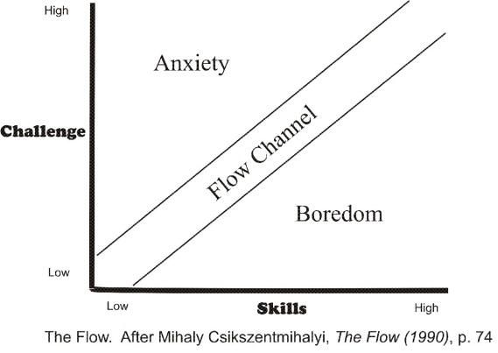

List Challenges
________________________ _________________ _________________
________________________ _________________ _________________
________________________ _________________ _________________
List Skills
________________________ _________________ _________________
________________________ _________________ _________________
________________________ _________________ _________________

Homework for the week:
Brainstorm ways to create more times in your business when you are in your flow state.

