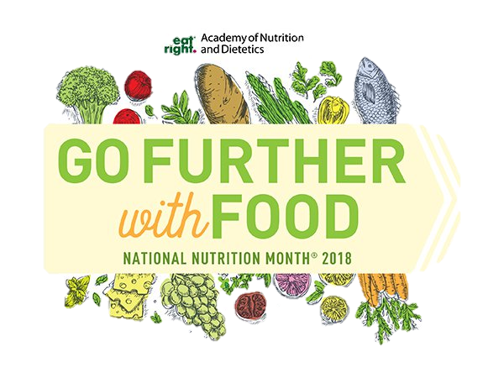

Join us for a WIC food demonstration and tasting!

**5:00 P.M. Wednesdays**

**11:00 A.M. Thursdays**

Location: **WIC** at **45 Kirk St**

In Honor of National Nutrition Month in **March** come on by WIC and see our Nutritionists creating meals on a budget



*For more information please call*  **978-454-6397**



***Building Communities, Changing Lives***

USDA is an Equal Opportunity Provider and Employer