**Break The Silence Sunday**

April 23, 2017

A time for the church to learn together

about the realities of rape and sexual violence;

about ways to create a community where survivors

can share their stories and receive support, hope, and love;

and to prayerfully consider ways in which they can be advocates

for change in their communities, and around the world.

**Resources for Worship**

**http://www.breakthesilencesunday.org**

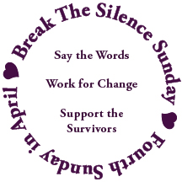

**Table Of Contents**

A Prayer to Begin 2

Introduction to The 2017 Break The Silence Sunday Materials 3

Acknowledgements 4

Notes for Worship Planners & Leaders 5

Sample Newsletter Article & Bulletin Announcement 7

Liturgy for Break The Silence Sunday 8

Liturgical Resources 21

Scripture Reflections From A Survivor 28

Sermon Suggestions 30

Talking With Children & Youth 32

Some Statistics & Helpful Definitions 34

Resources 37

Feedback Form 38

**A Prayer To Begin**

As you begin planning for Break The Silence Sunday you may feel many things, wondering if you can bring this word of hope to your congregation, and how they will respond when you do. You could be wondering what kind of stories will be shared with you, and if you will be able to hear them with your whole heart. You might be afraid of not knowing answers that you think are needed by those who come to you with questions about this day, with stories of their own, with fears and insecurities. Don't panic. This is a journey, and tentative first steps are still first steps. So sit in a comfortable place, take a few breaths, and then pray this prayer for yourself...

**A Prayer For Hesitant Clergy**

**by the Rev Don Niederfrank**

Divine Companion, you have encouraged and comforted me

at so many times,

in so many places,

with so many persons.

One more time, I ask, though afraid even in my asking,

be with me.

Strengthen my trembling knees,

that I may stand with those who have too often and too long stood alone.

Call to me in the tumult of my self-focused anxiety,

that I may bring your Presence, your Peace, to those whose terror is real.

Deliver me from my silencing fears

that I may speak your Word.

Holy Shepherd, I am yours. Send me to those you love.

**Introduction To The 2017 Break The Silence Sunday Materials**

When you start a new project you have high hopes, but they are often tempered by the reality of the world, the experience of past heartbreak, and the fear of getting overly excited about something which, while desperately important to you, may not be received the same way in other communities and contexts. So it was with Break The Silence Sunday last year. When the materials went out to churches I hoped that five, or perhaps six communities, including my own parish would participate.

To my great delight, and somewhat surprise, twenty-three communities dedicated an entire worship time to Break The Silence, and another twenty-eight communities had Break The Silence as part of another worship time, or a separate time for worship, study, and prayer. That means that in 2016 there were fifty-one congregations or communities participating in the work of breaking the silence, supporting survivors of rape and sexual assault, and working to change their communities.

I would love to see that number rise, to perhaps 75 this year, and 100 in 2018, but regardless of the number of communities participating I am grateful to every place where, in whatever way, the silence of sexual assault is being broken, the stigma shattered, voices and stories heard without judgement, and spaces where people can access the healing grace of God and community are created.

In these pages you will find:

* advice about newsletter articles and advance promotion of the event;
* new liturgy for 2017;
* scripture reflections & sermon resources;
* ideas about talking with about sexual violence with children and youth

On our website (<http://www.breakthesilencesunday.org)> you will also find the materials from 2016, and additional resources including a healing service.

As always, you are invited to adapt these materials, or simply use them as inspiration, to craft a worship or study opportunity that best fits the needs of your community. And we hope to receive feedback from you, about what you liked and didn’t like about these materials, what worked for you, what was a challenge, and what could be provided next year to help you better implement Break The Silence Sunday in your community. You’re welcome to email at any time to [breakthesilencesunday@gmail.com](mailto:breakthesilencesunday@gmail.com) or call me at 715-851-3080.

**Acknowledgements**

The work of Break The Silence Sunday would not be possible without those who contributed their words, their music, and their prayers. So many people have been a part of the years leading up to this project, who have patiently waited through the frustration, fears, anger, and silence.

* The Rev Franz Rigert for opening a door that has long felt firmly closed
* Lisa Hart for her support, and administrative resources
* The friends who have held my hand, offered tea, listened to my anger and frustration, and just plain loved me, I owe you more than you know ~ Richard & Trish Bruxvoort Colligan, Bryan Sirchio, Christopher & Carla Grundy, Andra Moran, Conie Borchardt, Ben Welch, Amy Englesdorfer, Brent & Sara Smith, Jody Clegg, Darryl Commings
* Bryan Sirchio for his amazing musical skills in setting my story to song; yes I know you say it’s my song, but it shall forever be ours in my mind
* The folks who have contributed to the liturgy…

Don Neiderfrank, Richard Bruxvoort Colligan, Bryan Sirchio,

Maren C Tirabassi, Holly Near, Christopher Grundy

* Students, faculty & staff at Eden Theological Seminary where I write so well in the reading room, fuelled by abundant coffee, and helpful interruptions
* The amazing folks of the Tri-Jo Parish United Church of Christ (Trinity UCC Shiocton, WI and St John’s UCC Cecil, WI) who have journeyed with me these years, trusting me with the privilege of being their pastor
* Hel Rowinski, for her editing skills
* Severin Provance, for his logo design
* My survivor sisters and brothers, particularly Patti Long, Jackie Gutschenritter, Darryl Commings, and Laurie Jacob who understand how hard this work is, and how incredibly important it is as well
* For all the survivors who are stronger than they imagine because they get up and face each day, I hope we have done well by your stories.
* For all of you reading this who shall faithfully plan and lead worship to help us break the silence; my gratitude for your courage.

In faith and hope, *Moira Finley*

**Notes For Worship Planners & Leaders**

There is no doubt that rape and sexual assault are difficult subjects. They are hard for our society to address, and no less difficult for the church.

There are survivors in every congregation, whether or not we know their stories. They are waiting for you to step up, to make it clear that your church, your community, is a place where they can tell their story without fear, that what they tell you will be heard, and honored, treated with respect, and dignity.

Preparation is essential. Of course you need to prepare yourself, and your worship team, but you need to prepare the congregation as well. Everyone needs to be made aware of what worship will be like on Break The Silence Sunday. They need to know that sometimes explicit words will be used, and that it will certainly be emotionally challenging. If there are survivors in your community that you are aware of, you need to make a special effort to reach out to them in advance, to personally let them know about the plans you are making for this day. Newsletter articles, and announcements in worship and bulletins, as well as on your social media can be helpful ways of preparing your community. On page 7 you will find a sample newsletter and bulletin announcement that you may adapt.

In the pages that follow, you will find a complete liturgy for Break The Silence Sunday. You are welcome to use the liturgy as it is, or adapt it for your particular setting, using the prayers, and hymn suggestions as a guide for your own community worship. There are also additional liturgical resources beginning on page 21.

There are many options for the sermon/reflection time during Break The Silence Sunday. There is also a page of sermon suggestions and ideas to get you started, and on our website you will find two survivor stories which you are free to use during worship (Moira’s Story and Jackie’s Story). There may be a survivor in your community who would share their story, or someone from a local support agency who could speak to the needs of survivors in your community. The website also contains a link to county-by-county resources agencies in Wisconsin who may well be able to help you as you plan your observance.

You may also find it helpful to work with survivors in your community to shape this service to best suit their needs. Survivors may well find it incredibly empowering, and healing, to be involved in the work of Break The Silence Sunday.

Every survivor’s story is different, and so every survivor’s healing journey is different as well. You need to go gently, taking care not to say there is one right way to do any of this. When we speak of healing it’s not necessarily physical, but the work of mending heart and soul, of making some sense of what has happened. Anything that involves the words should or must would best be avoided. Survivors have had enough of that already. What they need from you, and from their faith community, is a place to work at their own pace, to tell their story in their own way, to be heard with compassion, but not pity. Be careful when you speak of forgiveness. It is indeed a part of the life of faith, but it is not easy, and cannot be done quickly. Forgiveness may well be the work of this lifetime, and into life everlasting, but for a survivor to forgive their abuser is their work, and not something for the church, or its leaders, to set the schedule for.

Remember that every survivor is different. Some may not be at a place where it is safe, or healthy, for them to share their story, and they may have resistance to Break The Silence Sunday. Go gently.

Finally, there are resources at the end of this packet to help you respond to the needs of your community. There are national resources as well as a list of county by county resources for Wisconsin. If you aren’t familiar with them already, please get to know the people in your community who are on the front lines of helping survivors. And please, when a survivor shares their story with you don’t just refer them out to someone else. Offer to go with them, to reflect with them over a cup of coffee, to wrestle with their questions about God, and faith, and church. Be a part of their healing journey.

If you have questions as you prepare, please feel free to contact the Rev Moira Finley by email at [breakthesilencesunday@gmail.com](mailto:breakthesilencesunday@gmail.com) or by phone at 715-851-3080.

God’s blessings on your work.

**Sample Newsletter Article & Bulletin Announcement**

In the United States, every 107 seconds someone is sexually assaulted.

The survivors of these assaults are our friends, neighbors, colleagues, and members of our congregation. They need us to help them speak out, to create a place where they can share their stories without fear or judgment.

Join us for Break The Silence Sunday on April 23, 2017

In worship we will acknowledge the painful reality of rape and sexual violence. We will hear the stories of survivors, trusting in the good news of God’s love, and commit ourselves to being a listening people, and a people dedicated to changing the reality of violence in the world.

This service may be difficult and challenging.

Some parents may not want their young children to be present.

Please take time to prepare yourself . Ask God for the strength to open your heart and mind, that we shall support all the survivors who are part of our church, our community, and the world.

If you have questions or concerns about the service, or if you would like to help with worship leadership, please contact ___________________

**Liturgy For Break The Silence Sunday ~ April 23, 2017**

*Unless otherwise noted, prayers are written by the Rev Moira Finley.*

Musical Prelude

Welcome

*Welcome to worship. Today we stand with our sisters and brothers who have been victims of rape and sexual assault. We witness to their pain, and their strength; to their questions, and their faith; to what keeps them up at night, and what they need from us, as individuals and as communities of faith. Today we start to speak out, to break the silence of complicity and fear, and through it all trust in the good news of God’s incredible love for us, and for all the world.*

Call To Worship

One: We gather today, a community of hope,

Many: surrounded by the grace of God,

One: filled with the love of Jesus,

Many: trusting in the Spirit’s presence.

One: We gather today, a community of compassion,

Many: to listen to what may break our hearts,

One: to hear the pain of our sisters and brothers,

Many: to speak together words of comfort, and commitment.

One: We gather today, a community of justice

Many: to worship,

One: to pray,

All: to break the silence!

Gathering Prayer

*Inspired in part by a prayer by Howard Thurman,*

*the full text of which may be found in the Liturgical Resources section.*

Holy One, you breathed the world into being,

and in your love you created each of us,

a living embodiment of your image.

You weep with us when our hearts are broken,

and you carry our pain with us when it is too much to bear.

You know the stories our sisters and brothers hold

in their hearts, and their bones.

You know their fear, the shame and grief that lives in them,

because it has not been given voice.

Help us O God, that though we cannot truly know

the pain of those who have experienced sexual violence,

nor truly understand what they feel,

that we might offer the strength of our caring,

the warmth of our efforts to understand,

and the presence of our lives that their path,

as lonely as it may be, will never be walked alone. Amen.

Gathering Hymn ~ “Help Us Accept Each Other”, New Century Hymnal #388

Tune: Aurelia (“The Church’s One Foundation”)

Help us accept each other as Christ accepted us;

teach us as sister, brother, each person to embrace.

Be present, God, among us, and bring us to believe

we are ourselves accepted and meant to love and live.

Let your acceptance change us, so that we may be moved

in living situations to do the truth in love;

To practice your acceptance, until we know by heart

the table of forgiveness and laughter’s healing art.

God, for today’s encounters with all who are in need,

who hunger for acceptance, for righteousness and bread,

Bring us new eyes for seeing, new hands for holding on;

renew us with your Spirit; God! Free us, make us one!

Why We Have Come ~ Acknowledging The Reality Of Sexual Violence

*This prayer is not necessarily one for survivors to pray. It is, instead, for those who have had the privilege of living free from these experiences, perhaps with blinders on, unaware of the reality of rape and sexual violence in our communities, and around the world. During this prayer you might consider lighting candles (or inviting survivors to do so) to symbolize the experience of all those who live this reality in their daily lives.*

One: We have come

Many: to listen, and to hear things that will unsettle us, and make us uncomfortable, challenging things we think about the world.

One: We have come

Many: to hear the guilt, fear, and shame that survivors carry, the stories of those who have survived things we cannot begin to imagine.

One: We have come

Many: to listen to what keeps our sisters and brothers up at night, to listen with compassion, and love.

One: We have come

Many: to be present for survivors, doing our own spiritual work, so that we might listen without judgement or pity.

One: We have come

Many: to hear the memories, and nightmares, and flashbacks; the violation, cruelty, and suffering.

One: We have come

Many: to remember that not everyone survives the violation of rape and sexual assault, and that the grief and pain overwhelm many who seek to escape through self-harm, and suicide.

One: We have come

Many: to commit ourselves to the messy, difficult, sometimes excruciating work of changing the world, to the work that Christ showed us, the work of making the world whole.

One: We have come

Many: to remember that taking small, uncertain steps is an okay way to begin, that we do not have to do everything, but that we must do something, that we must listen, and then raise our voices for our sisters and brothers are depending on us.

All: Amen.

Hymn ~ “We Have Come”

by Christopher Grundy, © Hand and Soil Music, 2009; used with permission

(this is intended to be sung acapella)

/Users/brentsmith/Downloads/wehavecomeleadsheet.pdf

Breaking The Silence ~ A Time For Prayer

*Silence in worship can be powerful, a time for people to listen to the voice of their heart and soul. However, this is Break The Silence Sunday, a time no longer keep silence. This time of prayer seeks to provide some silence, acknowledging the reality of rape and sexual assault, but also breaking the silence of our complicity. In the United States someone is sexually assaulted an average of every 107 seconds. Using that amount of time as its basis each silence will be progressively shorter to show the urgency of speaking out. While this prayer uses statistics for the U.S., the problem is not unique to our country, and so we stand with our sisters and brothers around the world who live in the shadow of rape, and sexual violence.*

One: Once, in every one hundred and seven seconds…

*a silence of 107 seconds is held, then a bell is chimed*

One: Once, in every one hundred and seven seconds someone in the United States is sexually assaulted, and the church has been deafeningly silent.

*a silence of 80 seconds is held, then a bell is chimed*

One: Survivors have been shamed into silence, afraid to speak the truth of their experiences. When they have dared, they have been met with pity, contempt, hurtful and dangerous theologies, and victim blaming.

*a silence of 53 seconds is held, then a bell is chimed*

One: The time for our silence as the church is over. Rev Dr Martin Luther King, Jr once said, “In the end we will remember, not the words of our enemies, but the silence of our friends.”[1] It is time for us, the body of Christ broken by rape and sexual assault, to be outspoken about this violence. It is time for us to open our hearts, our minds, and our churches to the stories of survivors, to share with them the hope of God’s grace that is with us in our moments of deepest despair, and can in time bring hope.

*a silence of 26 seconds is held, then a bell is chimed*

One: Now! Now is the time for us to break our silence!

*a bell is chimed*

Sung Response ~ “I Am Welcome” by Bryan Sirchio, used with permission

(please see Liturgical Resources section for accompaniment)

/Users/brentsmith/Downloads/I Am Welcome.pdf

Invitation To Confession

*We have, as the church and as its individual members, been silent when the lives of those who we know have been shattered by sexual violence. We have shied away from those who would share their stories, afraid of what we might hear, of what it might mean for us, and for our lives. We have been quick to ask questions – what were you doing, what were you wearing, why didn’t you fight back – placing blame on survivors instead of where it belongs, with the perpetrators. Together, trusting in God’s grace, let us confess our responsibility in creating and perpetuating a culture of silence.*

Responsive Prayer Of Confession

Today we have come to listen, and to take responsibility. We have come to confess what we have done, and failed to do, that has allowed sexual violence to continue and has caused survivors to feel that they cannot share their stories with us.

We confess that sexual violence is real and present in our communities, in our church, in our families, and around the world. We confess that we are afraid, that we would prefer to believe the statistics are wrong. We pretend that this kind of violence, and violation can’t happen to us, or to someone we love. We pretend that we don’t know any survivors, that no one in our family, none of our friends, and surely no member of our church could possibly have endured what we cannot face.

We confess that the church has often silenced survivors with bad theology, holding up sacrifice and suffering as ideals of faithful living, and shaming survivors with our assumption that rape and abuse are about sex, rather than acts of violence and control.

We confess that we feel powerless, that we do not know how to help. We confess that our fear of what we might hear, of what survivors might tell us, is paralyzing. We confess that it feels like anything we might do is too small to matter, that the reality of rape and sexual assault seems overwhelming.

And yet we confess that we know we must do something, that our sisters and brothers are depending on us to listen, to hear them, to honor their questions and their struggles, to speak out, and to work for change. We pray for the grace to be present, with open hearts and minds, that the wounds might begin to be healed, and that the world might begin to be changed.

In hope we pray, Amen.

Assurance Of God’s Grace

Holy One, you know who we are, and who we might yet become. You know where we have not done the work of listening, of supporting, and of working on behalf of those who have suffered violence. We trust in your forgiveness, in another chance to be good companions on the journey with those who have experienced the trauma of rape and sexual violence. We give thanks for your grace and love that will not leave us where we are, but that guides us as we work with you, and with one another, to rebuild the world. Thanks be to God.

Scripture Readings

Isaiah 43.1-7 God’s promise to name and claim each of us

Psalm 121 Trusting in God’s presence on our journey of life

Luke 8.42b-48 Jesus heals a woman with a flow of blood

Sermon/Reflection/Stories from Survivors

Sung Response ~ “God Who Remembers” by Richard Bruxvoort Colligan,

used with permission

(please see the Liturgical Resources section for accompaniment)

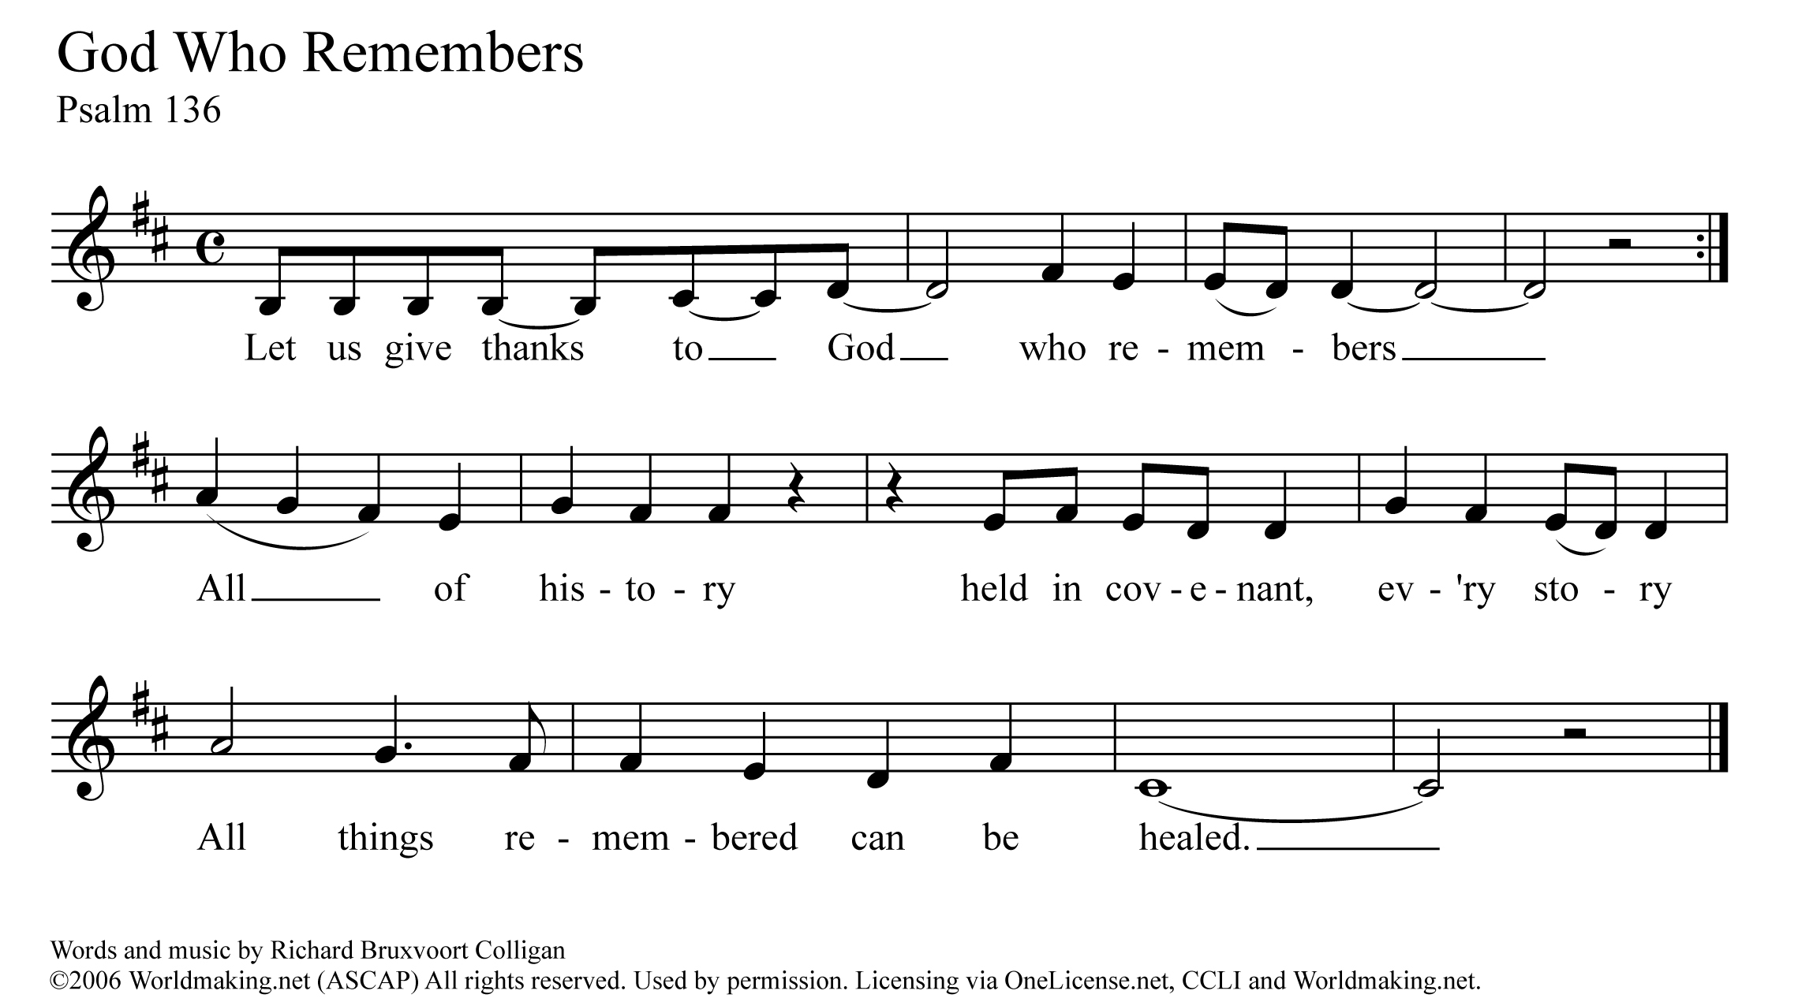

A Time Of Prayer

Holy One, you filled the world with your love, and your spirit, breathing into each of us the breath of life. You named each of us, and claimed each of us as your own. But some of your beloved children have been hurt, deep in their souls. They have experienced great violation through rape, abuse, incest, and assault. They come, asking to be heard. They come, asking us to stand with them and work for justice. They come, needing to be healed by your unending love. We pray for that healing this day, O God. We pray for your love and grace to be poured out abundantly on all those who have been hurt by rape and sexual assault – the survivors, and all those that love them. May your healing presence guide each of them in their path towards wholeness, and hope. And may your courageous spirit fill the rest of us this day. Give us the strength to speak out, to be bold, to trust in you. Give us the words we need to comfort those who struggle, and the commitment we need to work tirelessly for the wholeness of all your people. These, and all our prayers, we pray with the words that Jesus taught his first disciples saying together…

The Prayer Jesus Taught

Our Father, who art in heaven, hallowed be thy name, thy kingdom come, thy will be done, on earth as it is in heaven. Give us this day our daily bread, and forgive us our trespasses as we forgive those who trespass against us. Lead us not into temptation, but deliver us from evil. For thine is the kingdom, and the power, and the glory forever and ever. Amen.

Offering Our Gifts

*You might consider designating the morning offering, or a portion of it, to the local sexual violence resource center in your area, or to a national organization such as RAINN (Rape Abuse Incest National Network).*

Prayer Of Dedication

Generous God, we are grateful for all that you have given to us. We bring you these gifts, signs and symbols of our gratitude. We entrust them to you in the faithful hope that the work Christ began – the work of listening to the stories of God’s people, of healing the brokenness of the world, and of restoring creation – might continue in us and through us. Grant us the courage, and the blessing, to listen, to pray, and to speak out. In faith we pray, Amen.

/Users/brentsmith/Downloads/We Need to Tell the Stories - Full Score.pdfHymn ~ “I Love To Tell The Story Re-sung For Break The Silence Sunday”

Celebrating Communion

One: This table is not ours, but it belongs to God. All who seek to be fed and nourished by God’s grace, and sustained by this community are welcome to share at this table. We come, from the shadows of a waiting, hurting world, knowing that, wherever we have been, whatever we have experienced, we will be fed and renewed. We reach for the cup of God’s love, aware of an unquenchable thirst in the depths of who we are, a thirst for justice and hope. We come, trusting that God will meet us here. Let us pray together…

All: Holy One, we come to share the richness of table. We ask for your healing grace to be poured out on all those who have suffered sexual violence. Renew and restore them, and your church. Be present with us, and remind us that your presence is with us always. Give us the courage to truly be the Body of Christ.

One: Gracious God, in Jesus you have given us the greatest gift. We come to this table to know you, to remember your love, and to confess that your grace is for all. Some of us come to this table tired and anxious. Some of us come with hope in our hearts. All of us come, trusting in your Spirit’s presence, and trusting in the promise that we might all be One, whole and healthy, as your people. Let us pray together…

All: We thank you God for giving yourself to us in Jesus Christ. We thank you that he lived among us, and knew what it was like to be human. Feed us at this table, and give us the courage to be faithful to the One who dared to come into our world. Renew and revive us. Give us the courage to listen, and to speak out for our sisters and brothers, today and always. Amen.

One: We know the stories about Jesus’ life, how he would come to share many meals with his disciples and friends. He would welcome those who had been cast to the margins of society, eating with sinners and prostitutes, with the sick and the lame, with the wealthy and the poor alike. On one of those occasions, as his earthly life was nearing an end, he found himself with his disciples and those who had followed him closely in an upper room in Jerusalem. They were there to share the story of hope, of release from captivity, of God’s promise of freedom. During the meal he would take the bread, bless it, break it, and offer it to them saying, “this is my body which is given for you.” Later, after supper, he would take the cup, give thanks, and say, “this cup is a reminder for us of the new relationship God has made possible between us, and all of creation.”

The bread we share is a reminder for us that just as God blessed Jesus with an earthly body, so our earthly bodies are blessed. The cup we share is a reminder for us of Jesus’ life, and the grace of God that Jesus came to help us know. We pray that God would bless this bread, and this cup, and us as we receive them. We bring all our lives to God at this table, that we might be one people, united as the Body of Christ, working together for justice and peace. The gifts of God for the people of God. Come for all things are now ready. Come and see how good God is.

Sharing The Elements

Unison Prayer Of Thanksgiving

We give you thanks, Gracious God, that you come to us in bread and cup, and in the love of this community. Send us from this table, nourished and empowered. Help us listen with all our hearts, and speak with all our minds, that all your people might truly know peace.

Committing Ourselves To Change

One: In the presence of one another, we pledge ourselves to ending the violence of rape and sexual assault, working towards a vision of a healed community where all can live in dignity and peace.

One: We acknowledge the reality of rape and sexual violence, a plague that brings hopelessness and fear to our sisters and brothers.

Many: We stand in solidarity with those who have been victims. We promise to be open to their stories, and with the grace of God, to listen without judgment.

One: We know the promise of wholeness, and hope that Jesus came to bring to the world.

Many: We affirm the promise of God’s love for all the survivors in our world, those whose stories are known to us, and those whose stories are still shrouded in silence and fear.

One: We know that we have not done enough, that we have been silent when those around us have been struggling.

Many: We look forward with hope, trusting in God’s ability to give us strength to listen with courage, and to be silent no longer.

One: We believe that the future depends on us.

Many: We believe that there is something we can, and must do, as people of the Good News, and as members of one human family, to end the violence of rape and sexual assault.

One: We recognize that we cannot do this alone. We know we must learn to depend on each other, and on God, in the struggle to end sexual violence, and create justice.

All: Gracious God, help us to be aware of your loving disruption of our lives. Give us the courage to work with you, and with each other, to transform our hurting world. Empower us with your Spirit that we might break the silence of sexual violence. Help us listen and move together from fear and pain towards your realm of peace and justice. In Jesus’ name we pray, Amen.

Hymn ~ “We Are A Gentle, Angry People” by Holly Near, used with permission

from “Singing The Living Tradition” © 1993, Unitarian Universalist Association of Congregations

(please see the Liturgical Resources section for accompaniment)

We are a gentle, angry people, and we are singing, singing for our lives.

We are a gentle, angry people, and we are singing, singing for our lives.

We are a justice seeking people, and we are singing, singing for our lives.

We are a justice seeking people, and we are singing, singing for our lives.

We are young and old together, and we are singing, singing for our lives.

We are young and old together, and we are singing, singing for our lives.

We are a gentle, loving people, and we are singing, singing for our lives.

We are a gentle, loving people, and we are singing, singing for our lives.

Benediction & Musical Postlude

**Liturgical Resources**

The full text of the poem that inspired the gathering prayer may be found here, and in the Chalice Hymnal #508

“For One Who Suffers”

*Howard Thurman, 20th century African-American church leader*

I know I cannot enter all you feel

Nor bear with you the burden of your pain

I can but offer what my love does give –

The strength of caring

The warmth of one who seeks to understand

This I do in quiet ways –

That on your lonely path you may not walk alone.

**Notes On Music From The Liturgy**

“Help Us Accept Each Other”

from the New Century Hymnal (#388) and is sung to the familiar tune Aurelia (“The Church’s One Foundation”)

“We Have Come”

is intended to be sung acapella. You can listen to a recording at <http://www.christophergrundy.com/recordings/>

The song is on the album “Stepping In”, track number four.

“I Love To Tell The Story Re-sung For Break The Silence Sunday”

We are deeply grateful to Maren Tirabassi for her re-wording of this familiar hymn, and to Amy Englesdorfer for her transcription. “I Love To Tell The Story” is often sung to “Hankey” (in the New Century Hymnal #522), but here it is set to “Fischer”. Either setting will work.

“I Am Welcome”

Used with grateful permission of Bryan Sirchio; you may hear a recording at

<http://sirchio.com/cds/01--worship/01--CDs/937>

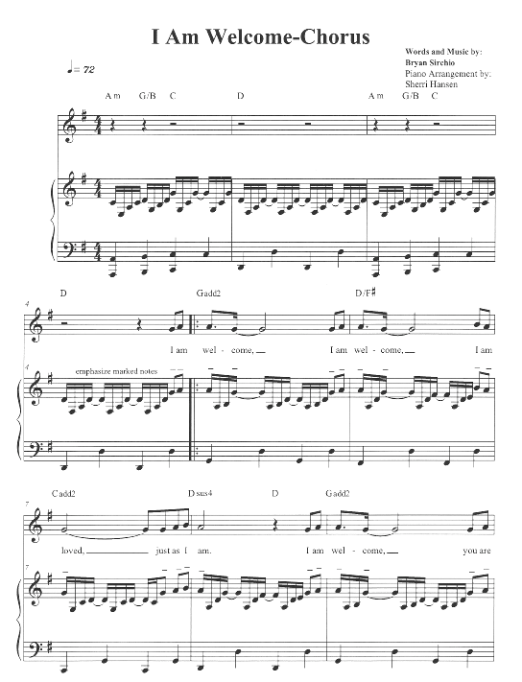

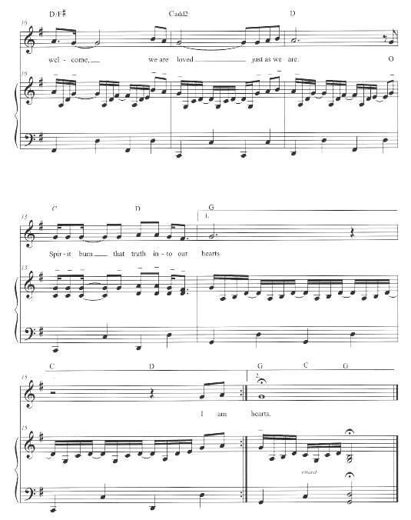

“God Who Remembers”

Used with grateful permission of Richard Bruxvoort Colligan

You may hear a recording at <http://www.psalmimmersion.com/psalm-136>



“We Are A Gentle Angry People”

Used with grateful permission from Holly Near.

These images are from the “Singing The Living Tradition”

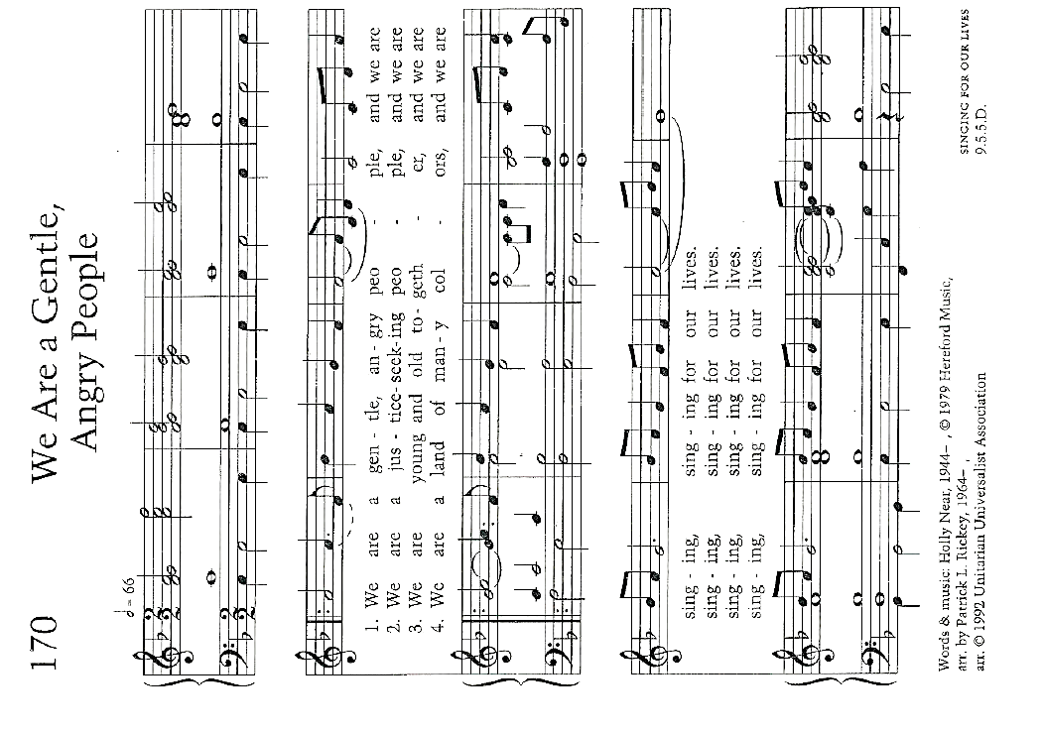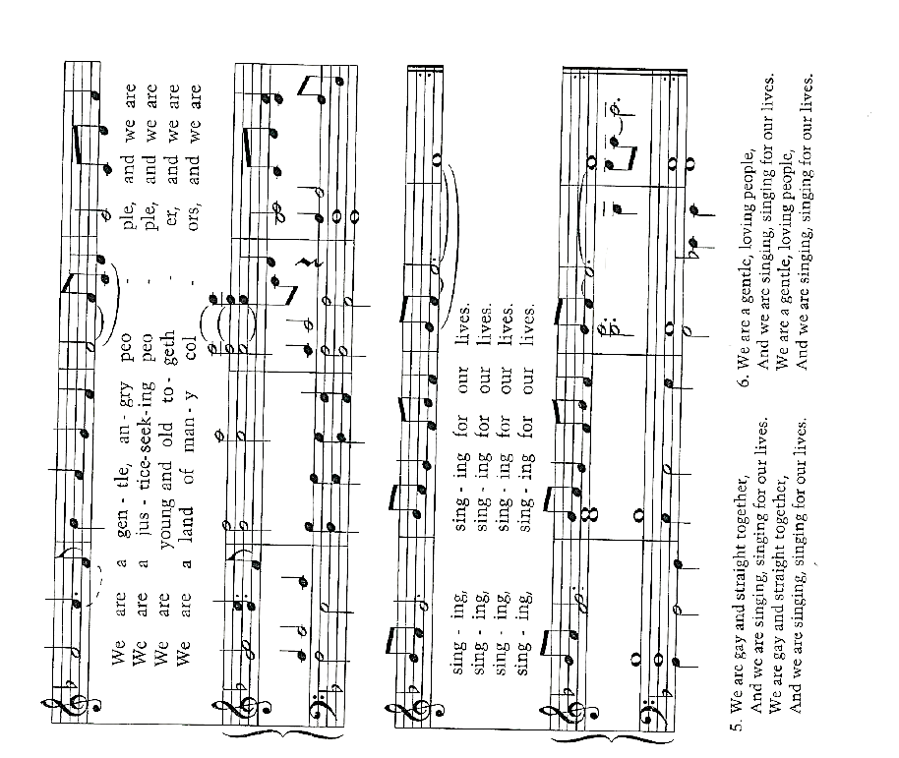

In addition to the song suggestions in the liturgy, you might consider other hymns with themes of healing, and justice. These are some suggestions from the New Century Hymnal (NCH):

“I Was There To Hear Your Borning Cry” (NCH #351)

“How Firm A Foundation” (NCH #407)

“My Life Flows On In Endless Song” (NCH #476)

“Amazing Grace” (NCH #547)

“Out Of The Depths, O God, We Call” (NCH #554)

“Lead Us From Death To Life” (NCH #581) – particularly the chorus

“Let Justice Flow Like Streams” (NCH #588)

Additional music you might consider for choir, band, teaching the congregation, or simply for listening:

“God Is Our Refuge And Strength” by Andra Moran

<https://www.etsy.com/shop/AMMOMusic>

“Light Of Heaven” by Andra Moran

<http://www.andramoran.com/track/8132/light-of-heaven?feature_id=59929>

“Here In This Place” by Christopher Grundy

<http://sites.fastspring.com/christophergrundy/product/catalog>

“From My Hands” by Christopher Grundy (particularly the second verse)

<http://www.christophergrundy.com/recordings/>

On the CD “In This Life”

“Welcome To This Circle” by The River’s Voice

<http://www.riversvoice.com/shop.php>

“God Is Holding Your Life (Psalm 121)” by Richard Bruxvoort Colligan

http://www.psalmimmersion.com/psalm-121

“Move (Psalm 109)” by Richard Bruxvoort Colligan

<http://www.psalmimmersion.com/#!move/cd4h>

“Stand With You” by Bryan Sirchio

<http://sirchio.com/songs/f/c/196>

**Scripture Reflections From A Survivor ~ the Rev Moira Finley**

Isaiah 43.1-7

One of the things many survivors struggle with is feeling as if what happened to them has damaged the core of who they are, that the violation of rape and sexual abuse has made them damaged goods, unclean in the eyes of the world, and unworthy in God’s eyes. This passage from Isaiah offers an antidote to those ideas, a reminder that each of us has been named, and claimed by God, that whatever challenges might come in life we are secure in God’s care for us, a God who will be with us always. In addition, many (most) survivors ask where God was when they were in the midst of their trauma, and where God is now that they are trying to heal. Without dismissing the pain, this passage reminds us that God is with us when the rivers overflow, and when the fires feel as if they will consume us. God is with us in the midst of the suffering, continuing to claim us as God’s very own, and perhaps in that there is hope, a realization that God stands with us, weeps with us, and holds us in the darkest moments of our lives.

Psalm 121

This is the traveler’s song, perhaps meant for those who were making the pilgrimage to Jerusalem for the celebration of Passover or another festival. It is a fitting psalm for survivors because the work of healing is a journey, the journey of an entire lifetime. Healing from rape and sexual violence is not something that can be accomplished by checking off a series of steps and then leaving it all behind. Instead, it is a journey full of U-turns, and pitfalls, moments of great clarity, and moments when it feels like all the work has been for nothing and that you’re back where you started. In those moments, the psalmist reminds us that God will never tire of walking with us, will be with us in the heat of the day and in the depths of the night keeping our lives through whatever challenges may come. Much like the passage from Isaiah, this psalm is a reminder that God is with us in the muck, in the middle of the challenges, carrying us through when we feel as if we can no longer carry ourselves. How might the church model this kind of journeying together in supporting survivors?

Luke 8.42b-48

This passage makes people uncomfortable because it describes so clearly the struggle of the woman in need of Jesus’ healing. It feels intimate to know that this woman has been suffering from hemorrhages for twelve years, visiting doctor after doctor none of whom are able to help her, draining her purse, but offering her no relief. The valuable part of this passage to me as a survivor is verse 47 (from the NRSV):

*When the woman saw that she could not remain hidden, she came trembling; and falling down before him, she declared in the presence of all the people why she had touched him, and how she had been immediately healed.*

She tells her story, in front of the entire gathered crowd, and in that telling she finds strength. A story we cannot tell eats at us. A story we cannot tell is a burden that will we eventually find too great to bear. But when we are able to tell our story, to have it heard, and honored, and respected then we find our strength, our healing, and the ability to go on. The church can do what the community did for this woman – they can listen, they can hear the story of the struggle, of the pain we carry, and how having someone else to help carry our story will make all the difference.

**Sermon Suggestions**

You need to carefully consider what your community needs during the sermon time on Break The Silence Sunday. Are you part of a community that is already familiar with the issues of rape and sexual violence? Is yours a community where these are new, and frightening topics? Does your community frequently engage in justice work in the world beyond the church doors? Are you aware of survivors in your pews, some who have shared their stories with you?

You could choose to use one of the survivor stories included in these materials. You could invite someone from a local resource organization to speak about their services to your community. And, of course, you can craft your own sermon.

If you choose to write your own sermon, you need to go carefully. The work of Break The Silence Sunday is to support survivors in their journey of healing. Don’t preach about any shoulds. Don’t tell survivors that they should forgive those who have hurt them, or should share their stories, or should behave in any particular way. This is not the moment to glorify the cross, so please don’t preach about the redemptive suffering of Jesus.

This is a time to speak about healing and wholeness, and the hope that Christ’s community can provide. This is a time to talk about justice – a justice for individual survivors (perhaps through the criminal justice system, but surely through having their voice heard and their stories honored in the church); and justice for all creation as we work to change the culture that allows this violence to continue.

There are scripture suggestions in the included liturgy. Isaiah 43.1-7 speaks of God’s claiming and naming each of us, walking with us through the struggles and fear of our lives; Psalm 130 is a prayer of trust that God will always be with us; and Luke 8.42b-48 tells the story of a woman with an issue of blood who is healed by Jesus’ touch, the important portion of this scripture being the freedom she feels to tell her story to the gathered community.

These scriptures all point toward a God of hope, of companionship, and of justice. There are other scriptures that you could use to speak of God’s support for those who are suffering, those who have been victims of injustice and violence, and those who have been silenced. You might also consider some of the other healing stories in the New Testament, but remember that healing is not necessarily physical, but an ability to fully participate in the life and work of the community, the chance for someone to be remembered, honored, and respected.

If your community is already engaged in the difficult work of justice on behalf of survivors, you might consider the story in Judges 19. It is a difficult scripture, and you will want to do considerable exegetical work, as well as much faithful preparation of your community so they are ready to hear, and receive the text.

You are invited to consider the final lines of Judges 19, whether you use that scripture in worship or not. Verse 20 reads (from the NRSV, emphasis added):

Then he commanded the men he sent, saying, “Thus shall you say to all the Israelites, ‘Has such a thing ever happened since the day that the Israelites came up from the land of Egypt until this day? ***Consider it, take counsel, and speak out.***’”

That is the work of Break The Silence Sunday, and your work in preaching and leading worship …

* Consider it - recognize the problem, admit that rape and sexual violence are real, hurting members of your community, and society as a whole
* Take Counsel – learn about rape and sexual violence, listen to the stories of survivors without judgment, walk with them through the struggles, support and encourage them as they journey towards healing and hope
* Speak Out – say something, often, be a voice for justice, for changing our communities, for creating places of peace and safety for all

**Talking With Children & Youth**

It’s a scary thought, that we need to talk to our children and youth about rape and sexual assault, but the reality of the world we live in means we need to prepare them to be aware of their bodies, how to set boundaries, and that, should something happen, they will be safe in telling about it.

Everything needs to be age appropriate, using words and ideas that each child can understand. The conversations should start early, when children are young, giving children the words to describe their bodies accurately, talking about what is and isn’t appropriate touch, and how to speak up when something feels wrong. Help young children understand that some body parts are private, that it’s ok to say no, and that they won’t be in trouble if they tell you something.

As children grow into their teen years the conversation needs to change. Sexual assault needs to be addressed directly. Continue conversations about consent, about the right everyone has to say no concerning their body; about staying aware about what is happening at parties, and when they’re out with their friends; and help them understand that most people who are sexually assaulted are the victims of someone they know, that perpetrators don’t look like the bad guy in the dark alley sometimes portrayed in the media, but in reality 93% of victims who are minors know their perpetrator. Help teens understand that violence has no place in a loving relationship.

Keep in mind that clergy in the state of Wisconsin are mandatory reporters of child abuse (sexual or otherwise). Information about the mandatory reporting requirements, and what they mean for the clergy, can be found via the Wisconsin Child Welfare Professional Development System at: <http://wcwpds.wisc.edu/mandatedreporter/requirements.html>

These links may also be helpful in gathering information to talk to children and youth about rape, sexual abuse, and sexual violence:

Talking To Your Kids About Sexual Assault ~ RAINN

<https://www.rainn.org/articles/talking-your-kids-about-sexual-assault>

Tip Sheet For Talking To Children and Teens ~ Stop It Now

<http://www.stopitnow.org/ohc-content/tip-sheet-8>

Start Talking (to engage teens about dating violence) ~ Love Is Respect

<http://www.loveisrespect.org/resources/start-talking/>

Talking To Your Children ~ US Department of Justice National Sex Offender Public Website

[https://www.nsopw.gov/en-US/Education/TalkingChild?AspxAutoDetectCookieSupport=1 - top](https://www.nsopw.gov/en-US/Education/TalkingChild?AspxAutoDetectCookieSupport=1#top)

**Some Statistics**

* There are an average of 293,066 victims (age 12 or older) of rape and sexual assault each year in the United States (source – U.S. Department of Justice. *National Crime Victimization Survey*. 2009-2013)
* Let’s do some math: there are 31,536,000 seconds per year (in a non-leap year). If we divide the number of victims (293,066) by the number of seconds it means that there is an average of one assault every 107 seconds.
* 17.7 million women in the United States (1 out of every 6) have been the victim of an attempted or completed rape in their lifetime (source – National Institute of Justice & Centers for Disease Control & Prevention. *Prevalence, Incidence, and Consequences of Violence Against Women Survey*. 1998)
* 2.78 million men in the United States (1 out of every 33) have been the victim of attempted or completed rape in their lifetime (source – National Institute of Justice & Centers for Disease Control & Prevention. *Prevalence, Incidence, and Consequences of Violence Against Women Survey*. 1998)
* 15% of sexual assault and rape victims are under the age of 12 (source – U.S. Bureau of Justice Statistics, *Sex Offenses and Offenders*. 1997)
* The year in a man’s life when he is most likely to be the victim of a sexual assault is age 4. The year in a woman’s life is age 14. (Source – U.S. Bureau of Justice Statistics. *2000 Sexual Assault Of Young Children As Reported To Law Enforcement*. 2000)
* 93% of juvenile sexual assault victims know their attacker (Source – U.S. Bureau of Justice Statistics. *2000 Sexual Assault Of Young Children As Reported To Law Enforcement*. 2000)

**Some Helpful Definitions**

Acquaintance Rape/Assault – where the perpetrator(s) is previously known to the victim; occurs in approximately 4 out of every 5 rapes/assaults in the United States; acquaintance may refer to a date (hence “date rape”), domestic partner, former partner, family member, classmate, neighbor, boss, coworker, and more.

Attempted Rape/Assault – a threat or rape or sexual assault, including verbal threats, and those made in other ways such as electronic communication (email, text), and on social media (Facebook, Tumbler, Twitter)

Domestic Violence – violence, and threats of violence, between spouses, domestic partners, and those who are co-habitating.

Force – methods used to coerce a victim into a non-consensual sex; this may include the use of a weapon, or physical violence, but also includes emotional and psychological manipulation, threats to the victim’s family, the withholding of finances, intimidation, threats regarding employment or child custody, and more.

Incest – sexual contact (which may or may not include penetration) between closely related persons such as parents, children, grandparents, aunts, uncles, siblings, cousins; in legal terms incest is often described as the crime of sexual contact between people who may not be legally married

Post Traumatic Stress Disorder (PTSD) – a condition resulting from the experiencing (or witnessing) of a traumatic event that causes long-term difficulty with flashbacks, intrusive memories, and severe anxiety; not all rape survivors will develop PTSD

Rape – a form of sexual assault; the U.S. Bureau of Justice Statistics defines rape as forced sexual intercourse which is defined as “vaginal, anal, or oral penetration by the offender(s)”; this also includes incidents where the penetration is by an object such as a bottle; legal definitions vary by state, and some states do not use this term at all in their laws instead they have degrees/grades of sexual assault.

Rape Culture – the way in which society blames victims of rape and sexual assault, and normalizes this violence, particularly male against female violence; the assumption that rape and sexual assault are an inevitable part of life; this includes the use of the word rape in other contexts (for example, when a sports team is defeated and commentators say “they were raped”), as well as the objectification of women’s bodies including school dress codes and purity movements that seek to control and limit women’s behaviors

Sexual Assault – sexual contact or behavior that occurs without explicit consent of the victim; this includes, but is not limited to: penetration of the victim’s body (see rape), attempted rape, forcing a victim to perform sexual acts on the perpetrator, fondling, unwanted sexual touching.

Stranger Rape/Assault – where the perpetrator(s) is previously unknown to the victim; occurs in approximately 1 of every 5 rapes/assaults in the United States.

Survivor Guilt – though most often associated with being a survivor after a mass catastrophe (such as an airplane crash), this phrase has also come to mean the guilt imposed on survivors of rape and sexual assault because of some perceived action, or inaction on their part

Victim Blaming – words and actions that imply the victim of rape or sexual assault is to blame for the actions of the perpetrator(s); this can be through questions about what the victim was wearing, why they were out alone, why they didn’t fight back, if they had been drinking or had previous sexual relations with the perpetrator, and questions about the previous sexual activity of the victim

**Resources**

**General Information About Rape & Sexual Assault**

* Rape Abuse Incest National Network (RAINN) – includes links to their online and telephone counseling services, <http://www.rainn.org>
* National Sexual Violence Resource Center, <http://www.nsvrc.org>
* Joyful Heart Foundation, <http://www.joyfulheartfoundation.org>
* No More (a national campaign to end sexual and domestic violence), <http://nomore.org>
* “What’s Their Problem? Sharing Our Pews With Sexual Abuse Victims and Survivors”, from *Christ And Pop Culture,*  <http://christandpopculture.com/whats-problem-sharing-pews-sexual-abuse-victims-survivors/>

**Resources on PTSD**

* From the Department of Veteran’s Affairs: <http://www.ptsd.va.gov/public/PTSD-overview/basics/index.asp>
* From the Rape Abuse Incest National Network (specific to rape victims): <https://rainn.org/effects-of-sexual-assault/post-traumatic-stress-disorder>

**State of Wisconsin Resources**

* Wisconsin Coalition Against Sexual Assault

Telephone: 608-257-1516; <http://www.wcasa.org>

Offers information and referral on any issue related to sexual violence; does not offer direct services to victims/survivors, but will connect them to local agencies

* County by County resources – please visit our website <http://www.breakthesilencesunday.org> and the Resources tab to find a chart which will identify sexual assault resource organizations in each Wisconsin county

**Feedback Form ~ Break The Silence Sunday 2017**

Please return to: BTSS c/o Moira Finley

PO Box 691

Bonduel, WI 54017

You may also submit this information by email at [breakthesilencesunday@gmail.com](mailto:breakthesilencesunday@gmail.com)

Your name:________________________________________________________

Your position (pastor/worship leader/other):______________________________

Your community/church:_____________________________________________

**Did you use the Break The Silence Sunday Liturgy?**

* Yes, as it was provided
* Yes, but we adapted it; please list how you adapted it:
* We used parts of it, but not the entire liturgy; please list the parts used:
* No, we wrote our own liturgy; if you are willing to share the liturgy you used, please email it to [breakthesilencesunday@gmail.com](mailto:breakthesilencesunday@gmail.com) or post to the above address

Please continue to the other side --->

**What did you use during the sermon time?**

* A survivor in our community shared their story (if possible, please connect them with us by emailing contact information to [breakthesilencesunday@gmail.com)](mailto:breakthesilencesunday@gmail.com))
* A community resource person came to help our community think through issues of sexual assault and rape
* Wrote our own sermon (if you are willing to share, please email it to [breakthesilencesunday@gmail.com](mailto:breakthesilencesunday@gmail.com) or post to the above address)
* Something else; please describe…

**What could we provide to you for 2018 that would help you better prepare, and lead Break The Silence Sunday?**

**Any additional comments, suggestions, concerns?**

1. Martin Luther King Jr. "The Trumpet of Conscience" Steeler Lecture, November 1967