Yoga Retreat in Costa Rica
January 21-28, 2017
Back by popular demand, Yoga Bella is offering its fourth retreat in Nosara, Costa Rica - the perfect place to get away from it all in the middle of winter. Daily temperatures are 85F with a tropical breeze from the nearby Pacific Ocean. Two daily yoga classes taught by Carole McMonigal or Denise Kennedy will make you stronger and more flexible. Wake up to the sounds of howler monkeys, walk the beach, learn to surf, zip line, paddleboard, enjoy a spa treatment, and fuel your body with healthy foods. RELAX in the land of Pura Vida!

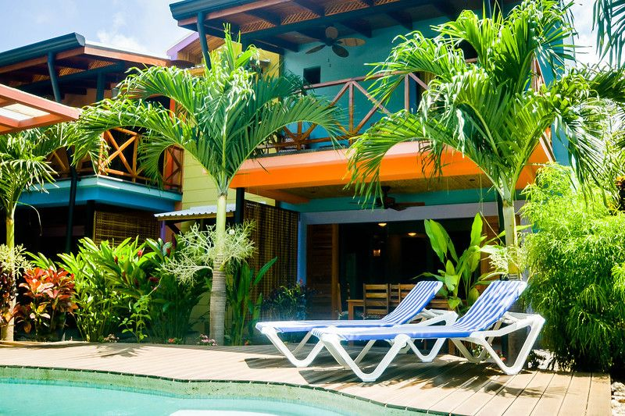
Total Cost: $1,650.00 Per Person
Trip Includes:
- Healthy Daily Breakfast, Two dinners
- 2 daily yoga classes
- Round trip transfers from Liberia airport
- 8 days/7 nights accommodations
The Beach House is three separate two bedroom villas surrounding a common pool and rancho. Each villa has its own kitchen, living room, dining room, outdoor patio, two bathrooms, safe and wifi. Located on the north side of Playa Guiones surrounded by lush landscaping and a short walk to the beach.
Your choice of a shared Queen bed or a Twin bed. All prices based on double occupancy. Sign up with a group of friends or come solo. New to yoga? No problema! Classes are designed for all levels. Come experience the trip that has sold out every year for the last three years. Come back feeling refreshed and energized. We hope you will join us!
Twin Room Queen Room
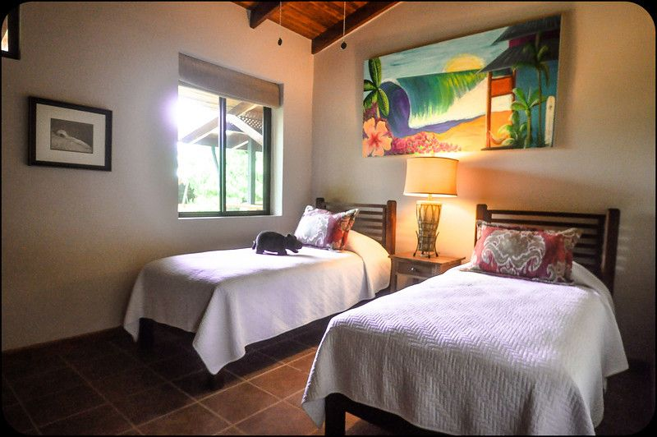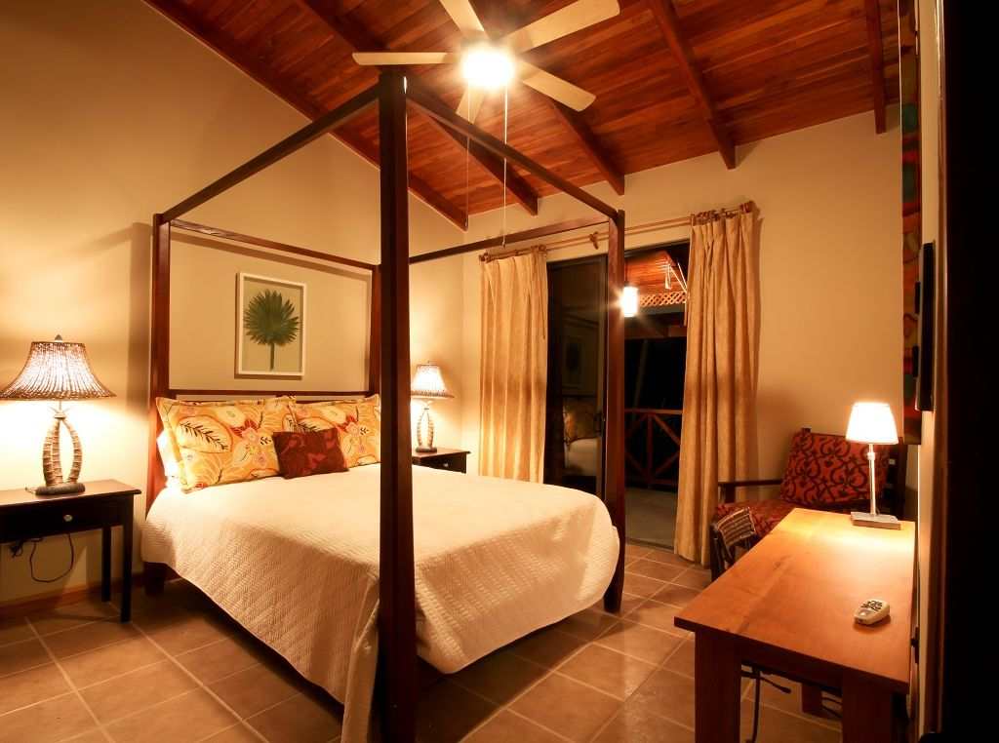
Pool at night Villa Living area
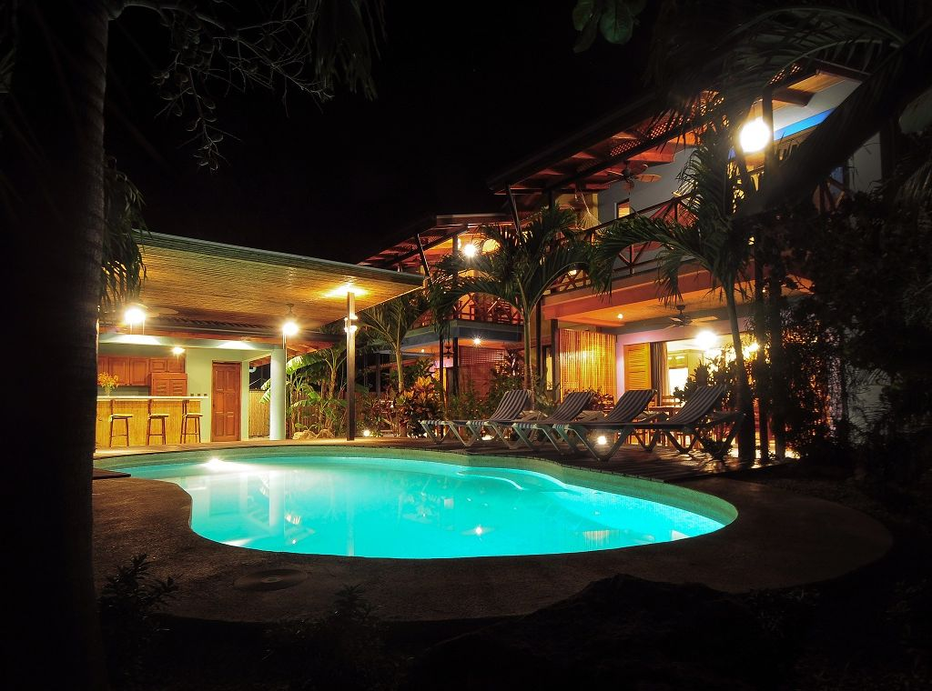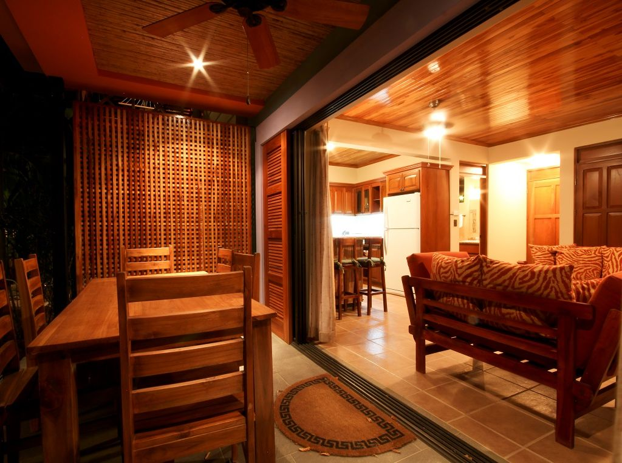
Questions? Call Denise: 612-819-9512 or Carole: 612-867-2173 or email: staff@yogabellastudio.com
Reserve your spot today!

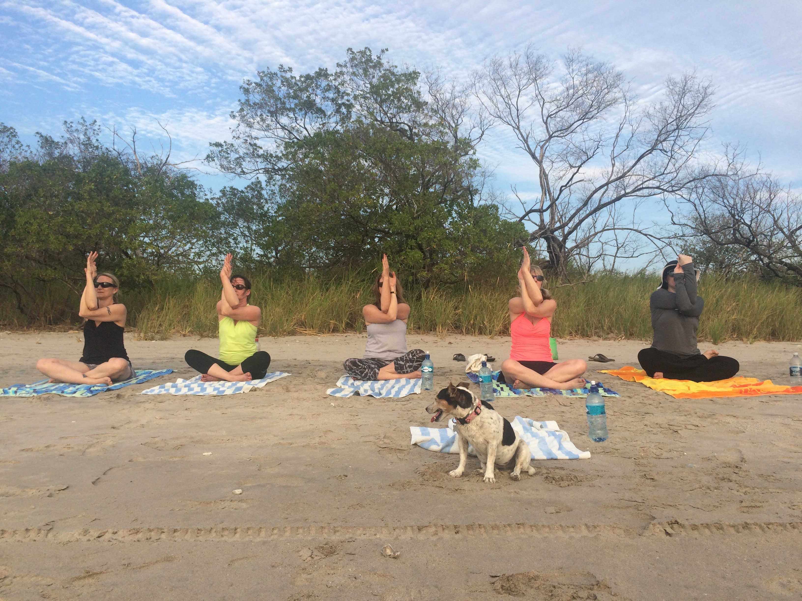
Reserve your spot by completing the forms below and send a $500 deposit to Yoga Bella.

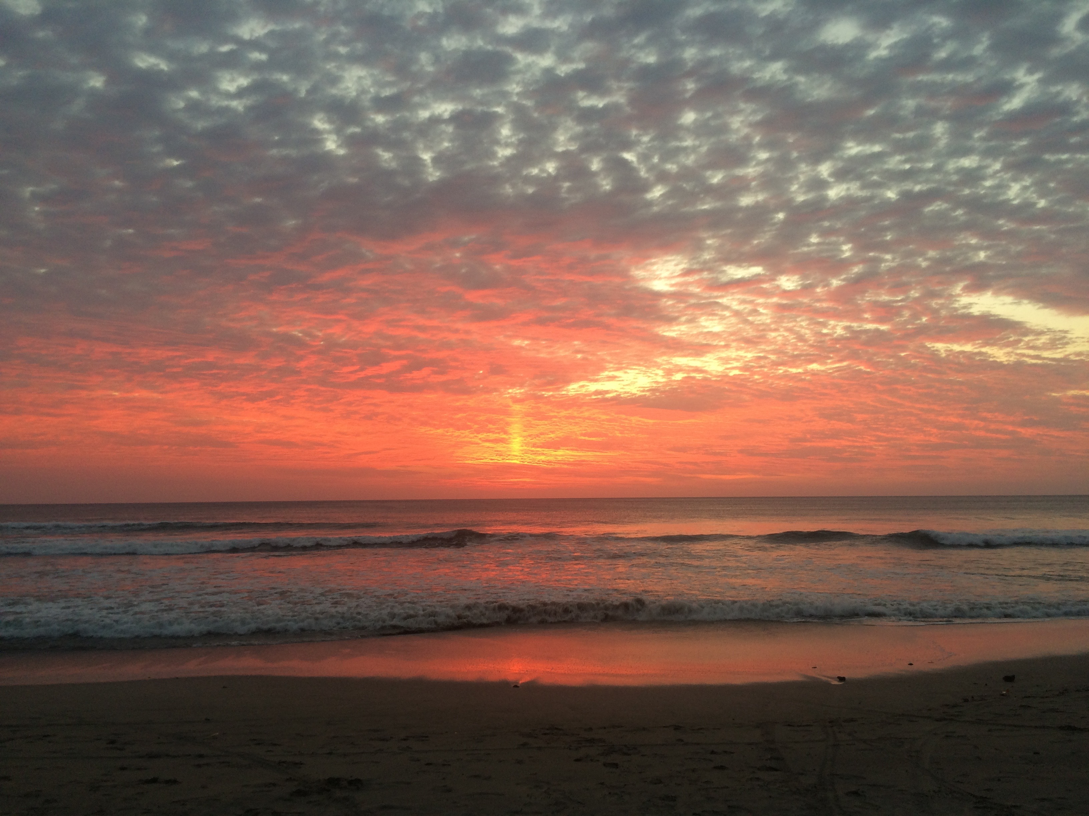

Yoga Bella
521 Lake Drive
Chanhassen, MN. 55317
Yoga Bella requires that all students/participants in travel abroad programs or related activities understand and agree to the following participation and responsibility requirements and wavier. The completion and return of this form is a requirement for participation in all Yoga Bella-sponsored travel/retreat abroad programs.
Please return the signed document to Yoga Bella immediately.
In addition, student participants should be aware of the following:
- Medical Insurance/Health Care Costs and Expenses
It is important to realize that most U.S. Insurance coverage is NOT recognized overseas. Students may wish to purchase emergency evacuation and repatriation insurance before they begin their trip abroad.

It is the student’s responsibility to ensure that he/she has health and/or hospitalization insurance, which is applicable in countries other than the United States.
- Personal Liability Insurance
Students desiring to obtain personal liability coverage may do so on a local basis or avail themselves of coverage that they may have with their Home Owners Insurance.

- Safety
All students/participants should inform themselves completely about the risks of foreign travel and participation in travel abroad programs. Yoga Bella does not guarantee quality of the participation experience, including any non-Yoga Bella programs and/or activities.

Date________________________

Signature________________________________

Yoga Bella Wellness Retreat Payment Contract
Please initial each line and sign below.
Registration Policies:
1. I understand that I am registering for the Yoga Bella Wellness Retreat January 21, 2017 to January 28, 2017.
Initial: ____________
2. I understand/agree to submit a NON -REFUNDABLE $500 to hold my spot on the retreat. I understand that I am not guaranteed a spot/room until I have submitted my $500 non- refundable deposit.
Initial: ____________
Payment Policies:
1. I understand that the remaining balance is due NO later than Friday, October 28th 2016. Please make checks out to Yoga Bella.
Initial: ____________
Cancellation Policies:
I understand that guests will receive a 80% refund if the cancellation is made in writing (via email) BEFORE November 15, 2016.
Initials: ____________
I understand that there is NO credit/refund for cancellations made AFTER November 15, 2016.
Initials: ____________
Retreat Policies:
I understand that the Yoga Bella retreat staff is subject change.
Initials: ____________

I agree to the above mentioned terms and conditions.
By:_______________________________________Date__________________

The Fine Print
Airfare is arranged individually. From Minneapolis you can fly direct on either Delta or Sun Country to Liberia, Costa Rica (LIR is the airport code).
When booking your flight make sure you arrive by 3:00 pm on January 21, 2017 and depart no earlier than 2:00 pm on January 28, 2017. Transfers to and from the Liberia airport have been arranged. Late arrival or earlier departure from the airport may result in additional costs.
Dine on fresh local cuisine. Breakfasts are included and will be served on the property. Lunch and all dinners, except two, are on your own. A group dinner will be arranged each evening if you would like to join the group.
There are several things to do in the area. Shop, surf lessons, rent a bike, spa treatments, zip line, walk the beach, SUP the river, see the turtles and aerial yoga to name a few. Depending on what you want to do in your ample free time additional funds might be needed.
Most merchants in Nosara take American dollars. And most activities are walking distance from The Beach House.

