Yoga Retreat in Costa Rica
January 13-20, 2018 or January 20-27, 2018
Once again Yoga Bella is offering its annual retreat in Nosara, Costa Rica - the perfect place to get away from it all in the middle of winter. Sunshine, sandy beaches, amazing food, yoga and tropical breezes make this retreat so popular we added a second week! Two daily yoga classes taught by Carole McMonigal or Denise Kennedy will deepen your yoga practice. Wake up to the sounds of howler monkeys, walk the beach, learn to surf, zip line, paddleboard, horseback ride, enjoy a spa treatment, and fuel your body with healthy foods. RELAX in the land of Pura Vida!

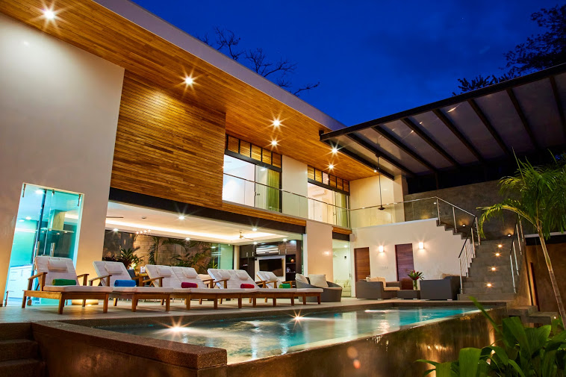

Total cost $1,750.00 Trip Includes:
- Healthy Daily Breakfast
- Two dinners
- 2 daily yoga classes
- Round trip transfers from Liberia airport
- 8 days/7 nights accommodations
- concierge services

Casa Almendra is a new five bedroom home in the heart of Playa Giuones with a central courtyard and infinity pool. There are three bedrooms with a king sized bed and private bath. There are two bedrooms with two twin beds that share a Jack and Jill bath.
You have a choice of a shared King bed or a Twin bed. All prices based on double occupancy. Sign up with a group of friends or come solo. New to yoga? No problema! Classes are designed for all levels. We will try to group experienced yogis and beginning yogis in two separate groups. Come experience the trip that has sold out every year for the last four years. Come back feeling refreshed and energized. We hope you will join us!

Questions? Call Denise: 612-819-9512 or Carole: 612-867-2173 or email: staff@yogabellastudio.com

Reserve your spot today!
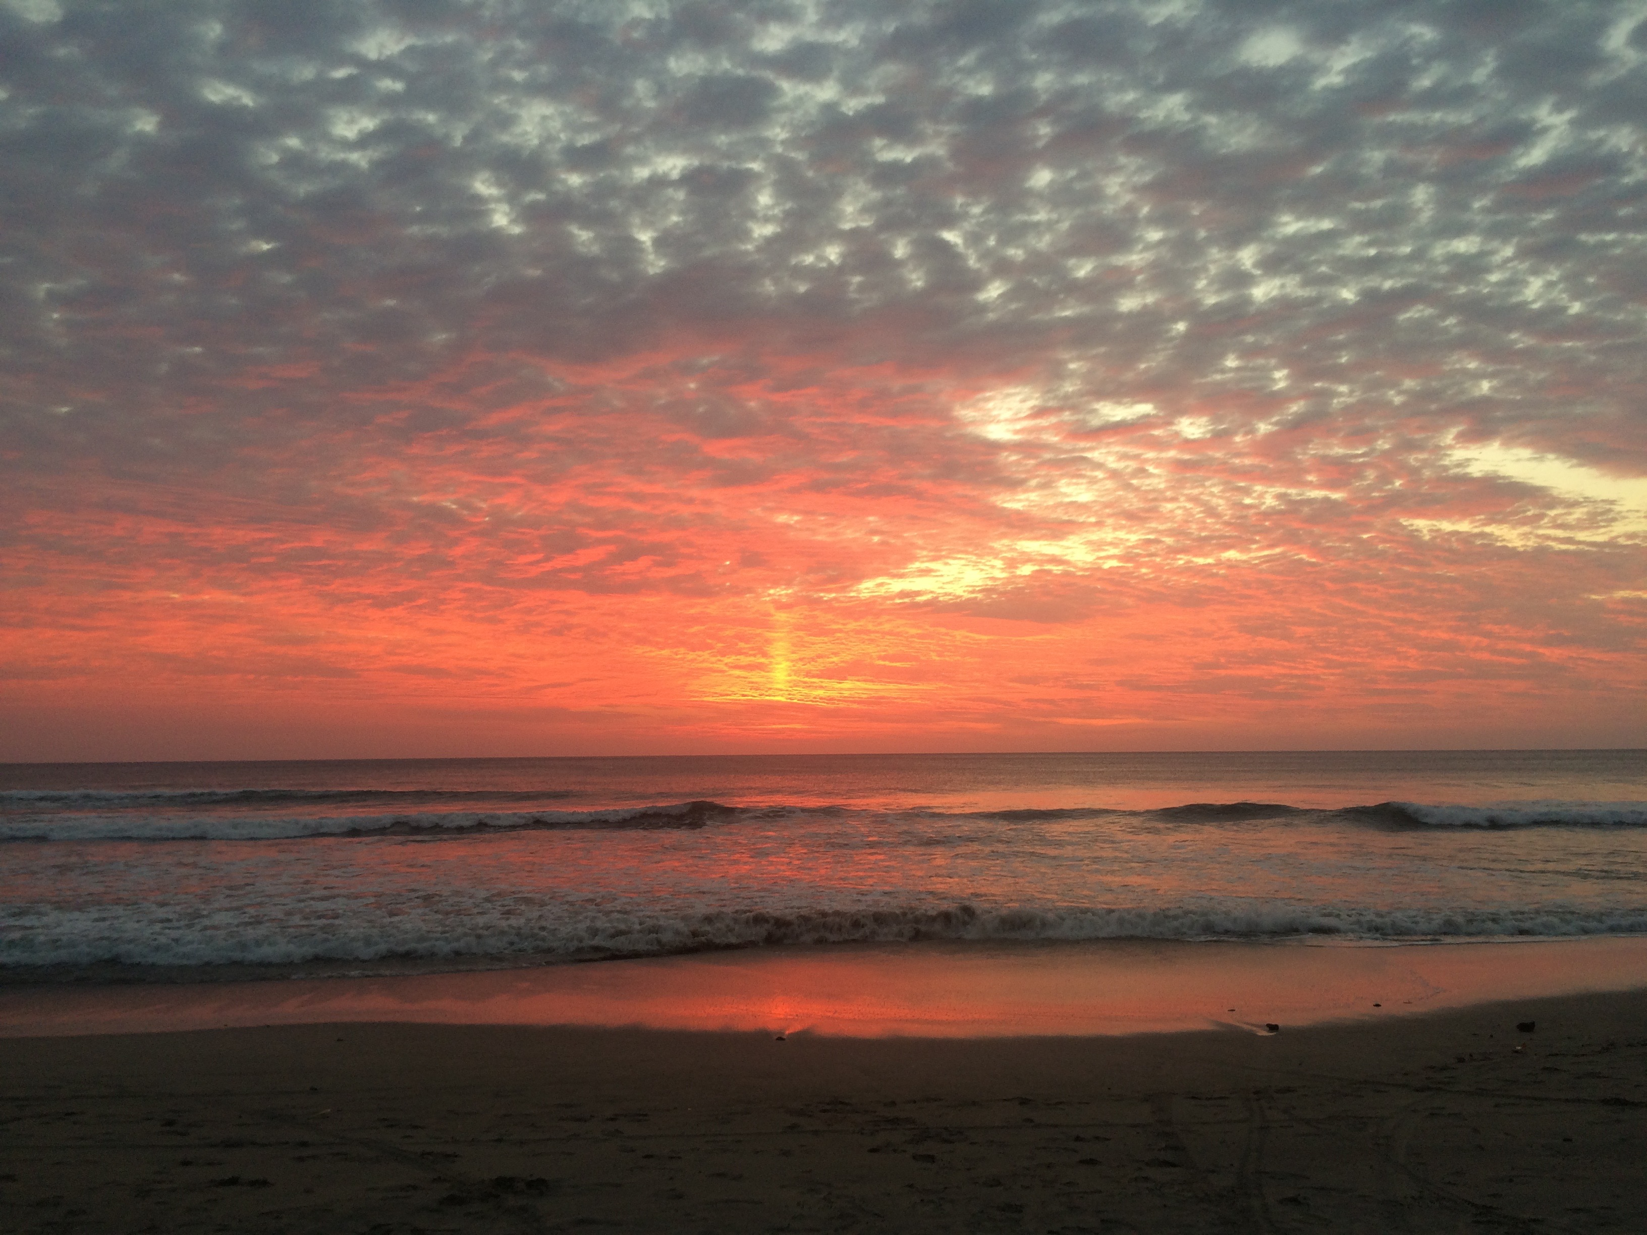

Reserve your spot by completing the forms below and send a $500 deposit to Yoga Bella.

Yoga Bella
521 Lake Drive
Chanhassen, MN. 55317
Yoga Bella requires that all students/participants in travel abroad programs or related activities understand and agree to the following participation and responsibility requirements and wavier. The completion and return of this form is a requirement for participation in all Yoga Bella-sponsored travel/retreat abroad programs. Please return the signed document to Yoga Bella immediately.
In addition, student participants should be aware of the following:

- Medical Insurance/Health Care Costs and Expenses
It is important to realize that most U.S. Insurance coverage is NOT recognized overseas. Students may wish to purchase emergency evacuation and repatriation insurance before they begin their trip abroad.

It is the student’s responsibility to ensure that he/she has health and/or hospitalization insurance, which is applicable in countries other than the United States.

- Personal Liability Insurance
Students desiring to obtain personal liability coverage may do so on a local basis or avail themselves of coverage that they may have with their Home Owners Insurance.

- Safety
All students/participants should inform themselves completely about the risks of foreign travel and participation in travel abroad programs. Yoga Bella does not guarantee quality of the participation experience, including any non-Yoga Bella programs and/or activities.

Date________________________

Signature________________________________

Yoga Bella Wellness Retreat Payment Contract
Please initial each line and sign below
Registration Policies:
1. I understand that I am registering for the Yoga Bella Wellness Retreat for either:
_______January 13-20, 2018 or _______January 20-27, 2018

Initial: ____________

2. I understand/agree to submit a NON -REFUNDABLE $500 to hold my spot on the retreat. I understand that I am not guaranteed a spot/room until I have submitted my $500 non- refundable deposit.

Initial: ____________

Payment Policies:
3. I understand that the remaining balance is due NO later than Friday, October 27th 2017. Please make checks payable to Yoga Bella.

Initial: ____________

Cancellation Policies:
4. I understand that guests will receive a 80% refund if the cancellation is made in writing (via email) BEFORE November 15, 2017.

Initials: ____________

5. I understand that there is NO credit/refund for cancellations made AFTER November 15, 2017.

Initials: ____________

Retreat Policies:
6. I understand that the Yoga Bella retreat staff is subject change.

Initials: ____________

I agree to the above mentioned terms and conditions.

By:_______________________________________Date__________________

The Fine Print

Airfare is arranged individually. From Minneapolis you can fly direct on either Delta or Sun Country to Liberia, Costa Rica (LIR is the airport code).

When booking your flight make sure you arrive by 3:00 pm on the designated day that the retreat begins, either January 23, 2018 or January 20, 2018 and depart no earlier than 2:00 pm on either January 20, 2018 or January 27, 2018. Transfers to and from the Liberia airport have been arranged. Late arrival or earlier departure from the airport may result in additional costs.

Dine on fresh local cuisine. Breakfasts are included and will be served on the property. Lunch and all dinners, except two, are on your own. A group dinner will be arranged each evening if you would like to join the group.

There are several things to do in the area. Shop, surf lessons, rent a bike, spa treatments, zip line, walk the beach, SUP the river, see the turtles and aerial yoga to name a few. Depending on what you want to do in your ample free time additional funds might be needed.

Most merchants in Nosara take American dollars. And most activities are walking distance from Casa Almendra.

We look forward to having you join us!

