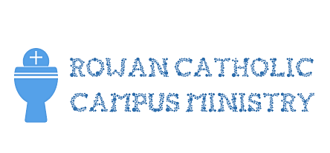
Come Retreat with us!
Where and When: At the Saint Raphaela center in Haverford, PA, on February 23-25
What: An awesome encounter with God through prayer, the sacraments, inspiring talks, community and fun!
Registration is $50. A $15 discount is available if you help with our fundraising at St. Bridget’s.
We will leave from the Newman House on Friday, late afternoon (around 5:00pm).
Checks should be made out to "Rowan Catholic Campus Ministry." Please return this form with your payment by dropping it off at the Newman House (1 Redmond Avenue).
Please contact Ivan at isoares@stbridgetup.org with questions.
This form and your payment is due by Wednesday, February 14th!
Name (First & Last):______________________________________________________________
Cell phone # and email address:
______________________________________________________________________________
Please list any food allergies or medical concerns:
______________________________________________________________________________
______________________________________________________________________________
By submitting this registration, I agree to pay the registration fee to Catholic Campus Ministry. I understand that I will have to pay the $50 in full or talk to my Campus Minister about other options. (Financial assistance is available for students – do not be afraid to ask!)
________________________________________________ ____________
Signature Date

